Introduction:-

In this report im going to talk in general about Dubai. Iam t also going to tell the important achievements.
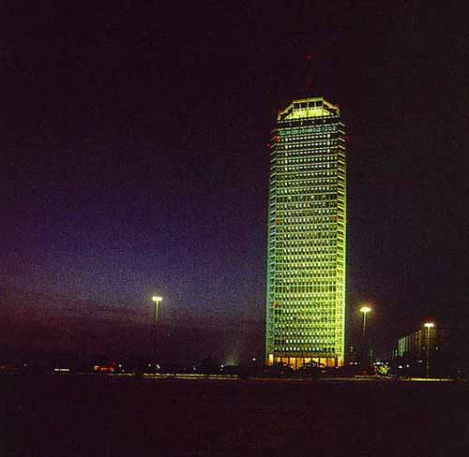
Dubai is the second largest emirate in the U.A.E. Its total area is around 1000 square miles.
The city of Dubai is divided by the famous Dubai creek or Khor. This natural harbour, and Dubai's strategic location on the international trading map has made it one of the world's leading trading and commercial centers.
The Ruler of Dubai, H.H. Sheikh Maktoum bin Rashid Al Maktoum, succeeded his father in 1990.
His father, Sheikh Rashid bin Saeed Al Maktoum was one of the founding fathers of the UAE together with H.H. Sheikh Zayed bin Sultan Al Nahayan and was the Vice-President and Prime Minister until his death in 1990.
Now, Sheikh Maktoum has taken the mantle of the above positions.

Culture in Dubai
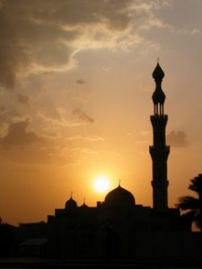
Deep rooted inside the Islamic traditions that form the main constituent of UAE’s lifestyle, the Culture in Dubai is diverse and rich. It is very much important for the foreign nationals to respect the tradition of the Emiratis when in UAE. Well-known as the entertainment hub of the Middle East, Dubai acts like a magnet for the party lovers who enjoy splurging inside the expensive clubs and bars of the city. Emiratis are quite popular for their warm hospitality who offers tempting refreshments to their guests.
When Arabs meet up, they take their own time and talk about general things. Men and Women do not greet each other outside their family. Men do shake hands and might even kiss each other on the cheek with their real good friends. On the other hand a woman tends to hug and kiss only her close friends.
Perhaps there are certain things that are to be kept in mind if you are invited in an Arab’s house. It is advised to dress gracefully, to be punctual as far as possible, and greet the elders first in a way to respect them, remove your shoes before entering and bring something small as a way of thanking. Flowers are generally given for a woman by the woman guest. Giving alcohol has to be avoided as a gift unless it is accepted positively. Hosts commonly do not open the gifts in front of the visitors. If you are served the Arabian coffee and dates, be obliged to taste it and if you are invited for a meal then it is understood that it is time to socialize and have a small talk before the meal is served. Residents generally sit crossed legged or else kneel down on one knee when having their meal on the floor and eat with their right hand. Tourists are requested to try a bit of each delicacy served.
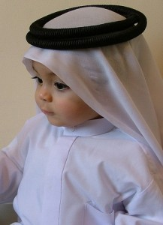
People normally dress up in their traditional clothes that make them the most comfortable. Men generally prefer the khandura or dishdasha, a long white shirt, along with the ghutra, white headdress, and the agal, a rope for the ghutra. Women wear the abaya, long black cloak, over their clothes and a hijab or sheyla, a scarf wrapped around face and head. Visitors are requested to dress sophisticated whilst traversing around the city. Men are requested to wear trousers and women to wear dress long enough to cover their knees. Visitors can wear clothes according to their wish when inside the hotel or at bar or club. Swim wear is accepted at the pool or beach. Alcohol consumption is allowed only inside the nightclubs, bars and some of the hotels. Locals can enjoy a drink inside their house as long as they possess an alcohol license given by the municipality. Residents or tourists are not allowed to consume alcohol on the streets or in public places.
When in Dubai visitors are requested not to exhibit Western culture habits on the streets wherein the foreign nationals may find it offensive. Tourists are asked for not to take photographs of airports, ports, government buildings and military installations. Before taking the snaps of the locals, especially women, tourists are requested to ask politely.

Food in Dubai
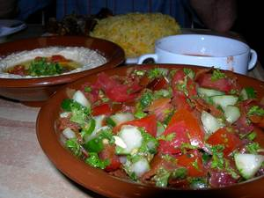
Arabian Food
There is no specific Dubai’s food in Dubai. The traditional Arabic food available here seems to come from the other regions of the Middle East. So, along with a try at the traditional Arabic food, you can also put your fork into the tempting dishes made by the cooks of different hotels and restaurant. It will not take a long time for you find a good-priced restaurant serving a dish from your country out here.
If you do want to splurge yourself on the food then going in for some of the Filipino, Pakistani or Indian restaurants can be a good idea, but if you do want to splurge around on the delightful dishes then just pop inside any of the Japanese, Thai, French or Italian restaurants. Also, going inside a steakhouse will be an excellent idea if you love meat. However, if you are still insisting on trying out some of the sumptuous Arabian delicacies then hop inside any of the Moroccan, Iranian or Lebanese restaurants.
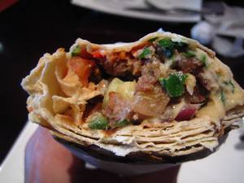
Shawarma
Hoummus, Ghuzi, Wara enab, Tabbouleh, Koussa mahshi, Haries, Matchbous, Shawarma, Falafel and the Arabic Bread are some of the items that should be missed out if you want to enjoy food in Dubai. Shawarma, is generally on the top of the list of the popular Dubai visitors. It is cooked with chicken or lamb thoroughly mixed with tomatoes, fries, garlic sauce and pickle and wrapped inside a small Arabic roti. Falafel is a mixture of chickpeas and different spices fried deeply in the form of a cutlet. It is generally enjoyed as a side dish. Hommus is a dip made by mixing chickpeas and sesame seeds. Ghuzi is a completely roasted lamb kept on the bed of cooked rice and nuts, Wara enab is Vine leaves filled with rice and Matchbous is spiced lamb served with rice. Koussa mahshi us nothing but stuffed courgettes, while Tabbouleh is crushed wheat mixed with well chopped parsley and mint. Haries is an affluent dish cooked very slowly with tender lamb and wheat. Arabic bread or Arabic roti is a worth try. It is baked in clay ovens and served with different curries. Try it with any of the Indian delicacies for a better experience.
After trying out all this do not forget to try out the regular Dubai desserts that include Umm Ali, Mehalabiya and Esh Asaraya. Umm Ali is a sort of bread pudding, Mehalabiya is a pudding speckled with pistachios and rosewater and the Esh Asaraya is a cheesecake topped with cream.

Sports in UAE
A country full of golden sand dunes of the desert, there are a variety of sports, other than camel and horse racing, played in the United Arab Emirates. Also, there are a lot of main international sporting events taking place in Dubai and UAE all round the year and your hotel or travel agent can help you out in getting the tickets of various sporting events hosted in UAE. If you are tired of lying down at the pool or on the bed of your hotel and if you wish to play the sports then don’t worry as there are a lot of sporting and recreational activities conducted by a lot of tour companies for the tourists. Don’t miss running in the Dubai Marathon if you are fit and healthy!
Horse Racing
Horse racing is a more popular as compared to camel racing in the UAE. Horse racing can be enjoyed at most of the major clubs. The Dubai World Cup horse race is the world’s richest horse race and can be revered in Dubai. People can also enjoy horse riding at the various clubs and the essential equipments are provided on request. Also, there are lessons conducted for the interested. The Abu Dhabi Tourist Club, Abu Dhabi Hunting & Equestrian Club, Ajman Equestrian Club, Club Joumana, Jebel Ali Equestrian Club, Sharjah Equestrian & Racing Club and the Umm al-Qaiwain Marine Club and Riding Centre are a few of the horse racing clubs located in UAE. Have an exclusive look of the Meydan Race Course City which will be inaugurated during the 2010 World Cup and is touted to be the largest one in the current horse racing scenario.
Football
Football or soccer is one of the most popular and favourite sport after Camel racing and Horse racing. There are a lot of stadiums spread across UAE. Zayed Sports City is the largest sports complex in the country.
Cricket
As most of the population in UAE comes from the Indian sub-continent, cricket is easily become the popular sport in the country. The Sharjah Cricket Stadium hosts the annual matches for the cricket world cup.
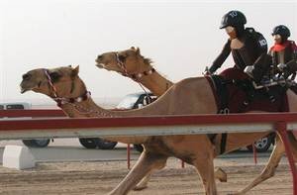Camel Racing
Generally takes place on weekend’s mornings in winter, Camel racing is a different sport and has become an essential part of the UAE tradition. The race takes place on special tracks and the atmosphere is completely enthusiastic during public holidays. Al Wathba Racetrack, Al Ain Racetrack and Nad al-Sheba camel track are a few of the racetracks located in UAE.
Golf
UAE has many golf courses and three of them are PGA championship golf courses. Almost all of the courses are managed by the UAE Golf Association and most of them are also found in the major hotels of the country. Dubai Desert Classic event takes place in Dubai and is marked by the world’s best golf players.
Tennis
The popularity of Tennis is taking its pitch high up and there are a lot of private clubs and hotels hosting their own tennis courts. The annual Dubai Tennis Championships is hosted in Dubai and is a WTA and ATP event wherein the top tennis players compete.
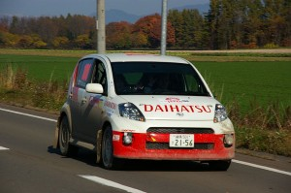Car Rallying
Most of the cars rallying events in UAE are organized by the Emirates Motor Sports Federation. The Desert Challenge is always held in the first week of December.
Polo
Dubai Polo Club offers a chance to play polo for the polo lovers. They also provide all the equipments on rent. The polo season is hosted in the country in between Mid-October to April.
Rugby
Rugby fans can play and enjoy watching rugby matches held throughout the year across the country. Dubai hosts Six Nations Rugby Tournament in April and Dubai Rugby Sevens in November and December.
Rock Climbing
There are some interesting rock-climbing routes on the UAE Mountains. Also, you can try out indoor climbing at the Pharaohs Club, Qud al-Mehta and Pyramids in Dubai.
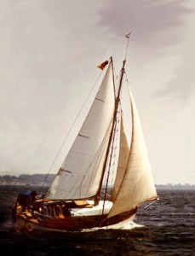Sailing
There are a lot of beach clubs and hotels offering an option of sailing through the waters of the Gulf for the short-time visitors of the UAE. For a true experience you can endow the sailing dhows or wooden crafts swaying off across the Indian Ocean. Abu Dhabi International Marine Sports Club, Abu Dhabi Catamaran Association, Dubai Offshore Sailing Club, Dubai International Marine Club and the UAQ Tourist Club provide sailing equipments for the sailors.
Ice-Skating
You can enjoy ice-skating when the sun always shines in the country. The Abu Dhabi Tourist Club has got a big ice-skating rink with floodlights and TV screens. Dubai has got two ice rinks, Hyatt Regency Galleria and Al Nasr Leisureland and you need to check for the activities before going.
Other Sports
Besides the common sports you can enjoy bowling, polo, rock climbing, canoeing, athletics, chess, archery and much more. Popular water sports include boat racing, powerboat racing and jet skiing.

Conclusion:-
I wish that you enjoy reading my report and now some new information in generally about Dubai.

