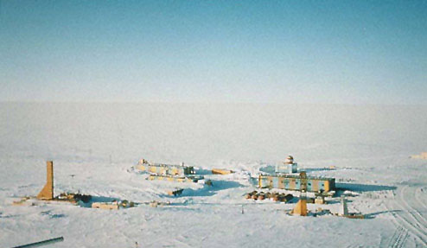

The confirmed coldest temperature on Earth was recorded in Vostok , Antarctica at a brisk -89.2 degrees Celsius (183 Kelvin). There is an unconfirmed report of the temperature reaching -91 degrees Celsius (181 Kelvin); either way you look at it; you are still freezing your butt off.

The high velocity winds at the South Pole don't make enduring the cold any easier by the dedicated scientists that work there. Winds can reach a velocity of 90 m/s. These temperatures were recorded during the Antarctic winter in June and July, during the period when the sun never actually rises.

Even at its balmiest, Vostok only reaches temperatures of around -25 degrees Celsius (248 Kelvin). When we are looking at temperatures that cold, the Kelvin scale helps make the picture look less bleak; no ominous negative sign out front to make you lose all hope of getting warm. Incidentally, the warmest recorded temperature at Vostok was -19 degrees Celsius (254 Kelvin).

Vostok's elevation is almost 3500 meters above sea level, and due to the density of oxygen being less towards the poles, the scientists are working at an effective height of 5000 meters above sea level.

Why would we journey to such an inviting place you might wonder? Vostok is located 1300 kilometers from the true South Pole, but is very near the Magnetic South Pole. Scientists study actinometrical; the measure of solar radiation in photons, geophysics; the study of the physical properties of the Earth, mainly electrical, gravitational and magnetic forces which also includes seismology, and climatology; the study of weather systems.

Vostok is operated as a permanent Antarctic station by the Russian Federation and carries out a wide range of scientific activities. It is situated in the centre of East Antarctica on the Polar Plateau at an altitude of 3,488 meters and is the most isolated of any Antarctic Base. It is also known as the coldest place on earth.
The Vostok station was opened on December 16, 1957. It is located on the snow surface of the ice plateau of Central Antarctica (with coordinates of 78 28'S and 106 48'E) in 1410 km from the Mirny station and in 1260 km from the nearest sea coast. The station height above sea level comprises 3448 m. The ice sheet thickness in this area is 3700 m.
The highest part of the ice plateau is at a distance of 450 km to the west-southwest of the station at the height of more than 4000 m above sea level. The station is located on the snow plane with a general insignificant eastward gradient presenting a slope of the main ice divide of the continent. Snow sastrugi and naduvy (blown snow fields) are typical micro-relief features of the snow surface in the station vicinity forming a slightly undulated surface. The height of sastrugi typically varies between 20-40 cm and that of naduvy is not greater than 50 cm.

References
1. Vostok temperature data.
http://www.nercbas.ac.uk/icd/gjma/vostok.temps.html.

