Parts of Plants

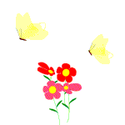
Each part of a plant has a very important function. All plants produce flowers for the same reason: to make seeds so another plant can grow.
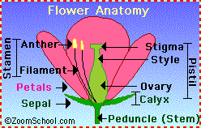
Leaves: These are the parts of the plant where food is made by photosynthesis. Leaves take in carbon dioxide from the air, water
from the soil, and energy from the sunlight. During photosynthesis, the leaves use light energy to change carbon dioxide and water into food. (sugar)

Flowers: These are the reproductive parts of a plant. Flower petals and the flowers smell attract insects and bees to pollinate the flower. After pollination, the petals fall off and seeds develop in the part of a flower called the ovary. The ovary itself usually becomes what we call the fruit.

Stems: These support the upper parts of plants. Water and dissolved nutrients from the soil travel up the stem in a system of tubes. Food from the leaves travel down stems to the roots. Stems also store food for the plant.

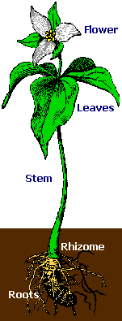
Roots: These anchor plants in the soil. Water and minerals are taken from the soil through the roots. Many plants such as carrots, store food in their roots.

Seeds: these contain a tiny embryo of a plant inside. The seed halves contain food which supplies energy and materials for growth until the plant grows its first leaves above the ground.
A seed is a tiny case containing plant life. A baby plant is in the seed. The seed sprouts. A little plant begins to grow. The seed has food for the new plant until it grows leaves to make its own food.
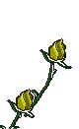
Seeds come in all different shapes and sizes. When you open the case of the seed you will see a tiny plant called an embryo. The seeds contain food so the little plant can survive until it can make food on its own. The food storage is called the cotyledon. Some plants such as the bean have two cotyledons. Others, such as corn have only one.

Almost all shrubs, vegetables, flowers and trees started as seeds. Some of the seeds grow into seedlings and then into their adult form.
When a seed is ripe, it drops from the plant. It begins to germinate or grow. In order to do this the plant needs: water, air, and of course sunlight to keep it warm. Sometimes if you are growing plants indoors, you can purchase a special kind of growth bulb. This, artificially, grows plants. A root eventually appears first and grows downward. Then a stem pushes upward toward the light. The first leaves appear and the plant can make its own food in its leaves.

There are so many different kinds of seeds that we eat. We also eat grasses. Yes, that's right, grasses. Corn, wheat, oats, and rice are different kinds of grasses called cereals. The seeds of these cereals provide food for many of the animals that we eat.

There are also non-flowering plants such as ferns, mosses, and algae that produce spores. A spore is a cell with a think protective covering, much smaller than the smallest seed. Spores develop directly into the adult plant. Spores are distributed by air or water.
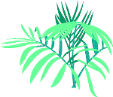
On the underside of fern leaves, you can find small brown lumps. These lumps produce spores. When the spores are ripe, they fall to the ground and grow into new ferns.

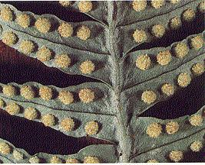

Life Cycle of a fern:

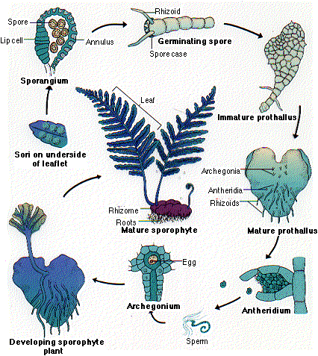


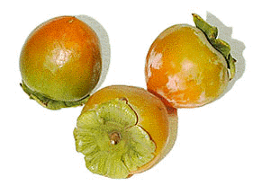
Asparagus is a member of the lily family, which also includes onions, leeks, and garlic, but asparagus has a unique mild flavor, nothing like the flavor of its onion cousins.
Asparagus plants are perennials, which means the same asparagus plant will produce spears year after year. In fact, one plant may produce spears for up
to 25 years!

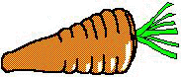
The bright orange color of carrots tell you they’re an excellent source of Vitamin A which is important for good eyesight, especially at night. Vitamin A helps your body fight infection, and keeps your skin and hair healthy.

Blueberries are the second most popular berry in the United States.

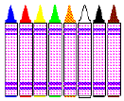
Soy crayons have been created to replace toxic petroleum-wax crayons, soy crayons are safer to use, brighter in color, and less expensive to produce.

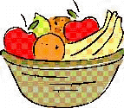
Onions contain a mild antibiotic that fights infections, soothes burns, tames bee stings and relieves the itch of athletes foot.
• Archeologists have found evidence that humans have enjoyed eating apples since 6500 B.C. Each of us eats more than 19 pounds of apples annually.
• Grapes are one of the oldest cultivated fruits. They have been around for more than 8,000 years.
• Americans eat about 125 pounds of potatoes a year, about half from fresh potatoes and half in processed foods.

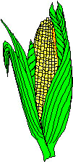
One bushel of corn will sweeten more than 400 cans of pop.
• There are about 600 kernels on each ear of corn.
• Farmers grow corn on every continent except Antarctica.
• Each tassel on a corn plant releases as many as 5 million grains of pollen.

An acre of trees can remove about 13 tons of dust and gases every year from the surrounding environment.
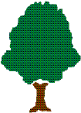
• Almost a third of the world’s total land area is covered by forests.
• Some tissue-making machines can produce as many as 6000 feet of toilet tissue every minute out of trees.
• About 1.5 million tons of ground cocoa beans from the tropical tree are used each year to make chocolate and cocoa products. That’s greater than the weight of more than 300,000 elephants!
• Every year in the United States each person uses the equivalent of one tree, 100 feet tall and 16 inches in diameter, to fulfill their wood and paper needs.

Bananas are the most popular fruit in America. The average person eats 33
pounds of bananas a year!

A single baked potato contains less than 250 calories and is over 99% fat free.
Bell peppers are usually sold green, but they can also be red, purple or yellow.
Tomatoes are very high in the carotenoid Lycopene; eating foods with carotenoids can lower your risk of cancer.
Other vegetables high in carotenoids are carrots, spinach, sweet potatoes, and collard greens.
Most of the nutrients in a potato reside just below the skin layer.
A horn worm can eat an entire tomato plant by itself in one day!
In the United States, more tomatoes are consumed than any other single fruit or vegetable!
California produces almost all of the broccoli sold in the United States.
White potatoes were first cultivated by local Indians in the Andes Mountains of South America.


Little Brown Seeds
Author unknown
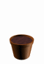
Little brown seeds so small and round
Are you sleeping quietly underground?
Down came the raindrops
Sprinkle, sprinkle, sprinkle.
Out comes the rainbow
Twinkle, twinkle, twinkle.
Little brown seeds way down below
Up through the earth they
Grow, grow, grow.
Little green leaves come one by one.
They hold up their heads
And look at the sun.
The Seed
Carol Simpson
I'm planting a seed.
I hope it will grow.
I'll water it carefully.
And one day I know
That something will happen.
Just wait and see.
That tiny little seed
Will grow into a tree.
A Daffodil
A little yellow cup,
A little yellow frill,
A little yellow star,
And that's a daffodil.
A Poem Garden
Tomato,
Perfect, round and red,
Growing in your garden bed.
Cornstalk,
Tall and green
With yellow corn inside, unseen.
Melon,
Sweet and round,
Resting on the ground.
String bean,
On the vine,
Green like this garden of mine.

Dig A Little Hole
Dig a little hole.
Plant a little seed.
Pour a little water.
Pull a little weed.
Chase a little bug --
Heigh-ho, there he goes!
Give a little sunshine,
Grow a little rose.
Planting
I took a little seed one day
About a month ago.
I put it in a pot of dirt,
In hopes that it would grow.
I poured a little water
To make the soil right.
I set the pot upon the sill,
Where the sun would give it light.
I checked the pot most every day,
And turned it once or twice.
With a little care and water
I helped it grow so nice.
Dick Wilmes
Package of Seeds
They can't see their pictures,
they can't read the label --
the seeds in a package --
so how are they able
to know if they're daisies
or green for the table?
It sounds like a fancy,
it sounds like a fable,
but you do the sowing,
the weeding, the hoeing,
and they'll do the knowing
of how to be growing.
Aileen Fisher
Waking Up
A little bean baby
Jumped out of bed,
With a white nightcap
Upon his head.
He yawned and stretched
In the warm, sunny air,
Till his cap tumbled off
His shiny green hair.
Irene M. Crofoot

http://tqjunior.advanced.org/3715/glossary_text.html
http://www.dnr.state.wi.us/org/caer/ce/eek/veg/plants/wildflowerindex.htm
http://www.urbanext.uiuc.edu/gpe/
http://205.146.39.13/success/lessons/Lesson2/Lesson2a/PSCb2_L.HTM
http://www.guilford.k12.nc.us/webquests/plants/plants1.htm
http://www.atozteacherstuff.com/lessons/InsideSeed.shtml
http://aggie-horticulture.tamu.edu/kindergarden/survey/survey.htm

Thank u
Bint uae9

