They made our world
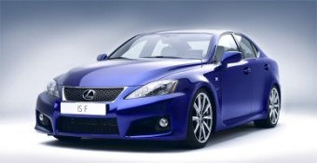
1 – Match :

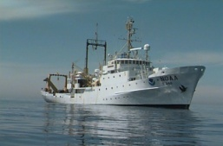
Sail
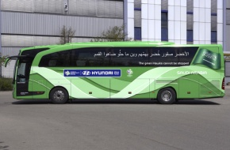
Drive
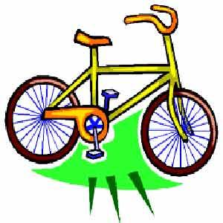
ride

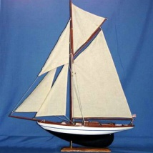
`
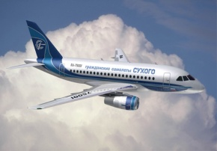

2- write this words in Alphabetical order :
UAE ------- Alphabetical order 3
Table ------- * As you know , information is often
Run -------- in alphabetical order . You must
Sail ------- learn the order in English , here are
Yellow ------ the final letters ..
Vote ------- q - r - s - t - u – v – w – x – y - z
Queen -------
Woman -------
By : Nawar Wathiq

