Floods
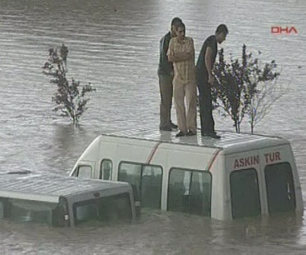

What causes Floods?
Flooded areas of land usually start off as very dry land. Floods are caused by heavy rains that pour to much water into rivers and other waterways. Making these natural channels unable to carry all the water. Rising water flows over or breaks the banks to the waterways causing the surrounding land to be flooded. Different causes of floods can come from masses of snow melting of tidal waves.

Where do Floods occur?
The type of land that is prone to flooding are broad and flat usually situated on the banks of a river or main waterway. Rivers that flood are regarded in three different stages. They are:-
ONE:- Water comes off the mountains, eroding the beds and banks of the river as it flows.
TWO:- This type river travels through broad valleys which slows the current of the river down. If the current is slow it will transport less material down the river.
THREE:- Flood-plain stage. Little if not any erosion takes place most of the material tha tis carried in the current is suspended and deposited to the form a flood plain.
Tornado

What is a Tornado?
A tornado is a violent whirling wind, accompanied by a funnel-shaped cloud extending down from a cumulonimbus cloud. Commonly known as a twister, a tornado has an average width of a few hundred meters, but can be anywhere from a few meters to a kilometer wide where it touches the ground. It can move over land for distances ranging from short hops to many kilometers, causing great damage wherever it descends.
How do Tornadoes occur?  Tornadoes form when two masses of different temperatures and humidity meet. If the lower layers of the atmosphere are unstable, a strong upward movement of warmer air is formed. This starts to spiral as it rises, and intensifies. Only a small percentage of these systems develop into the narrow, violent funnels of tornadoes. | 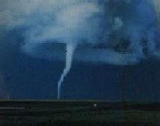

Where and when do Tornadoes occur?
Tornadoes are probably the most spectacular type of storm, but are certainly one of the most violent. Fortunately, however, they are restricted in their range. Although they occur in some form on all continents, it is the U.S.A. where they most frequently cause disaster. Tornadoes usually form during cloudy, stormy weather and descend from severe thunderstorms as rapidly-spinning white funnels of cloud.
Earthquakes
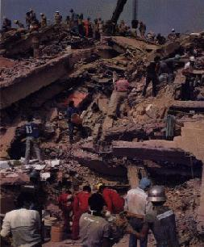
What causes Earthquakes?
Earthquakes are caused when tension is released from the rocks in the Earth's crust and upper mantle. This tension is due to friction between what scientists believe are large 'plates' floating on magma on the Earth's surface. Sometimes earthquakes happen when the rocks in the earth's crust bend and break. This causes shock waves to travel on the earth's surface, resulting in widespread destruction.
Where do Earthquakes occur?
Earthquakes usually occur in places where two plates meet, called faults. Earthquakes are mostly generated deep within the earth's crust, when the pressure between two plates is too great for them to be held in place. The underground rocks then snap, sending shock waves out in all directions. These are called seismic waves. The underground origin of an earthquake is called the focus. The point at which an earthquake originates on the surface is called the epicenter.

Bushfires

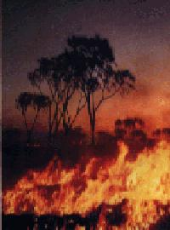

What causes Bushfires?
There are many different conditions that can trigger a bushfire, including dry weather, high temperatures and flammable vegetation. In remote bush land areas lightning is the most common igniter.

Where do Bushfires occur?
Australia is a popular area for bushfires due to its high temperatures, dry climate and weather patterns. If there is an area of bush near a town or city, arsonists and negligent people are the greatest starters of fires.

