Polynomial Long Division

An Example.
In this section you will learn how to rewrite a rational function such as
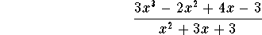
in the form
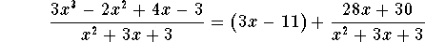
The expression
is called the quotient, the expression
is called the divisor and the term
is called the remainder. What is special about the way the expression above is written? The remainder 28x+30 has degree 1, and is thus less than the degree of the divisor 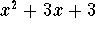.
It is always possible to rewrite a rational function in this manner:
DIVISION ALGORITHM: If f(x) and 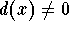are polynomials, and the degree of d(x) is less than or equal to the degree of f(x), then there exist unique polynomials q(x) and r(x), so that
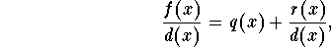
and so that the degree of r(x) is less than the degree of d(x). In the special case where r(x)=0, we say that d(x) divides evenly into f(x).
How do you do this? Let's look at our example
in more detail. Write the expression in a form reminiscent of long division:
First divide the leading term of the numerator polynomial by the leading term of the divisor, and write the answer 3x on the top line:
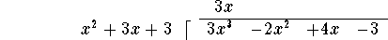
Now multiply this term 3x by the divisor , and write the answer
under the numerator polynomial, lining up terms of equal degree:
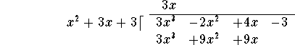
Next subtract the last line from the line above it:
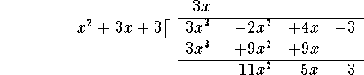
Now repeat the procedure: Divide the leading term of the polynomial on the last line by the leading term of the divisor to obtain -11, and add this term to the 3x on the top line:
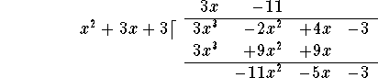
Then multiply "back": 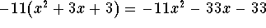and write the answer under the last line polynomial, lining up terms of equal degree:
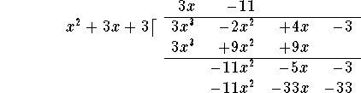
Subtract the last line from the line above it:
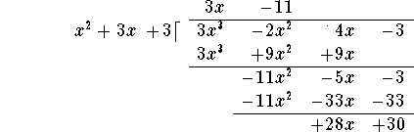
You are done! (In the next step, you would divide 28x by , not yielding a polynomial expression!) The remainder is the last line: 28x+30, and the quotient is the expression on the very top: 3x-11. Consequently,
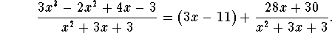

How to check your answer?
The easiest way to check your answer algebraically is to multiply both sides by the divisor:
then to multiply out:
and then to simplify the right side:
Indeed, both sides are equal! Other ways of checking include graphing both sides (if you have a graphing calculator), or plugging in a few numbers on both sides (this is not always 100% foolproof).

Another Example.
Let's use polynomial long division to rewrite
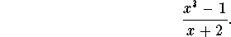
Write the expression in a form reminiscent of long division:
First divide the leading term of the numerator polynomial by the leading term x of the divisor, and write the answer on the top line:
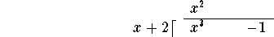
Now multiply this term by the divisor x+2, and write the answer
under the numerator polynomial, carefully lining up terms of equal degree:
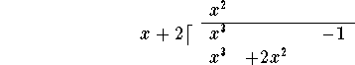
Next subtract the last line from the line above it:
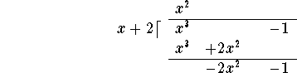
Now repeat the procedure: Divide the leading term of the polynomial on the last line by the leading term x of the divisor to obtain -2x, and add this term to the on the top line:
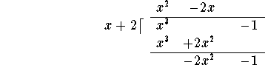
Then multiply "back": 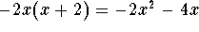and write the answer under the last line polynomial, lining up terms of equal degree:
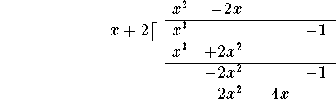
Subtract the last line from the line above it:
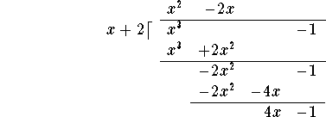
You have to repeat the procedure one more time.
Divide:
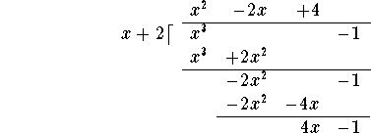
Multiply "back":
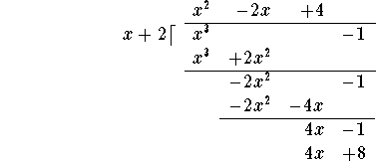
and subtract:
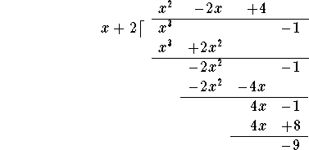
You are done! (In the next step, you would divide -9 by x, not yielding a polynomial expression!) The remainder is the last line: -9 (of degree 0), and the quotient is the expression on the very top: 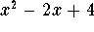. Consequently,
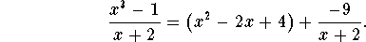

An Example: Long Polynomial Division and Factoring.
Let's use polynomial long division to rewrite
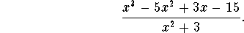
Write the expression in a form reminiscent of long division:
First divide the leading term of the numerator polynomial by the leading term of the divisor, and write the answer x on the top line:
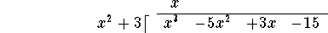
Now multiply this term x by the divisor 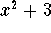, and write the answer
under the numerator polynomial, carefully lining up terms of equal degree:
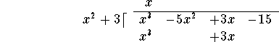
Next subtract the last line from the line above it:
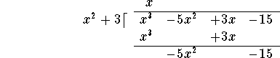
Now repeat the procedure: Divide the leading term of the polynomial on the last line by the leading term of the divisor to obtain -5, and add this term to the x on the top line:
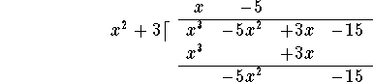
Then multiply "back": 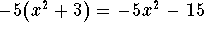and write the answer under the last line polynomial, lining up terms of equal degree:
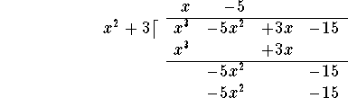
Subtract the last line from the line above it:
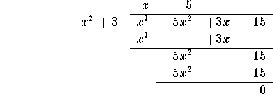
You are done! In this case, the remainder is 0, so divides evenly into 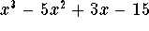.
Consequently,
Multiplying both sides by the divisor yields:
In this case, we have factored the polynomial , i.e., we have written it as a product of two "easier" (=lower degree) polynomials.

Exercise 1.
Use long polynomial division to rewrite
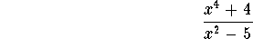

Answer.

Exercise 2.
Use long polynomial division to rewrite
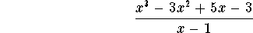

Answer.

Exercise 3.
Use long polynomial division to rewrite
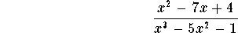

Answer.

Exercise 4.
Use long polynomial division to rewrite
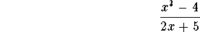

Answer.

Exercise 1.

The answer is:
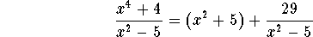

Exercise 3.
Use long polynomial division to rewrite

Answer.

There is nothing to do. The numerator polynomial already has a degree strictly lower than the denominator polynomial

Answer.

Exercise 5.
Use long polynomial division to rewrite
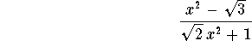

Answer.

Exercise 5.
Use long polynomial division to rewrite
Answer. The answer is
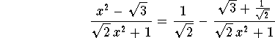

Solution.
Divide the leading term of the numerator polynomial by the leading term 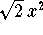of the divisor:
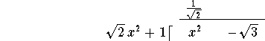
Multiply "back": 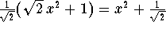, and subtract:
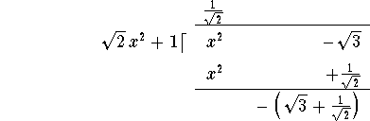
This is it! Your answer is

Quadratic Polynomials: Factoring by Guessing

There are three methods to factor a quadratic polynomial: Factoring by guessing, "completing the square", and the quadratic formula. On this page you will learn the first method. The next two pages are devoted to the other methods.
You may also want to visit the S.O.S. Mathematics section The Quadratic Equation.

A first example.
Consider the polynomial 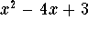. If it is reducible, the answer will look like this:
the catch being that we do not know the roots -a and -b. One popular trick in Mathematics is to work backwards: Using the FOIL method we can write
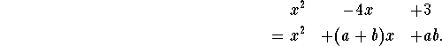
From this we see that the two unknowns a and b have to satisfy
In English: we need two numbers whose product is 3 and whose sum is -4. At this point, start guessing using integer values for a and b. There are really only two choices which come to mind: Among integers only the pair 1 and 3 and the pair -1 and -3 have product 3. Checking their sums we see that we have to have a=-1 and b=-3 (or vice versa). We are done:

Another example.
Let's try with the polynomial
We want to find integers a and b whose sum is 7 and whose product is -8. There are four choices for two integers with product -8: a=1, b=-8; a=-1, b=8; a=2, b=-4 and a=-2 and b=4. Among these, only a=-1, b=+8 has the required sum 7. We are done:

What is the catch?
This method is amazingly simple; with some experience it will take you no longer than a couple of seconds to come up with a factorization, but only if this method works. In reality, chances are pretty slim that a random polynomial, even with integer coefficients, will have integer roots (and we are restricting our search for a and b to integers!); in the classroom, your chances are better: most teachers are nice (and/or lazy?), so quite a few polynomials you see on the blackboard can probably be factored by guessing.

A last example.
Let's try
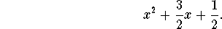
Did you already gain some practice? Even though the roots are rational numbers instead of integers, I hope the solution will "jump at you" after staring at the polynomial for a few seconds: a=1 and b=1/2 will work:
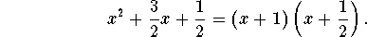

Exercise 1.
Which of the following polynomial can be factored by the guessing method? Give the factorization in these cases!
- 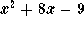
- 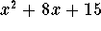
- 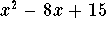

Answer.
I can "factor by guessing" all but the third one:
- 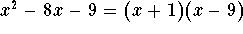
- 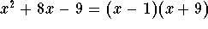
- My guesses for integers with product -4 are: 1 and -4; -1 and 4; and 2 and -2. None of them have the required sum -5.
- 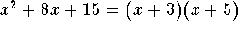
- 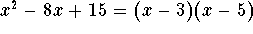

http://www.sosmath.com/algebra/logs/log4/log44/log44.html

PROPERTIES OF LOGARITHMS

Property 1: because .
Example 1: In the equation , the base is 14 and the exponent is 0. Remember that a logarithm is an exponent, and the corresponding logarithmic equation is where the 0 is the exponent.
Example 2: In the equation 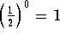, the base is and the exponent is 0. Remember that a logarithm is an exponent, and the corresponding logarithmic equation is .
Example 3: Use the exponential equation to write a logarithmic equation. The base x is greater than 0 and the exponent is 0. The corresponding logarithmic equation is .
Property 2: because .
Example 4: In the equation , the base is 3, the exponent is 1, and the answer is 3. Remember that a logarithm is an exponent, and the corresponding logarithmic equation is .
Example 5: In the equation , the base is 87, the exponent is 1, and the answer is 87. Remember that a logarithm is an exponent, and the corresponding logarithmic equation is .
Example 6: Use the exponential equation 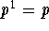to write a logarithmic equation. If the base p is greater than 0, then .
Property 3: because .
Example 7: Since you know that , you can write the logarithmic equation with base 3 as 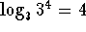.
Example 8: Since you know that , you can write the logarithmic equation with base 13 as 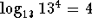.
Example 9: Use the exponential equation to write a logarithmic equation with base 4. You can convert the exponential equation
to the logarithmic equation . Since the 16 can be written as
, the equation can be written 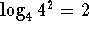.
The above rules are the same for all positive bases. The most common bases are the base 10 and the base e. Logarithms with a base 10 are called common logarithms, and logarithms with a base e are natural logarithms. On your calculator, the base 10 logarithm is noted by log, and the base e logarithm is noted by ln.
There are an infinite number of bases and only a few buttons on your calculator. You can convert a logarithm with a base that is not 10 or e to an equivalent logarithm with base 10 or e. If you are interested in a discussion on how to change the bases of a logarithm, click on Change of Base.
For a discussion of the relationship between the graphs of logarithmic functions and exponential functions, click on graphs.

Change of Base

CHANGING THE BASE OF A LOGARITHM

Let a, b, and x be positive real numbers such that and (remember x must be greater than 0). Then can be converted to the base b by the formula
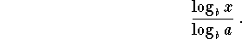

Let's verify this with a few examples.
Example 1: Find to an accuracy of six decimals. Note that the answer will be between 1 and 2 because and , and 7 is between 3 and 9. According to the change of logarithm rule, can be written 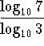.
When the base is 10, we can leave off the 10 in the notation. Therefore can be written 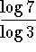. Using your calculator,
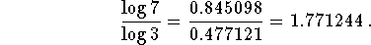
You will note that the answer is between 1 and 2.
Let's check the answer. If , our answer is correct. . Close enough. Why isn't it 7 exactly? Well we rounded to six places, so our answer won't check exactly. If we rounded to ten places, then when we checked the answer, it would be closer to 7 than this answer.
Example 2: We could work the same problem by converting to the base e. According to the change of logarithm rule, can be written 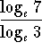. When the base is e, we can leave off the e in the notation and can be written . Using your calculator,
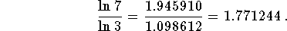
You will note that the answer is between 1 and 2.
Example 3: Find . We know that and , and that 18 is between 16 and 32; therefore, we know that the exponent we are looking for is between 4 and 5. In fact, it is closer to 4 than to 5 because 18 is closer to 16 than it is to 32.
Let's solve this problem by changing the base to 10. can be written 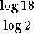. Using your calculator,
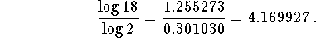
Let's check the answer. If , our answer is correct. . Close enough. Why isn't it 18 exactly? Since we rounded to six places, our answer won't check exactly. If we rounded to ten places, then when we checked the answer, it would be closer to 18 than this answer.
Example 4: We could work the problem in Example 3 by converting to the base e. According to the logarithmic rule, can be written 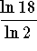. Using your calculator,
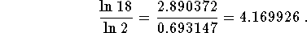
The answer is the same as the answer you found when you converted the base to 10

graphs.

GRAPHS OF EXPONENTIAL AND LOGARITHMIC FUNCTIONS

GRAPHS OF EXPONENTIAL FUNCTIONS
By Nancy Marcus
In this section we will illustrate, interpret, and discuss the graphs of exponential and logarithmic functions. We will also illustrate how you can use graphs to HELP you solve exponential and logarithmic problems and check your solutions.

Graphs of Functions in General:
Recall that graphs are made up of points that are plotted on rectangular coordinate systems. The points consist of two parts: (independent variable, dependent variable). The dependent variable is so named because it's value and behavior depend on the value and behavior of the independent variable. For purposes of discussion, we will refer to the independent variable as x and the dependent variable as y or f(x). In reality, you could label them anything: (p, q), (a, b), (d, c), etc.
Reminder: Remember that when we talk about the function, the function value, the value of the function, y or f(x), we are talking about the value and behavior of the y part of the point (x, y) in the full set of the points that form the graph..
Exponential Graphs:
Once you know the shape of an exponential graph , you can shift it vertically or horizontally, stretch it, shrink it, reflect it, check answers with it, and most important interpret the graph.
Example 1:
The function 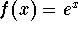is always positive. There is simply no value of x that will cause the value of to be negative. What does this mean in terms of a graph? It means that the entire graph of the function is located in quadrants I and II.
Graph the function . Notice that the graph never crosses the x-axis. Why is that so? It is because there is no value of x that will cause the value of f(x) in the formula to equal 0.
Notice that the graph crosses the y-axis at 1. Why is that so? The value of x is always zero on the y-axis. Substitute 0 for x in the equation : 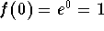. This translates to the point (0, 1).
Notice on the graph that, as the value of x increases, the value of f(x) also increases. This means that the function is an increasing function. Recall that an increasing function is a one-to-one-function, and a one-to-one function has a unique inverse.
The inverse of an exponential function is a logarithmic function and the inverse of a logarithmic function is an exponential function.
Notice also on the graph that as x gets larger and larger, the function value of f(x) is increasing more and more dramatically. This is why the function is called an exponential function.
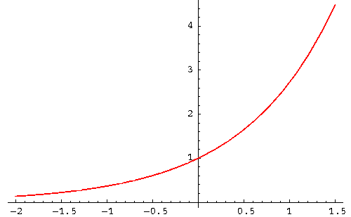
If you are interested in reviewing the graphs of exponential functions, examples and problems, click on Exponential.
Logarithmic Graphs:
Once you know the shape of a logarithmic graph , you can shift it vertically or horizontally, stretch it, shrink it, reflect it, check answers with it, and most important interpret the graph.
Example 2:
Graph the function 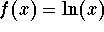. Notice that the graph of this function is located entirely in quadrants I and IV. Notice also that the graph never touches the y-axis.
What does that mean? It means that the value of x (domain of the function f(x) in the equation is always positive. Why is this so? Recall that the equation can be rewritten as the exponential function . There is no value of f(x) that can cause the value of x to be negative or zero.
The graph of will never cross the y-axis because x can never equal 0. The graph will always cross the x-axis at 1.
Notice on the graph that, as x increases, the f(x) also increases. This means that the function is an increasing function. Recall that an increasing function is a one-to-one-function, and a one-to-one function has a unique inverse.
Notice on the graph that the increase in the value of the function is most dramatic between 0 and 1. After x = 1, as x gets larger and larger, the increasing function values begin to slow down (the increase get smaller and smaller as x gets larger and larger).
Notice on the graph that the function values are positive for x's that are greater than 1 and negative for x's less than 1.
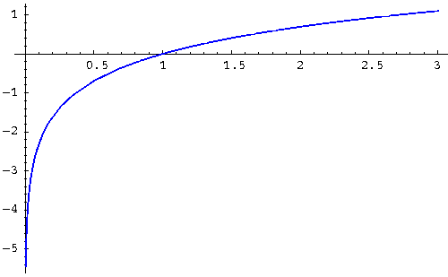
If you are interested in reviewing the graphs of logarithmic functions, click on Logarithmic.

