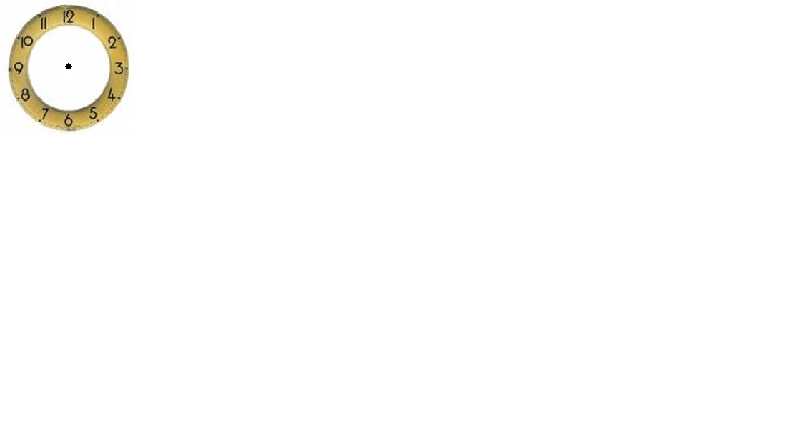
Draw The Hands On The clocks :
clock ۥO It's four clock ۥO It's eleven clock ۥ It's six O

clock ۥ clock It's Twelve O ۥ It 's three O clock ۥO It's One
Circle the correct answer :

clock . ( get up / gets up ) ۥ 1- She…………….at six o
2- Nick ….………a fire fighter . (am / is / are )
3 - I………..….a police officer . (am / is / are )
. (am / is / are ) we …………playing soccer -4
( watch /watches ) 5 - He……………………………..TV .

