
United Arab Emirates
Ministry of Education
Al-Rams school

Under supervision of: T. Jihad
Done by: Ahmed Ali Mohamed Qudor
Class: 10/ 3
Subject: English
Academic year: 2010-2009

Part: 1
My CV

CV

Name: Ahmed Ali Mohamed Abdulla Qudor Shehhi
School: Al Rams
Grade: 10
Section: 3
Address: United Arab Emirates
Telephone number: 050 /1964448
E-mail address: mrahmed@live.com
Date of Birth: 1994\12\21
Graduate from high school and I will be chemical.
Interests and hobbies:
I have many hobbies like reading, computer and playing football.
Skills and qualifications:
Computer: Power point and ms word–Searching in Internet.

Language: Arabic, English.

Part: 1 My CV
Part: 2 Table of contents
Part: 3 vision and mission
Part: 4 self reflections
Part: 5 peer reflection
Part: 6 reading log
Part: 7 Community Services
Part: 8 Visuals
Part: 9 Writing Samples

Self Reflection (1) Writing Checklist
Name:
Conventions
-------- Each of my paragraphs has one main idea.
-------- I have used correct grammar.
-------- I have used correct punctuation.
-------- Full stops are at the end of my sentences.
-------- I have quotation marks" “around dialogue.
-------- My spelling is correct.
-------- I left white spaces between my words.
-------- My handwriting is legible.
Fluency
-------- My sentences begin in different ways.
-------- My sentences build upon the ones before.
-------- My sentences are different lengths.
-------- The meaning of each of my sentences is clear.
-------- My sentences flow and use correct grammar.
-------- My sentences are complete.
Organization
-------- My writing is sequenced in order.
-------- My introduction is exciting and inviting
-------- My ideas flow and are well connected through using connectors like because, but, so
-------- I have a satisfying conclusion.

Capitalization
--------- I used both capital and lower case letters.
--------- I have capitalized the first word in each sentence.
--------- I have capitalized people and pet names.
--------- I have capitalized months and days.
--------- I have capitalized cities, states, and places.
--------- I have capitalized titles of books, movies, etc.
Word Choice
---------- Every word seems just right
---------- I used the dictionary to spell the words I don't know.
---------- I used synonyms (words of the same meaning) to add variety.
Ideas
---------- I used a graphic organizer to create and organize ideas.
---------- My ideas are written in my own words.
---------- My writing is clear and focused.
---------- I understand my topic.
---------- My details give the reader important information.
---------- My ideas relate to one another.
---------- I have listened to suggestions from the teacher or peer.
Comment
My points of strength are:
1. -------------------------------------------------------------------------------------------
2. -------------------------------------------------------------------------------------------
I should take care of the following points.
1. -------------------------------------------------------------------------------------------
2. -------------------------------------------------------------------------------------------

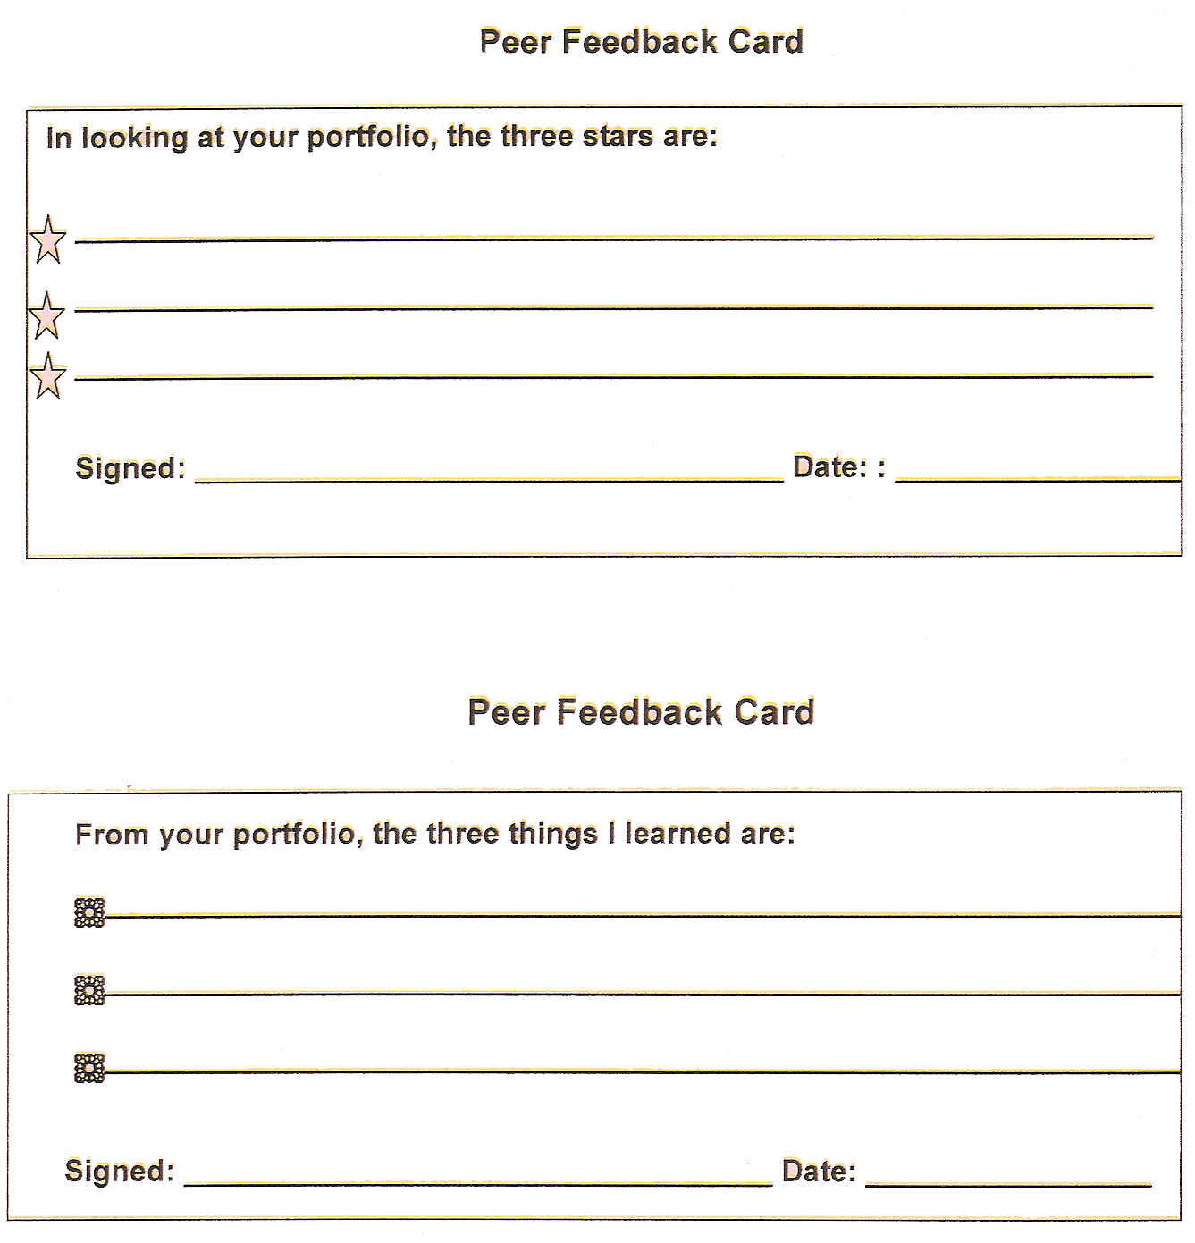

Pages | Title and Author | Type | Date
My Reading Log

Types: JR = Just Reading Book E = Easy Book C= Challenging

Community Services

Last week, I went to visit my cousin in the hospital, when I arrived there I heard the nurses that they want a donor because there is a patient who he wants a blood, I went quickly to the doctor to donate some of my blood to the patient, when he woke up from his coma he thanked so much.

