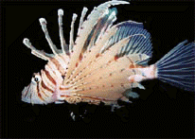
Description
The lion-fish belongs to the Scorpion fish family.
This brightly coloured fish is usually found in coral reefs, especially in shallow waters hovering in caves or near crevices. Lion-fish have venomous fin spines that can produce painful puncture wounds.
Fatalities, however, are rare.
The fish have elongated dorsal fin spines and enlarged pectoral fins, and each species has a particular pattern of zebra like stripes.
A person punctured by one of the sharp spines will immediately feel strong pain. Rapid swelling of the affected body area develops along with the possibility of making movement of limbs very difficult. Lion-fish stings can cause nausea, breathing difficulties, paralysis, convulsions and collapse. Even death may occur in exceptional circumstances. Most people survive in spite of the great pain. The venom in the spines remains active for days, so even discarded spines should be treated with caution. It may take several months for a full recovery and if the sting is left untreated, gangrene may develop.

At first immerse the affected area (most often a hand or foot) into hot water. This is thought to improve the blood flow and disperse the venom. Local anesthetic agents may provide deep relief in most cases and occasionally a nerve-block may be required. An X-ray of the wound should be performed to detect any presence of broken spines, so any possible infection can be prevented.

From Wikipedia, the free encyclopedia
Jump to: navigation, search
For the United States Navy submarine, see USS Lionfish.
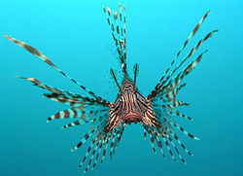
Head on view of a Red lionfish
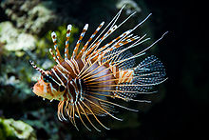
Pterois antennata in Schönbrunn Zoo, Vienna, Austria
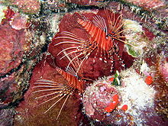
Antennata Lionfish, Peleliu, Palau
A Lionfish is any of several species of venomous marine fish in the genera Pterois, Parapterois, Brachypterois, Ebosia or Dendrochirus, of the family Scorpaenidae. The lionfish is also known as the Turkey Fish, Scorpion or Fire Fish.^{[1]} They are notable for their extremely long and separated spines, and have a generally striped appearance, red, green, navy green, brown, orange, yellow, black, maroon, or white.

There are many types of lionfish that vary in size. The common lionfish generally reaches a size of 30 cm to 35 cm (12 inches), while smaller lionfish, like the Fuzzy Dwarf, are typically the size of a tennis ball, not including fins. In the Caribbean where lionfish aren't native, they grow to a size of up to 55 cm.

Lionfish are voracious predators. They do not use their spines to capture prey; only for protection. When hunting, they corner prey using their large fins and then use their quick reflexes to swallow the prey whole. They hunt primarily from late afternoon to dawn. In captivity, lionfish can be trained to eat frozen krill and mysis.

هذه يساعدكم في تتقديم البحث بس انتو عدلو ورتبوه

