Worksheet

Solve the following questions.

1. Choose the correct answer.

  - Which tool of the following is used to scratch lines on metal?

A
B
C
D

  - How can scratches on metal be made to appear more clearly?

A | By using pen
B | By using chalk
C | By covering a metal with marking blue
D | By using pencil

  - How is the pivoting leg of a pair of dividers stopped from sliding over the surface of metal?

A | By using scriber
B | By using prick punch
C | By using height gauge
D | By using caliper

2. Match the following.
a. Match the marking out tools in column B with their correct functions
in column A, Write your answer in the box below?

Column A | 1 | 2 | 3 | 4 | 5
Column B | B | C | D | E | A

Column A | Column B
1) Is used for checking the  straightness of a workpiece. | A) 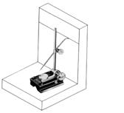
2) Is used to scratch lines | B) 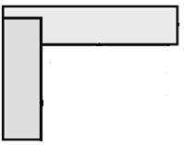
3) Is used for making indents that  position the drill points and stop them slipping | C)
4) Is used for supporting or  setting up work vertically. | D)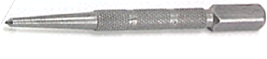
5) Is used for scratching lines  parallel to a surface. | E)  