Welcome

To

My

Profile

My cv

My name :-

Under supervision of : T.

Class :- 10

Subject :- English

Academic year :- 2010 - 2011

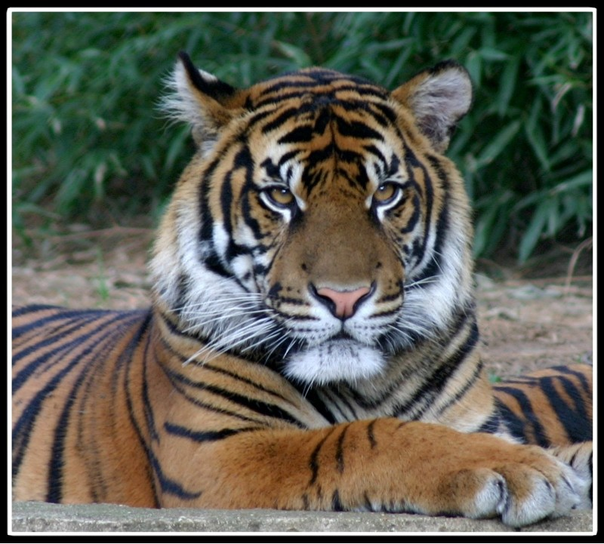
The tiger
Tiger great and powerful animal as food, meat, and cats, which includes species, leopard cat, and others, there is in North Africa,
And sub-Saharan Africa, India, China, Manchuria,
And is the smallest of the four big cats belonging to the genus Panthera is, after all of the tiger, lion, jaguar and greater than the size
Tiger has a relatively short lists in addition to the body of a long and massive skull
Tiger and the majestic animal, gorgeous, beautiful appearance, gait, flexibility, and the beauty of Vruh make it one of the most beautiful animals
Ranges and weighs between fifty and ninety kilos, the average length of the order of 215 cm except for its tail which reaches a length of ninety cm. And a height at the shoulder between 95 cm and 110 cm; The strain of giant living in Manchuria was the length of the tiger which to 3.6 m.
Webber Tiger Thumper yellow to brown dotted black; the chest, white color
Fangs very large solid and sharp, his nails are contraction, the sense of smell and hearing him powerful, Istamlhma to detect prey, but he does not have the sense of sight is very insightful.
And Tiger Lily habits often brilliant at climbing trees, feeding on animals and birds, reptile, and may attack people sometimes, and it can be based jumps upload six meters from the ground to reach out to prey on a branch of towering tree, and his criticism of the prey is always silent, it seeks to cause harm and approaching them gracefully so as not separated by only three or four meters hereof by and posed to the ground, and breaking her spine at the neck, and then dragged her body to a remote location of the prey, suggests Sharp.
Do not eat the catch of other walking (king) with that does not belong to the forest, very angry, if it reaches him angry amount to kill himself
Arabian leopard is one of the seven varieties was recorded from the tiger. Types of tigers living in the south of the peninsula smaller on average than Tiger Africa living in areas of savannah.
The Arabian leopard is threatened with extinction, its numbers are estimated remaining today, including at least 200 tigers in the wild.

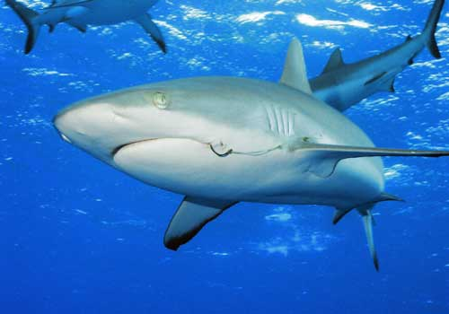
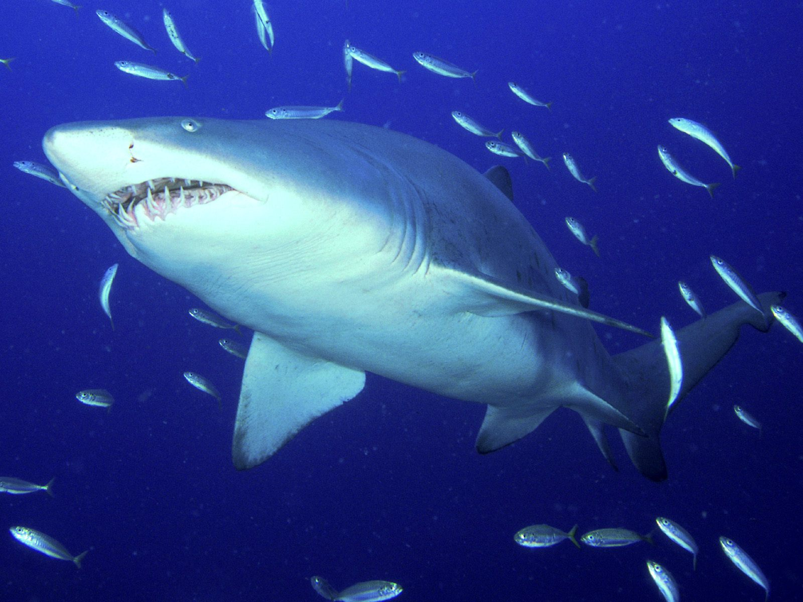
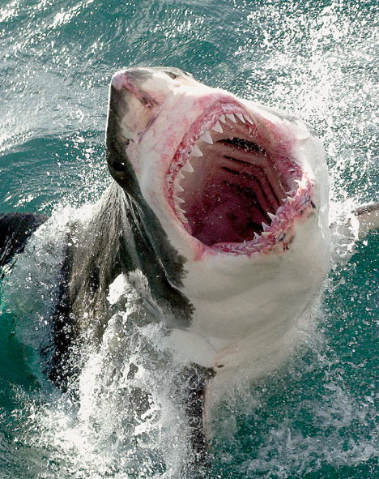
Commanded by God the Almighty Baltvkr in his creatures, and secrets are deposited therein, because it increases our faith in the greatness, glory and majesty, and from these creatures sharks, which prey assess accurately the first bite of _ _ to know how much power will Alihaa them, and whether was worth a try or not, and therefore is a perfect seven-sea prey, because of the high proportion of fat in the body, while not a skinny person, for example savory dish. Nine meters, and three tons: the length of the White Shark can be up to 9 meters, and weighs close to 3 tons, and his body from the inside not the bones!!
Fahiklh procedure consists of cartilage, sharks and used electric and magnetic fields to monitor the prey, and recognize the shark on the ocean in which they live and on Fraish Bwaasitp eyes, which see them in the dark!!
As the sense of smell has a strong and can smell blood from a distance and up to more than kilometers.
And has the permission, indoor distinction by which the votes, and the White Shark of the most endangered species, and teeth triangular and serrated edges, because he used to cut up the prey.
White sharks swim in a sustained, standing Vhrkih allow water to enter the shark gills to get oxygen Lowering of his life, College of very large sharks, and filled with large quantities of oils, to help the body buoyancy, and corkscrew-shaped intestine, helping digestion and the sharks do not usually affected by cancers or diseases of the circulatory system, and has a tremendous ability to heal wounds quickly, shark skin strong and flexible and is composed of very small flakes.
Growth and young:
Most shark species grow very slowly, and reach reproductive age after many years is estimated to be between 12 to 20 years by type, and duration of pregnancy when the sharks between 9 to 21 months, as the female keeps her eggs inside her body until they hatch, and put the female number of eggs between the eggs 10_80 by type.
And graduated from the belly of the shark young mother as born, and come to life with little on its own very first time, and the female cannot be bleaching large numbers at a time, and does not live them usually only two or three!!
Born small and is usually weighs about 20 to 25 kg, and may hatch eggs of some species at one time, about 60 small or more, but most of them produces a number much lower, and do not take care of parents Besgaarhama to the extent they may eater all of this group. White Death! :
White Shark "and named" Death House ",
Is the most dangerous shark species as a whole, live in the tropics, and it is attacking its prey very quickly, not attack it unless he was hungry, and called this name because the white color of the abdomen, but the color of the back varies from gray and blue.

