
United Arab Emiratis ministry of education Fujairah educational zone Abu tammam school

PROJECT OF UNIT (5)
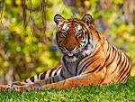
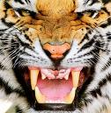
TIGER
The tiger is the largest wild cat in the world . Easily recognized by its coat of reddish-orange with dark stripes. The big wild cat weighs up to 720 pounds (363 kilograms), stretches 6 feet (2 meters) long , and it has a 3-foot- (1-meter-) long tail. The powerful predator generally hunts alone, able to bring down prey such as deer and antelope.
Tigers wait until dark to hunt. Once a tiger has spotted its prey, it sneaks as close as possible to its victim. Then the tiger sprints to the unsuspecting animal, usually pulling it off its feet with its teeth and claws. If the prey animal is large, the tiger bites its throat to kill it and small prey is usually killed when the tiger breaks its neck.

Name : Saif Saeed Mohamed . Grade : 10 . Subject : English language .

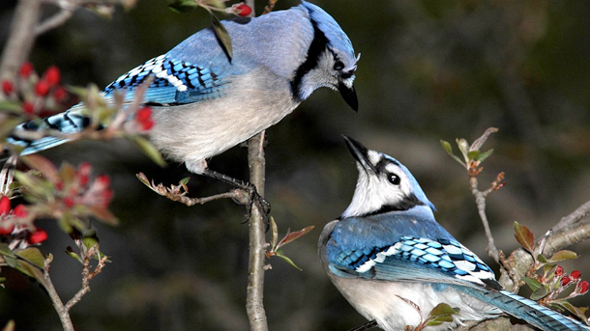
Let’s Write an outline
Topic sentence
The tiger is the largest wild cat in the world .
The color of its coat is reddish – orange and the color of its stripes is dark black .
It weighs over 720 pounds ( 363 kilograms ) and its length is 2 meters .
It can attack the most powerful predator and it able to bring down prey such as deer and antelope .
It always go out to hunt at night .
Details
When it finds its victim , it sneaks as close as possible to its victim , then it attacks its victim and pulling it off its feet with its teeth and claws .
If its victim is large , it bites its throat to kill .
If its victim is small , it usually killed when it breaks its neck .


