2010
Grade : 10
Name :
1/1/2010
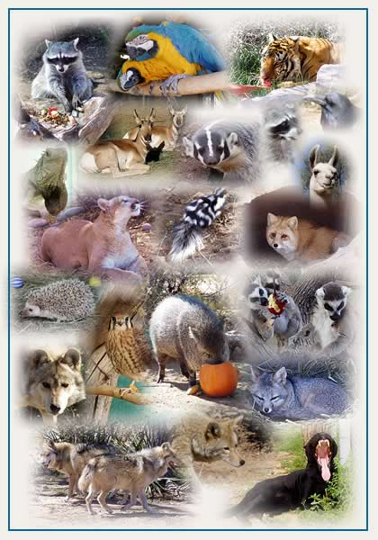
The animals

A crocodile 1-
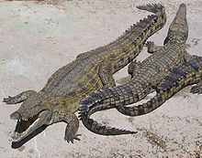
A crocodile is any species belonging to the family Crocodylidae (sometimes classified instead as the subfamily Crocodylinae). The term can also be used more loosely to include all members of the order Crocodilia: i.e. the true crocodiles, the alligators and caimans (family Alligatoridae) and the gharials (family Gavialidae), or even the Crocodylomorpha which includes prehistoric crocodile relatives and ancestors. Crocodiles are large aquatic reptiles that live throughout the tropics in Africa, Asia, the Americas and Australia. Crocodiles tend to congregate in freshwater habitats like rivers, lakes, wetlands and sometimes in brackish water. They feed mostly on vertebrates like fish, reptiles, and mammals, sometimes on invertebrates like mollusks and crustaceans, depending on species. They are an ancient lineage, and are believed to have changed little since the time of the dinosaurs. They are believed to be 200 million years old whereas dinosaurs became extinct 65 million years ago; crocodiles survived great extinction events.
Crocodiles are among the more biologically complex reptiles despite their prehistoric look. Unlike other reptiles, they have a cerebral cortex; a four-chambered heart; and the functional equivalent of a diaphragm, by incorporating muscles used for aquatic locomotion into respiration (e.g. M. diaphragmaticus);^{[6]} Their external morphology on the other hand is a sign of their aquatic and predatory lifestyle. A crocodile’s physical traits allow it to be a successful predator. They have a streamlined body that enables them to swim swiftly. Crocodiles also tuck their feet to their sides while swimming, which makes them faster by decreasing water resistance. They have webbed feet which, although not used to propel the animal through the water, allow it to make fast turns and sudden moves in the water or initiate swimming. Webbed feet are an advantage in shallower water where the animals sometimes move around by walking.
Crocodiles have a palatal flap, a rigid tissue at the back of the mouth that blocks the entry of water. The palate has a special path from the nostril to the glottis that bypasses the mouth. The nostrils are closed during submergence. Like other archosaurs, crocodilians are diapsid, although their post-temporal fenestrae are reduced. The walls of the braincase are bony but they lack supratemporal and postfrontal bones.^{[1]} Their tongues are not free but held in place by a membrane which limits movement; as a result, crocodiles are unable to stick out their tongues.^{[7]}
Crocodiles are very fast over short distances, even out of water. Since crocodiles feed by grabbing and holding onto their prey, they have evolved sharp teeth for tearing and holding onto flesh, and powerful muscles that close the jaws and hold them shut. These jaws can bite down with immense force, by far the strongest bite of any animal. The jaws are opened, however, by a very weak set of muscles. Crocodiles can thus be subdued for study or transport by taping their jaws or holding their jaws shut with large rubber bands cut from automobile inner tubes. They have limited lateral (side-to-side) movement in their neck.

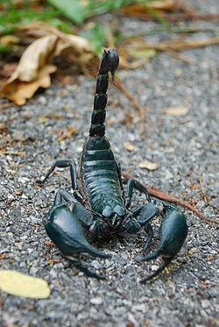
Scorpions 2-
Scorpions are predatory arthropod animals of the order Scorpiones within the class Arachnida. The word scorpion derives from Greek σκορπιός – skorpios.^{[1]} The eight-legged venomous arthropod is easily recognised due to it's narrow, segmented tail which is carried in a characteristic forward curve over the back and which has a sting in it. Though the scorpion has a fearsome reputation as a killer of man and his animals, only 25 species worldwide have venom capable enough to kill a man. Mankind's long fascination with scorpions have caused it to be an important motif in human culture and folklore. The order is also scientifically interesting because of its medical importance, its wide geographic distribution and diversity and the variety of physiological, morphological, biochemical and ecological adaptations which have allowed the scorpions to flourish on earth from the Silurian period (443 - 416 mya) onwards.^{[2]:1}
Scorpions are found widely distributed south of about 49° N , except Antarctica. They have been introduced by man to England and New Zealand. Scorpions number about 1400 described species and subspecies with thirteen extant families recognised as of date. However, the taxonomy has undergone changes and is likely to change as a number of genetic studies are bringing forth new information.
Scorpions are almost universally distributed south of 49° N, except in Antarctica, and their geographical distribution shows in many particulars a close and interesting correspondence with that of the mammals, including their entire absence from New Zealand. The facts of their distribution are in keeping with the hypothesis that the order originated in the northern hemisphere and migrated southwards into the southern continent at various epochs, their absence from the countries to the north of the above-mentioned latitudes being due, no doubt, to the comparatively recent glaciation of those areas. When they reached Africa, Madagascar was part of that continent; but their arrival in Australia was subsequent to the separation of New Zealand from the Austro-Malayan area to the north of it. In the United States, scorpions are most common in southern Arizona and in a swath of land extending through central Texas and central Oklahoma.
Scorpions have been accidentally introduced by man in England and New Zealand.^{[2]:3} Five colonies of scorpions (Euscorpius flavicaudis) have established themselves in southern England Sheerness on the Isle of Sheppey in the UK. This small colony has been resident since the 1860s having probably arrived with imported fruit from Africa, but the number of colonies could be lower now because of the destruction of their habitats. This scorpion species is small and completely harmless to humans. This marks the northernmost limit in the world where scorpions live in the wild.

3-tiger
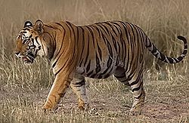
The tiger (Panthera tigris) is a member of the Felidae family; the largest of the four "big cats" in the genus Panthera.^{[4]} Native to much of eastern and southern Asia, the tiger is an apex predator and an obligate carnivore. Reaching up to 3.3 metres (11 ft) in total length and weighing up to 300 kilograms (660 pounds), the larger tiger subspecies are comparable in size to the biggest extinct felids.^{[5][6]} Aside from their great bulk and power, their most recognisable feature is a pattern of dark vertical stripes that overlays near-white to reddish-orange fur, with lighter underparts. The most numerous tiger subspecies is the Bengal tiger while the largest subspecies is the Siberian tiger.
Highly adaptable, tigers range from the Siberian taiga, to open grasslands, to tropical mangrove swamps. They are territorial and generally solitary animals, often requiring large contiguous areas of habitat that support their prey demands. This, coupled with the fact that they are indigenous to some of the more densely populated places on earth, has caused significant conflicts with humans. Of the nine subspecies of modern tiger, three are extinct and the remaining six are classified as endangered, some critically so. The primary direct causes are habitat destruction and fragmentation, and hunting. Their historical range once stretched from Mesopotamia and the Caucasus through most of South and East Asia. Today it has been radically reduced. While all surviving species are under formal protection, poaching, habitat destruction and inbreeding depression continue to threaten the species.
Tigers are among the most recognisable and popular of the world's charismatic megafauna. They have featured prominently in ancient mythology and folklore, and continue to be depicted in modern films and literature. Tigers appear on many flags and coats of arms, as mascots for sporting teams, and as the national animal of several Asian nations, including India.
In the past, the tiger's range was widespread in Asia, from the Caucasus and the Caspian Sea to Siberia and Indonesia. During the 19th century, these cats completely vanished from western Asia, and became restricted to isolated pockets in the remaining parts of their range. Today, their range is fragmented, and extends from India in the west to China and Southeast Asia in the east. The northern limit is close to the Amur River in south eastern Siberia. The only large island inhabited by tigers today is Sumatra. Tigers vanished from Java and Bali during the 20th century, and in Borneo are known only from fossil remains.
Tiger habitats will usually include sufficient cover, proximity to water, and an abundance of prey sources. Bengal Tigers live in many types of forests, including wet; evergreen; the semi-evergreen of Assam and eastern Bengal; the mangrove forest of the Ganges Delta; the deciduous forest of Nepal, and the thorn forests of the Western Ghats. Compared to the lion, the tiger prefers denser vegetation, for which its camouflage colouring is ideally suited, and where a single predator is not at a disadvantage compared with the multiple felines in a pride. Among the big cats, only the tiger and jaguar are strong swimmers; tigers are often found bathing in ponds, lakes, and rivers. Unlike other cats, which tend to avoid water, tigers actively seek it out. During the extreme heat of the day, they often cool off in pools. Tigers are excellent swimmers and can swim up to 4 miles. This cat will also carry their dead prey across lakes.
4-Snakes
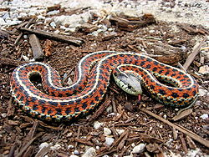
Snakes are elongate legless carnivorous reptiles of the suborder Serpentes that can be distinguished from legless lizards by their lack of eyelids and external ears. Like all squamates, snakes are ectothermic amniote vertebrates covered in overlapping scales. Many species of snakes have skulls with many more joints than their lizard ancestors, enabling them to swallow prey much larger than their heads with their highly mobile jaws. In order to accommodate their narrow bodies, snakes' paired organs (such as kidneys) appear one in front of the other instead of side by side, and most have only one functional lung. Some species retain a pelvic girdle with a pair of vestigial claws on either side of the cloaca.
Living snakes are found on every continent except Antarctica and on most islands. Fifteen families are currently recognized comprising 456 genera and over 2,900 species.^{[1][2]} They range in size from the tiny, 10 cm long thread snake to pythons and anacondas of up to 7.6 metres (25 ft) in length. The recently discovered fossil Titanoboa was 15 metres (49 ft) long. Snakes are thought to have evolved from either burrowing or aquatic lizards during the Cretaceous period (c 150 Ma). The diversity of modern snakes appeared during the Paleocene period (c 66 to 56 Ma).
Most species are non-venomous and those that have venom use it primarily to kill and subdue prey rather than for self-defense. Some possess venom potent enough to cause painful injury or death to humans. Those which are non-venomous either swallow prey alive or kill it via constriction.
All modern snakes are grouped within the suborder Serpentes in Linnean taxonomy, part of the order Squamata, though their precise placement within squamates is controversial.^{[1]}
There are two infraorders of Serpentes: Alethinophidia and Scolecophidia.^{[1]} This separation is based on morphological characteristics and mitochondrial DNA sequence similarity. Alethinophidia is sometimes split into Henophidia and Caenophidia, with the latter consisting of "Colubroid" snakes (colubrids, vipers, elapids, hydrophiids, and attractaspids) and acrochordids, while the other alethinophidian families comprise Henophidia.^{[14]} While not extant today, the Madtsoiidae, a family of giant, primitive, python-like snakes, was around until 50,000 years ago in Australia, represented by genera such as Wonambi.
There are numerous debates in the systematics within the group. For instance, many sources classify Boidae and Pythonidae as one family, while some keep the Elapidae and Hydrophiidae (sea snakes) separate for practical reasons despite their extremely close relation.
Recent molecular studies support the monophyly of the clades of modern snakes, scolecophidians, typhlopids + anomalepidids, alethinophidians, core alethinophidians, uropeltids (Cylindrophis, Anomochilus, uropeltines), macrostomatans, booids, boids, pythonids and caenophidians.

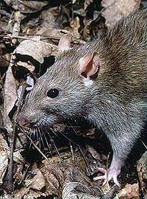
5-Rats
Rats are various medium-sized, long-tailed rodents of the superfamily Muroidea. "True rats" are members of the genus Rattus, the most important of which to humans are the black rat, Rattus rattus, and the brown rat, Rattus norvegicus. Many members of other rodent genera and families are also referred to as rats, and share many characteristics with true rats.
Rats are typically distinguished from mice by their size; rats are generally large muroid rodents, while mice are generally small muroid rodents. The muroid family is very large and complex, and the common terms rat and mouse are not taxonomically specific. Generally, when someone discovers a large muroid, its common name includes the term rat, while if it is small, the name includes the term mouse - scientifically, the terms are not confined to members of the Rattus and Mus genera. Compare the taxonomic classification of the pack rat and cotton mouse.

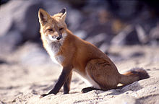
6-Fox
Fox is a common name for many species of carnivorous mammals belonging to the Canidae family. Foxes are small to medium-sized canids (slightly smaller than the median-sized domestic dog), characterized by possessing a long narrow snout, and a bushy tail (or brush).
Members of about 37 species are referred to as foxes, of which only 12 species actually belong to the Vulpes genus of 'true foxes'. By far the most common and widespread species of fox is the red fox (Vulpes vulpes), although various species are found on almost every continent. The presence of fox-like carnivores all over the globe has led to their appearance in both popular culture and folklore in many cultures around the world (see also Foxes in culture). The gray fox is one of only two canine species known to climb trees; the other is the raccoon dog.

The blue whale 7-

The blue whale (Balaenoptera musculus) is a marine mammal belonging to the suborder of baleen whales (called Mysticeti).^{[3]} At up to 33 metres (108 ft) in length and 180 metric tons (200 short tons)^{[4]} or more in weight, it is the largest animal ever known to have existed.^{[5]}
Long and slender, the blue whale's body can be various shades of bluish-grey dorsally and somewhat lighter underneath.^{[6]} There are at least three distinct subspecies: B. m. musculus of the North Atlantic and North Pacific, B. m. intermedia of the Southern Ocean and B. m. brevicauda (also known as the pygmy blue whale) found in the Indian Ocean and South Pacific Ocean. B. m. indica, found in the Indian Ocean, may be another subspecies. As with other baleen whales, its diet consists almost exclusively of small crustaceans known as krill.^{[7]}
Blue whales were abundant in nearly all the oceans until the beginning of the twentieth century. For over 40 years, they were hunted almost to extinction by whalers until protected by the international community in 1966. A 2002 report estimated there were 5,000 to 12,000 blue whales worldwide^{[8]}, located in at least five groups. More recent research into the Pygmy subspecies suggests this may be an underestimate.^{[9]} Before whaling, the largest population was in the Antarctic, numbering approximately 239,000 (range 202,000 to 311,000).^{[10]} There remain only much smaller (around 2,000) concentrations in each of the North-East Pacific, Antarctic, and Indian Ocean groups. There are two more groups in the North Atlantic, and at least two in the Southern Hemisphere

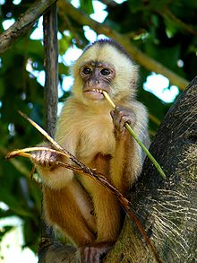
8- monkey
A monkey is any cercopithecoid (Old World monkey) or platyrrhine (New World monkey) primate. All primates that are not prosimians (lemurs and tarsiers) or apes are monkeys. The 264 known extant monkey species represent two of the three groupings of simian primates (the third group being the 21 species of apes). Monkeys are generally considered to be intelligent and, unlike apes, monkeys usually have tails.
The New World monkeys are classified within the parvorder Platyrrhini, whereas the Old World monkeys (superfamily Cercopithecoidea) form part of the parvorder Catarrhini, which also includes the apes. Thus, scientifically speaking, monkeys are paraphyletic (not a single coherent group) and Old World monkeys are actually more closely related to the apes than they are to the New World monkeys.
Due to its size (up to 1 m/3 ft) the Mandrill is often thought to be an ape, but it is actually an Old World monkey. Also, a few monkey species have the word "ape" in their common name

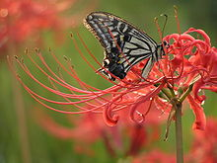
butterfly 9-
A butterfly is any of several groups of mainly day-flying insects of the order Lepidoptera, the butterflies and moths. Like other holometabolous insects, butterflies' life cycle consists of four parts, egg, larva, pupa and adult. Most species are diurnal. Butterflies have large, often brightly coloured wings, and conspicuous, fluttering flight.
- Butterflies comprise the true butterflies (superfamily Papilionoidea), the skippers (superfamily Hesperioidea) and the moth-butterflies (superfamily Hedyloidea). All the very many other families within the Lepidoptera are referred to as moths.
- Butterflies exhibit polymorphism, mimicry and aposematism.
- Some, like the Monarch, will migrate over long distances. Some butterflies have evolved symbiotic and parasitic relationships with social insects such as ants.
- Butterflies are important economically as agents of pollination.
- The caterpillars of some butterflies eat harmful insects. Conversly, a few species are pests because in their larval stages they can damage domestic crops or trees.
- A butterfly is like a flying flower, and they help to make the world more beautiful.^{[1]}
- Culturally, butterflies are a popular motif in the visual and literary arts.

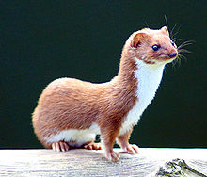
10- Weasels
Weasels are mammals of the genus Mustela of the Mustelidae family. They are small, active predators, long and slender with short legs.
The English word "weasel" (pronounced /ˈwiːzəl/) was originally applied to one species of the genus, the European form of the Least Weasel (Mustela nivalis). This usage is retained in British English, where the name is also extended to cover several other small species of the genus. However, in technical discourse and in American usage the term "weasel" can refer to any member of the genus, or to the genus as a whole. Of the 17 extant species currently classified in the genus Mustela, ten have "weasel" in their common name. Among those that do not are the stoat or ermine, the polecats or ferrets, and the European Mink (the superficially similar American Mink is now regarded as belonging in another genus, Neovison).
Weasels vary in length from 12 to 45 centimetres (5 to 18 in), and usually have a red or brown upper coat and a white belly; some populations of some species moult to a wholly white coat in winter. They have long slender bodies, which enable them to follow their prey into burrows. Their tails may be from 22 to 33 centimetres (9 to 13 in) long. As is typical of small carnivores, weasels have a reputation for cleverness and guile.
Weasels feed on small mammals, and have from time to time been considered^{[by whom?]} vermin since some species took poultry from farms, or rabbits from commercial warrens. Certain species of weasel and ferrets have been reported^{[by whom?]} to perform the mesmerizing weasel war dance, after fighting other creatures, or acquiring food from competing creatures. In folklore at least, this dance is particularly associated with the stoat^{[citation needed]} .
Collective nouns for a group of weasels include boogle, gang, pack, and confusion.^{[1]}
Weasels occur all across the world except for Antarctica, Australia, and neighbouring islands.

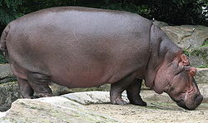
11- Hippopotamus
The hippopotamus (Hippopotamus amphibius) or hippo, from the ancient Greek for "river horse" (Ιπποπόταμος), is a large, mostly herbivorous mammal in sub-Saharan Africa, and one of only two extant species in the family Hippopotamidae (the other is the Pygmy Hippopotamus.) The hippopotamus is the third largest land animal (after the elephant and the white rhinoceros) and the heaviest extant artiodactyl, despite being considerably shorter than the giraffe.
The hippopotamus is semi-aquatic, inhabiting rivers and lakes where territorial bulls preside over a stretch of river and groups of 5 to 30 females and young. During the day they remain cool by staying in the water or mud; reproduction and childbirth both occur in water. They emerge at dusk to graze on grass. While hippopotamuses rest near each other in the water, grazing is a solitary activity and hippos are not territorial on land.
Despite their physical resemblance to pigs and other terrestrial even-toed ungulates, their closest living relatives are cetaceans (whales, porpoises, etc.) from which they diverged about 55 million years ago.^{[3]} The common ancestor of whales and hippos split from other even-toed ungulates around 60 million years ago.^{[4]} The earliest known hippopotamus fossils, belonging to the genus Kenyapotamus in Africa, date to around 16 million years ago.
The hippopotamus is recognizable by its barrel-shaped torso, enormous mouth and teeth, nearly-hairless body, stubby legs and tremendous size. It is the third-largest land mammal by weight (between 1½ and 3 tonnes), behind the white rhinoceros (1½ to 3½ tonnes) and both species of elephant (3 to 9 tonnes). Despite its stocky shape and short legs, it can easily outrun a human. Hippos have been clocked at 30 km/h (19 mph) over short distances. The hippopotamus is one of the most aggressive creatures in the world and is often regarded as the most ferocious animal in Africa. There are an estimated 125,000 to 150,000 hippos throughout Sub-Saharan Africa; Zambia (40,000) and Tanzania (20,000–30,000) possess the largest populations.^{[1]} They are still threatened by habitat loss and poaching for their meat and ivory canine teeth.

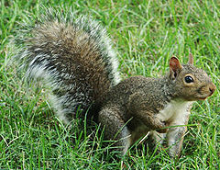
12-Squirrel
Squirrels belong to a large family of small or medium-sized rodents called the Sciuridae. The family includes tree squirrels, ground squirrels, chipmunks, marmots (including woodchucks), flying squirrels, and prairie dogs. Squirrels are indigenous to the Americas, Eurasia, and Africa and have been introduced to Australia. Squirrels are first attested in the Eocene, about forty million years ago, and are most closely related to the mountain beaver and to dormice among living species.
Squirrels are generally small animals, ranging in size from the African pygmy squirrel, at 7–10 cm (2.8–3.9 in) in length, and just 10 g (0.35 oz) in weight, to the Alpine marmot, which is 53–73 cm (21–29 in) long, and weighs from 5 to 8 kg (11 to 18 lb). Squirrels typically have slender bodies with bushy tails and large eyes. Their fur is generally soft and silky, although much thicker in some species than others. The color of squirrels is highly variable between – and often even within – species.
The hindlimbs are generally longer than the forelimbs, and they have four or five toes on each foot. Their paws on their forefeet include a thumb, although this is often poorly developed. The feet also have a soft pad on the underside.^{[3]}
Squirrels live in almost every habitat from tropical rainforest to semiarid desert, avoiding only the high polar regions and the driest of deserts. They are predominantly herbivorous, subsisting on seeds and nuts, but many will eat insects, and even small vertebrates.
As their large eyes indicate, squirrels generally have an excellent sense of vision, which is especially important for tree-dwelling species. They also have very versatile and sturdy claws for grasping and climbing.^{[4]} Many also have a good sense of touch, with vibrissae on their heads and limbs.^{[3]}
The teeth of sciurids follow the typical rodent pattern, with large gnawing incisors that grow throughout life, and grinding cheek teeth set back behind a wide gap, or diastema.

