Love flowers…
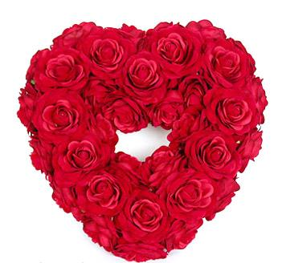
Love flowers provide us a beautiful medium for verbalizing our feelings of love and warmth for our beloveds who mean the world to us. In poetry and fairy tales you must have heard of the notion that flowers, plants, birds and wind, all have a language of their own in which they talk to us. Just like all of them the love flowers also have a language of which..
they make use of to help us in our purpose of conveying our deepest feelings of love for our loved ones.
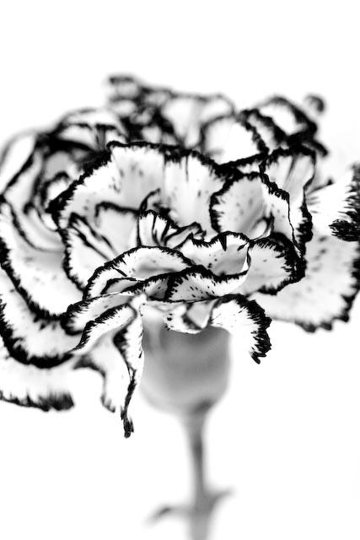
There are many varieties of the love flowers surrounding us but all of have don't signify the same meanings. Some flowers indicate towards the feeling of love at first sight while some flowers point towards the feeling of pure love and some other love flower points towards some other feeling of love..

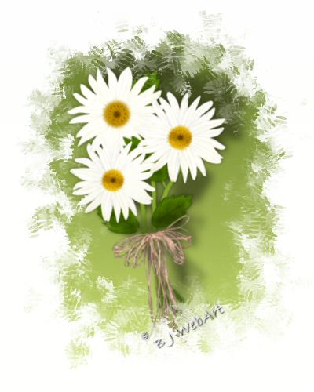
Here are some kinds of flowers and their meaning:
Orchid - Beauty, Love
Orange Blossom - Eternal Love
Carnation White - Pure Love
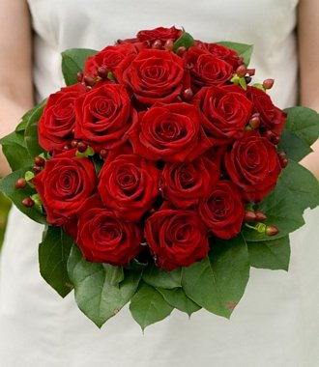
Gloxinia - First sight love
Daisy - Loyal Love
Tulip(Red) - Show your love
Rose (ridal) - Happy Love
Aster - Love Symbol
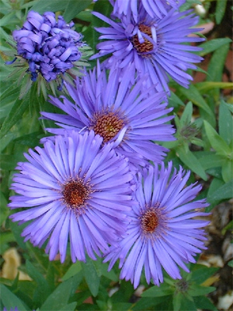
Gardenia - Secret Love
Rose(Red) - Love You
Rose(Thornless) - First sight Love
Rosebud(red) - Pure Love
Rosebud(red) - Show your love

