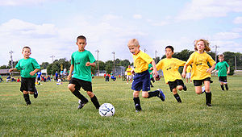
A sport is commonly defined as an organized, competitive, and skillful physical activity requiring commitment and fair play. It is governed by a set of rules or customs. In a sport the key factors are the physical capabilities and skills of the competitor when determining the outcome (winning or losing). The physical activity involves the movement of people, animals and/or a variety of objects such as balls and machines. In contrast, games such as card games and board games, though these could be called mind sports, require only mental skills. Non-competitive activities such as jogging and rock-climbing, are usually classified as recreations.
Physical events such as scoring goals or crossing a line first often define the result of a sport. However the degree of skill in some sports such as diving, dressage and figure skating is judged according to well-defined criteria. This is in contrast with other judged activities such as beauty pageants and body-building shows, where skill does not have to be shown and the criteria are not as well defined.
Accurate records are kept and updated for most sports at the highest levels, while failures and accomplishments are widely announced in sport news. Sports are most often played just for fun or for the simple fact that people need exercise to stay in good physical condition. However professional sport is a major source of entertainment.
Although they do not always succeed, sports participants are expected to display good sportsmanship, standards of conduct such as being respectful of opponents and officials, and congratulating the winner when losing.

Sportsmanship
Sportsmanship is an attitude that strives for fair play, courtesy toward teammates and opponents, ethical behaviour and integrity, and grace in victory or defeat.
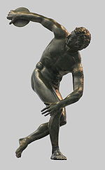
Sportsmanship expresses an aspiration or ethos that the activity will be enjoyed for its own sake. The well-known sentiment by sports journalist Grantland Rice, that it's “not that you won or lost but how you played the game," and the Modern Olympic creed expressed by its founder Pierre de Coubertin: "The most important thing . . . is not winning but taking part" are typical expressions of this sentiment.
Violence in sports involves crossing the line between fair competition and intentional aggressive violence. Athletes, coaches, fans, and parents sometimes unleash violent behaviour on people or property, in misguided shows of loyalty, dominance, anger, or celebration. Rioting or hooliganism are common and ongoing problems at national and international sporting contests.

Physical art
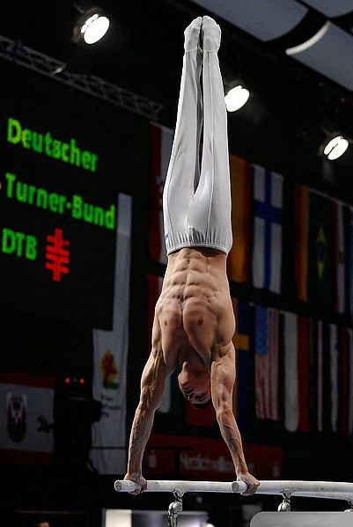
GymnasticsSports have many affinities with art. Ice skating and Tai chi, and Dancesport for example, are sports that come close to artistic spectacles in themselves. Similarly, there are other activities that have elements of sport and art in their execution, such as artistic gymnastics, Bodybuilding, Parkour, performance art, Yoga, bossaball, dressage, culinary arts, etc. Perhaps the best example is Bull-fighting, which in Spain is reported in the arts pages of newspapers. The fact that art is so close to sports in some situations is probably related to the nature of sports. The definition of "sports" above put forward the idea of an activity pursued not just for the usual purposes, for example, running not simply to get places, but running for its own sake, running as well as we can.
This is similar to a common view of aesthetic value, which is seen as something over and above the strictly functional value coming from an object's normal use. So an aesthetically pleasing car is one which doesn't just get from A to B, but which impresses us with its grace, poise, and charisma.
In the same way, a sporting performance such as jumping doesn't just impress us as being an effective way to avoid obstacles or to get across streams. It impresses us because of the ability, skill, and style which is shown. Art and sports were probably more clearly linked at the time of Ancient Greece, when gymnastics and calisthenics invoked admiration and aesthetic appreciation for the physical build, prowess and 'arete' displayed by participants. The modern term 'art' as skill, is related to this ancient Greek term 'arete'. The closeness of art and sport in these times was revealed by the nature of the Olympic Games which, as we have seen, were celebrations of both sporting and artistic achievements, poetry, sculpture and architecture.

Terminology
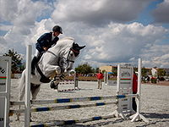
Show Jumping, an equestrian sport.In British English, sporting activities are commonly denoted by the mass noun "sport". In American English, "sports" is more used. In all English dialects, "sports" is the term used for more than one specific sport. For example, "football and swimming are my favourite sports", would sound natural to all English speakers, whereas "I enjoy sport" would sound less natural than "I enjoy sports" to North Americans.
The term "sport" is sometimes extended to encompass all competitive activities, regardless of the level of physical activity. Both games of skill and motor sport exhibit many of the characteristics of physical sports, such as skill, sportsmanship, and at the highest levels, even professional sponsorship associated with physical sports. Air sports, billiards, bridge, chess, motorcycle racing, and powerboating are all recognized as sports by the International Olympic Committee with their world governing bodies represented in the Association of the IOC Recognised International Sports Federations.

