





United Arab Emirates
Ministry of Education
Al Ain Educational Zone
Al Safwa private school

English file
Port folio

Rehab Ashraf
10-A

Part : 1
Table of
Contents

Table of
Contents

Part1: Table of contents

Part2: My CV

Part3: My reading

Part4: My writing

Part5: Community Services

Part6: My drawing

Part7: self reflection

Part: 2
My CV

CV

Name :
School:
Grade: 10
Section: A
Address: United Arab Emirates
Religion: Muslim
Telephone number: 055 /
E-mail address:
Date of Birth:
Interests and hobbies:

Skills and qualifications:

Part: 3
My reading

My reading

The Tortoise and the Hare

Once upon a time there was a hare who, boasting how he could run faster than anyone else, was forever teasing tortoise for its slowness. Then one day, the irate tortoise answered back: "Who do you think you are? There's no denying you're swift, but even you can be beaten!" The hare squealed with laughter.
"Beaten in a race? By whom? Not you, surely! I bet there's nobody in the world that can win against me, I'm so speedy. Now, why don't you try?"
Annoyed by such bragging, the tortoise accepted the challenge. A course was planned, and the next day at dawn they stood at the starting line. The hare yawned sleepily as the meek tortoise trudged slowly off. When the hare saw how painfully slow his rival was, he decided, half asleep on his feet, to have a quick nap. "Take your time!" he said. "I'll have forty winks and catch up with you in a minute."
The hare woke with a start from a fitful sleep and gazed round, looking for the tortoise. But the creature was only a short distance away, having barely covered a third of the course. Breathing a sigh of relief, the hare decided he might as well have breakfast too, and off he went to munch some cabbages he had noticed in a nearby field. But the heavy meal and the hot sun made his eyelids droop. With a careless glance at the tortoise, now halfway along the course, he decided to have another snooze before flashing past the winning post. And smiling at the thought of the look on the tortoise's face when it saw the hare speed by, he fell fast asleep and was soon snoring happily. The sun started to sink, below the horizon, and the tortoise, who had been plodding towards the winning post since morning, was scarcely a yard from the finish. At that very point, the hare woke with a jolt. He could see the tortoise a speck in the distance and away he dashed. He leapt and bounded at a great rate, his tongue lolling, and gasping for breath. Just a little more and he'd be first at the finish. But the hare's last leap was just too late, for the tortoise had beaten him to the winning post. Poor hare! Tired and in disgrace, he slumped down beside the tortoise who was silently smiling at him.
"Slowly does it every time!" he said.

Part : 4
My writing


My writing


Homework is important part of school
education
As people are different in their characters and personalities, they are also different in their way of thinking. These individual differences can clearly appear when we discuss a controversial topic like the one we have. Some people think that the H.W is an important part of school education while others have an opposing situation in which they see that the H.W is not important part of school education.

In my opinion, I see that the first groups of people are right and their own point of view should be followed and taken for granted because their way of thinking is highly positive and it has so many a advantages. First, doing homework will motivate you to study, because it will help you to practice skills you take it at the school . Second, doing homework well improve children's fluently. If you solve many math problems, you will answer any questions in the exams and it will help you to get high marks.

On the contrary, I see that the second groups of people are not thinking deeply of the topic: they reed the book from only the outer covering. Her are some of their opinion. First, students don’t have times to do their homework's, for example. When the student's comeback from the school at 4o'clock they don’t have the time for studying.

In a word, I think that don’t giving homework's for the students should be stopped and given the whole ignorance for its demerits and lack of usefulness While given homework's to the students (not a lot of them) should given the whole support as it is good for the students.

Part : 5
Community service


Community Service

ضعي صورتك وأنت تجلسين على النت أو فاتحة أي برنامج

Each person must do social work, even if it is simple but it would help people, whether financial or moral support or assistance in intellectual.
As I'm a good user in using many computer software like PowerPoint, Macromedia Flash MX, Internet, and Word so that makes me help many of my friends in using these software. In my opinion the development of people helps the development of countries.

I feel happiness when I teach any one of my friends.

My vision for the future is to be a PROGRAMER, and join the College of Information Technology. I like this college because I like using computer for many times, I'm working hard to achieve this objective by concern for my grades in school to get a proper ratio for the qualification for entering this college.



Part : 6
My drawing

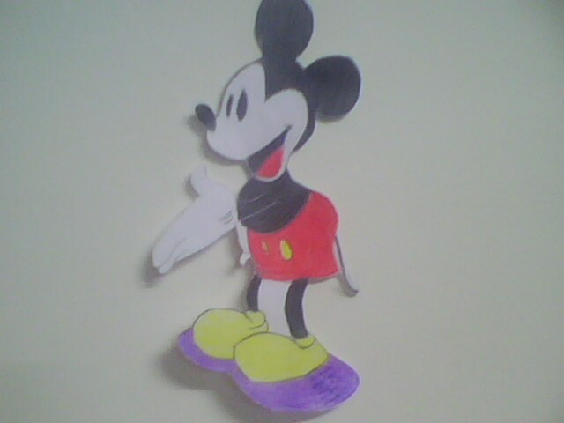
My drawing

I like drawing, so I drew Mickey Mouse and several other sketches.

Part : 7
Self reflection

Self Reflection
Conventions
-------- Each of my paragraphs has one main idea.
-------- I have used correct grammar.
-------- I have used correct punctuation.
-------- Full stops are at the end of my sentences.
-------- I have quotation marks" " around dialogue.
-------- My spelling is correct.
-------- I left white spaces between my words.
-------- My handwriting is legible.
Fluency
-------- My sentences begin in different ways.
-------- My sentences build upon the ones before.
-------- My sentences are different lengths.
-------- The meaning of each of my sentences is clear.
-------- My sentences flow and use correct grammar.
-------- My sentences are complete.
Organization
-------- My writing is sequenced in order.
-------- My introduction is exciting and inviting
-------- My ideas flow and are well connected through using connectors like because , but , so
-------- I have a satisfying conclusion.
Capitalization
--------- I used both capital and lower case letters.
--------- I have capitalized the first word in each sentence.
--------- I have capitalized people and pet names.
--------- I have capitalized months and days.
--------- I have capitalized cities, states , and places.
--------- I have capitalized titles of books , movies , etc.
Word Choice
---------- Every word seems just right
---------- I used the dictionary to spell the words I don't know.
---------- I used synonyms ( words of the same meaning ) to add variety.
Ideas
---------- My ideas are written in my own words.
---------- My writing is clear and focused.
---------- I understand my topic.
---------- My details give the reader important information.
---------- My ideas relate to one another.
---------- I have listened to suggestions from the teacher or peer.

