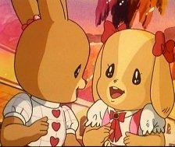

I’ll never forget...
((Memories))



New word

- Represent - amazed
- Happy – Sad -unary
-Memory - win.
-Forget -Glad
- Remember – Remind
- Boring – Interesting
- Still. - Excited
- Feel – Felt.
- Astonished.
- Surprised.
- Overcome
- bored
- shocked
- Nervous

Some things I remember

- When I was child I played Bicycle with my friends out the home.

- I remember my mother when she want cut my hear.

- When I child I remind when I fall down in the street.

- I think my face was nice when I was baby.

- When I was I tenth grade many happy and funny thing happened to me.

- I remember when one of my friends of mine overthrew the stairs.

Strange day

In two years ago. It was a normal day like any other day. The weather was something nice. In this day suddenly something happened …

When my parents want to visit they friends my mother was Prepare herself also my father. Then I hit my sister than I run. Than she was run to catch me than there was water on the ground. Then she fall down from water then her head opened. I saw the blood I felt so afraid it was like ketchup… than my father hear my sister scream and my scream than he toke my sister to hospital.

It was a strange day . I can’t Describe my feel I this time..

