Depreciation Revision

Name: ___________________________

Section A Multiple Choice

 | The table below shows the depreciating value of photographic equipment.  Which of the following graphs best represents the depreciation of this equipment?  A  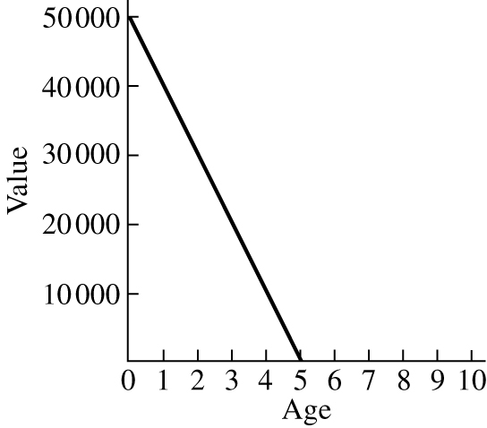  B  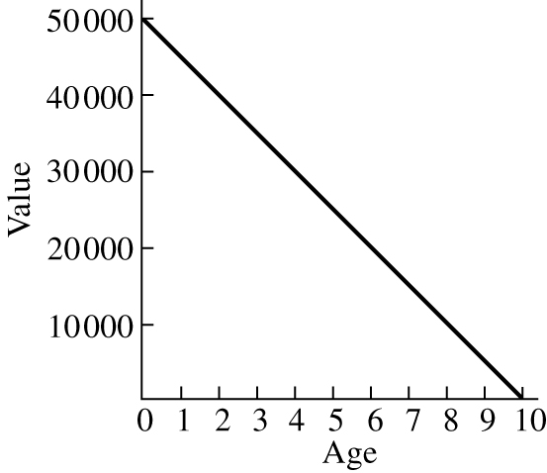  C  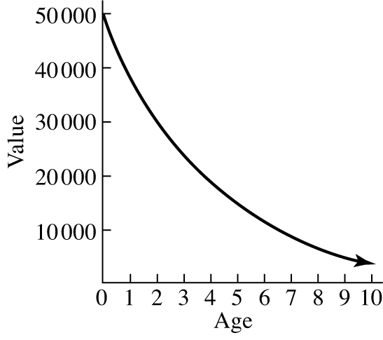  D  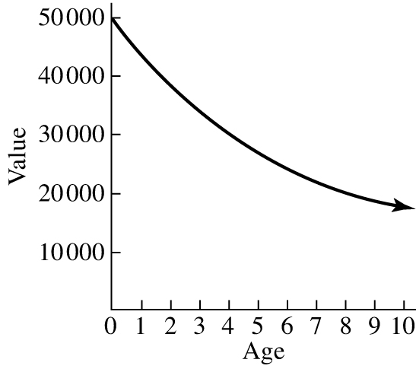 | C
 | Which of the following tables shows straight-line depreciation?  A  B | A
C
D

 | A ride-on mower bought for $5000 by a mowing company depreciates 15% of its purchase price each year under straight-line depreciation. The salvage value, of the mower after 3 years is:  A $750  B $2000  C $2250  D $2750 | d
 | A yacht that is purchased for $225 000 depreciates by $12 500 per year under straight-line depreciation. The number of years that it will take for the yacht to have a salvage value of $100 000 is:  A 4 years  B 10 years  C 12 years  D 18 years | B
 | A rock band has musical equipment that has a total value of $165 000. The musical equipment is depreciated under straight-line depreciation and after 12 years has a salvage value of $15 000. The amount by which the equipment is depreciated each year is:  A $10 000  B $11 250  C $12 500  D $15 000 | C
 | A machine costs $25 000. Its depreciation is calculated at 20% p.a. declining balance. The salvage value after 5 years is:  A $6553.60  B $8192  C $10 240  D $12 800 | b
 | A computer has a purchase price of $12 000. The computer is depreciated by 12.5% p.a. under declining balance depreciation. Which of the following will correctly find the salvage value of the computer after 4 years?  A 12 000 × 0.875⁴  B 12 000 × 0.125⁴  C 12 000 × 0.625  D 12 000 × 0.375 | A
 | A car has a purchase price of $56 000 when new. The car is depreciated by 20% p.a. under declining balance depreciation. The car can be written off for tax purposes when the value falls below $10 000.  The car can be written off after:  A 7 years  B 8 years  C 9 years  D 10 years | B
 | The table below shows the depreciated value of $1 at different rates of depreciation under the declining balance method.  A company has office furniture that is valued at $75 000.  The furniture is depreciated at a rate of 20% p.a. The salvage value of the furniture after 4 years is:  A $15 000  B $30 750  C $44 250  D $60 000 | B
 | A truck has an initial value of $400 000. It can be depreciated under straight-line depreciation at a rate of $40 000 per year or under declining balance of 15% p.a.  The number of years that it will take until the truck is worth more under declining balance depreciation than under straight-line depreciation is:  A 5 years  B 6 years  C 7 years  D 8 years | B

Credit and Borrowing Revision

 | - CalcCalculate the amount of flat-rate interest paid on each of the following loans.  - $24 000 at 8% p.a. for 4 years  - $18 500 at 11.5% p.a. for 18 months | - I = Prn  = $24 000 × 0.08 × 4  = $7680  - I = Prn  = $18 500 × 0.115 ×  = $3191.25
 | Calculate the total amount to be repaid on each of the following flat-rate interest loans.  - $40 000 at 7.5% p.a. for 6 years  - $37 500 at 18% p.a. for 9 months | - I = Prn  = $40 000 × 0.075 × 6  = $18 000  Total repayments = $40 000 + $18 000  = $58 000  - I = Prn  = $37 500 × 0.18 ×  = $5062.50  Total repayments = $37 500 + $5062.50  = $42 562.50
 | An entertainment centre with a cash price of $8400 is sold on the following terms:  - 15% deposit  - balance plus interest to be repaid over two years in monthly payments with interest charged at 12% p.a.  - Find the amount of the deposit.  - What is the balance owing?  - Calculate the amount of interest charged.  - What is the total amount to be repaid?  - Calculate the amount of each monthly repayment. | - Deposit = 15% of $8400  = 0.15 × $8400  = $1260  - Balance owing = $8400 – $1260  = $7140  - I = Prn  = $7140 × 0.12 × 2  = $1713.60  - Total repayments = $7140 + $1713.60  = $8853.60  - Monthly repayments = $8853.60 ÷ 24  = $368.90
 | Carlos borrows $15 000 to buy a car and repays the loan over 4 years at a rate of $481.25 per month. Calculate the flat rate of interest that Carlos has been charged. | Total repayments = $481.25 × 48  = $23 100  Interest = $23 100 – $15 000  = $8100  Annual interest = $8100 ÷ 4  = $2025  Percentage annual interest = × 100  = 13.5%
 | The Davies family borrow $350 000 to buy a home. They take out the loan over a 25-year term with monthly repayments of $2794.75. Calculate the total amount in repayments made on this loan. | Total repayments = $2794.75 × 300  = $838 425

Share Dividend Revision

A company that has 8.9 million shares and makes a profit of 16 million. If this entire amount is distributed among the shareholders, calculate the dividend that will be declared.

The table below shows the fluctuations in a share price over a period of 1 year.
Month | Share price | Month | Share price
January | $15.76 | July | $16.60
February | $16.04 | August | $16.77
March | $16.27 | September | $16.51
April | $16.12 | October | $16.71
May | $16.49 | November | $16.69
June | $16.39 | December | $16.98

- On a set of axes plot the share price for each month
- Draw a line of best fit on your graph and use your line to predict the share price after a further year

A company with a share price of 25c declares a dividend of 0.4c per share. Calculate the dividend yield on this investment

In 1995, Fatima bought a limited edition photograph autographed by Hussein Al Jassmi for $240. If the photograph appreciates in value by 15% per annum, calculate the value of the photograph in 2010 (to the nearest $100)

A company that has an after tax profit of $1.1 billion distributes this among its 365 million shares. Calculate the dividend that this company will declare.

