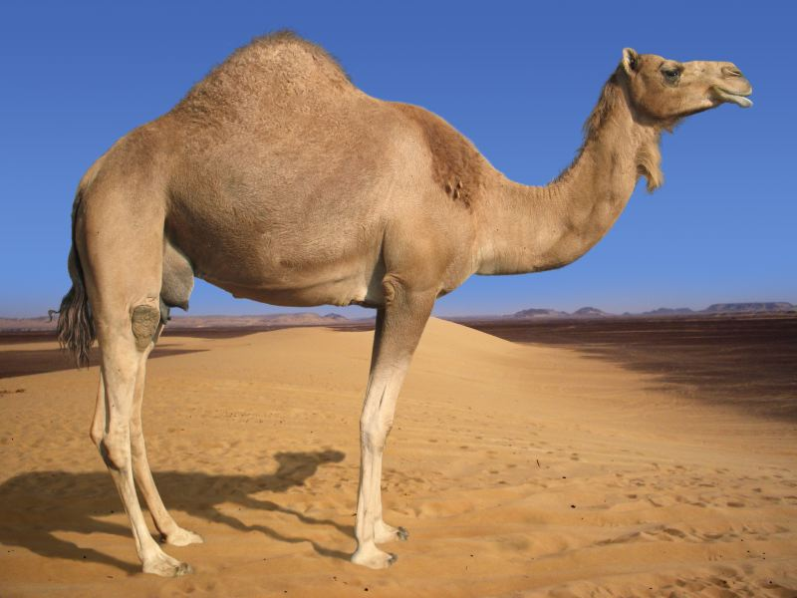


- A camel has a thick coat of hair that protects it from the sun .
camel has a single hump on its back. -

Camel has adaptations that help it live in desert .-

