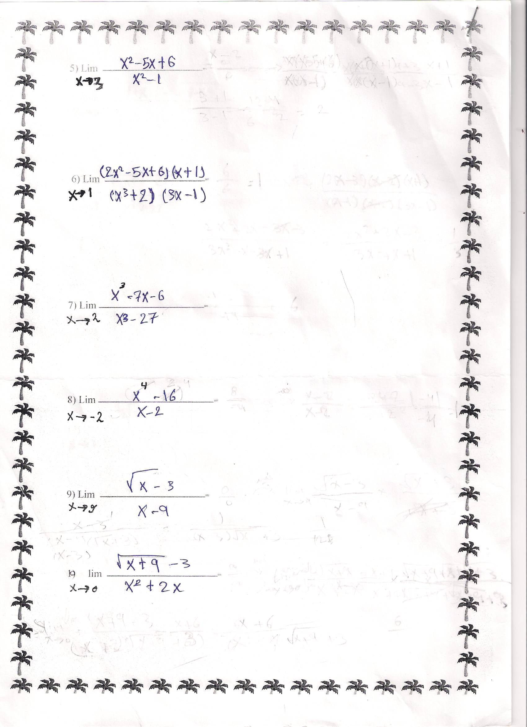

5] $\lim_{x→3}{\frac{\left(3^{2}\right)-5\left(3\right)+6}{\left(3^{2}\right)-1}}=0$

6 ] $\lim_{x→1}{\frac{\left(2\left(1\right)-5+6\right)(1+1)}{\left(1+2\right)(3-1)}}=1$

7] $\lim_{x→2}{\frac{\left(2^{3}\right)-7\left(2\right)-6}{\left(2^{3}\right)-27}}=\frac{-12}{-19}=\frac{12}{19}$

8] $\lim_{x→-2}{\frac{({-2)}^{4}-16}{-2-2}=\frac{0}{-4}}=0$

9] $\lim_{x→9}{\frac{\sqrt{x}-3}{x-9}=\frac{0}{0}=\lim_{x→9}{\frac{\sqrt{x}-3}{x-9}*\frac{\sqrt{x}+3}{\sqrt{x}+3}}} = \lim_{x→9}{\frac{x-9}{\left(x-9\right)(\sqrt{x}+3)}=\frac{1}{\sqrt{9}+3}=\frac{1}{6}}$

استخدمت خاصية الضرب بالمرافق

استخدمت خاصية الضرب بالمرافق

10] $\lim_{x→0}{\frac{\sqrt{x+9 }-3}{x^{2}+2x}*\frac{\sqrt{x+9 }+3}{\sqrt{x+9 }+3}}=\lim_{x→0}{\frac{x+9-9}{x\left(x+1\right)(\sqrt{x+9 }+3)}=\lim_{x→0}{\frac{1}{\left(x+1\right)(\sqrt{x+9 }+3)}=\frac{1}{2*6}=\frac{1}{12}}}$

