


United Arab Emirates
Ministry of Education

Under supervision of : T. Abdelhamed
Done by : hesham
Class : 11/s
Subject : English
Academic year : 2010-2011

Part: 1
My CV

CV

Name : Hesham ALSayed
School: mnar ALEman
Grade: 11
Section: s
Address: shj- United Arab Emirates
Telephone number: 050 /
E-mail address: hshom_321@hotmail.com
Date of Birth: 25/11/1994
Graduate from high school and I will be chemical.
Interests and hobbies:
I have many hobbies like reading, computer and playing football.
Skills and qualifications:

Computer:Power point and ms word–Searching in Internet.

Language: Arabic, English.

Part: 1 My CV
Part: 2 Table of contents
Part:3 vision and mission
Part: 4 self reflection
Part: 5 portfolio peer reflection
Part: 6 reading log
Part: 7 Community Services
Part: 8 Photographs /Awards / Certificates
Part: 9 Quizzes And Worksheets
Part: 10 Teachers Evaluation

Within the passage of time,
- I will be able to speak English communicating my messages clearly.
- I will also go on studying English through summer courses
My name is : A. Rahman M.D. Saeed
I am in grade: 10
I am studying at: Al-bayan private school
This school is in Sharjah Educational Zone. My portfolio reflects my goals which are:
- Reading short stories and summarizing them.
- Writing simple essays.
- Writing a Resume.
- Planning my work with English.
- Keeping a record of my work and progress.
These are my goals, but what are the ways to achieve them?!
First, I'd like to tell you about the reasons for choosing such goals:
- They will make me able to speak English more clearly.
- They will also make me able to read and write in a good way.
To achieve these goals I'll follow certain steps:
1. Reading short stories 2. Following my teacher's instructions

Self Reflection ( 1 ) Writing Checklist
Name :
Conventions
-------- Each of my paragraphs has one main idea.
-------- I have used correct grammar.
-------- I have used correct punctuation.
-------- Full stops are at the end of my sentences.
-------- I have quotation marks" " around dialogue.
-------- My spelling is correct.
-------- I left white spaces between my words.
-------- My handwriting is legible.
Fluency
-------- My sentences begin in different ways.
-------- My sentences build upon the ones before.
-------- My sentences are different lengths.
-------- The meaning of each of my sentences is clear.
-------- My sentences flow and use correct grammar.
-------- My sentences are complete.
Organization
-------- My writing is sequenced in order.
-------- My introduction is exciting and inviting
-------- My ideas flow and are well connected through using connectors like because , but , so
-------- I have a satisfying conclusion.
Capitalization
--------- I used both capital and lower case letters.
--------- I have capitalized the first word in each sentence.
--------- I have capitalized people and pet names.
--------- I have capitalized months and days.
--------- I have capitalized cities, states , and places.
--------- I have capitalized titles of books , movies , etc.
Word Choice
---------- Every word seems just right
---------- I used the dictionary to spell the words I don't know.
---------- I used synonyms ( words of the same meaning ) to add variety.
Ideas
---------- I used a graphic organizer to create and organize ideas.
---------- My ideas are written in my own words.
---------- My writing is clear and focused.
---------- I understand my topic.
---------- My details give the reader important information.
---------- My ideas relate to one another.
---------- I have listened to suggestions from the teacher or peer.
Comment
My points of strength are :
1 . -------------------------------------------------------------------------------------------
2 . -------------------------------------------------------------------------------------------
I should take care of the following points.
1 . -------------------------------------------------------------------------------------------
2 . -------------------------------------------------------------------------------------------

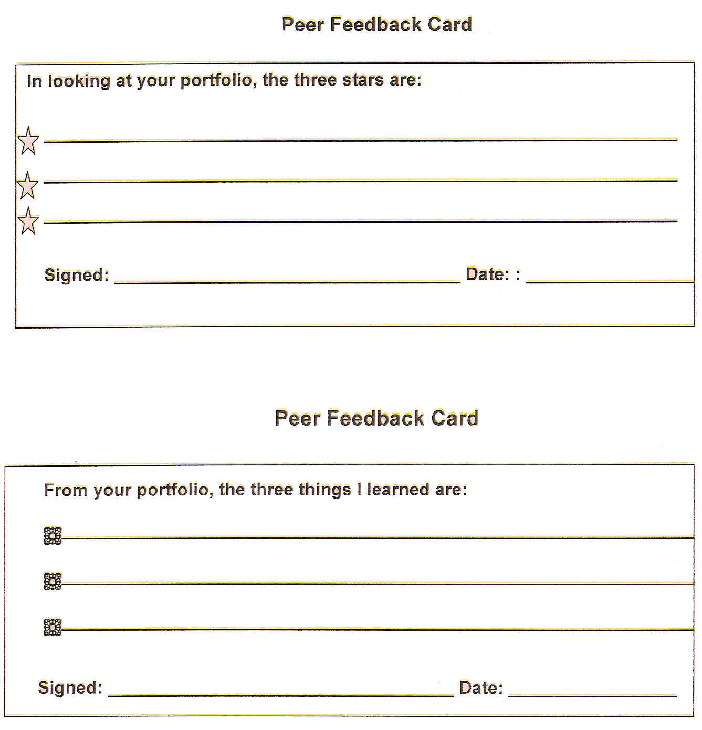

Pages | Title and Author | Type | Date
My Reading Log

Types: JR = Just Reading Book E = Easy Book C= Challenging

Part 7:
Community Services

Community Services

Last week, I went to visit my cousin in the hospital, when I arrived there I heard the nurses that they want a donor because there is a patient who he wants a blood, I went quickly to the doctor to donate some of my blood to the patient, when he woke up from his coma he thanked so much.

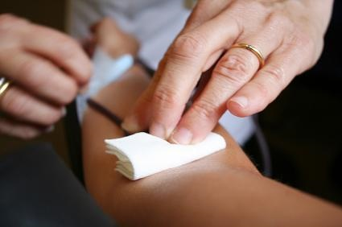

Part 8: Photographs /
Awards / Certificates

---------------------------------------------------------------------------------------------------------------------------------------------------------------------------------------------------------------------------------------------------------------------------------------------------------------------------------------------------------------------------------------------------------------------------------------------------------------------------------------------------------------------------------------------------------------------------------------------------------------------------------------------------------------------------------------------------------------------------------------------------------------------------------------------------------------------------------------------------------------------------------------------------------------------------------------------------------------------------------------------------------------------------------------------------------------------------------------------------------------------------------------------------------------------------------------------------------------------------------------------------------------------------------------------------------------------------------------------------------------------------------------------------------------------------------------------------------------------------------------------------------------------------------------------------------------------------------------------------------------------------------------------------------------------------------------------------------------------------------------------------------------------------------------------------------------------------------------------------------------------------

