The volume of this prism, correct to one decimal place is:
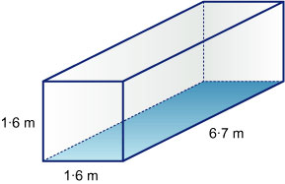
2·56 m³
10·72 m³
9·9 m³
17·2 m³

To draw a circle of circumference 15·0 cm, you would need to set the radius to approximately ...
4·8 cm
2·4 cm
1·8 cm
3·2 cm

The volume of this cylinder, correct to the nearest whole number is:
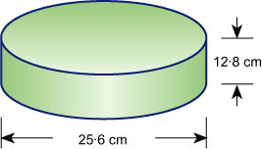
13177 cm³
6588 cm³
26354 cm³
3509 cm³

Match the following prisms with their correct volume (to the nearest cm³).
Using the pull-down menus, match each item in the left column to the corresponding item in the right column.
1050 cm³
67 cm³
263 cm³
421 cm³

4.1 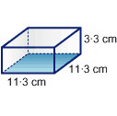
4.2 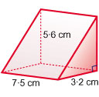
4.3 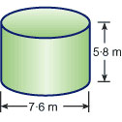
4.4 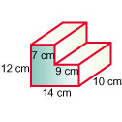

To calculate the volumes of ______ figures, we usually add or subtract the volumes of simpler shapes.
composite
cylindrical
cubic
corresponding

A is a shape that has a uniform cross-section.

The volume of a square pyramid of height 20 cm and base length 5 cm would be closest to …
167 cm³
133 cm³
33 cm³
500 cm³

The volume of a cone of height 20 cm and base radius 5 cm would be closest to ...
105 cm³
483 cm³
524 cm³
450 cm³

The base radius and height of four cones are listed on the left. Match one with its correct volume (to the nearest cm³).
Using the pull-down menus, match each item in the left column to the corresponding item in the right column.
524 cm³
262 cm³
134 cm³
452 cm³

9.1 r = 5 cm; h = 10 cm
9.2 r = 10 cm; h = 5 cm
9.3 r = 12 cm; h = 3 cm
9.4 r = 4 cm; h = 8 cm

We use the word when discussing how much liquid a container can hold.

The volume of a cylinder is ____ times the volume of a cone of the same base radius and height.
four
three
two
π

The only measurement that we use to calculate the volume of a sphere is its _____ .
diameter
circumference
radius
height

Match each pyramid, defined by its base area and height, with its volume from the list on the right.
Using the pull-down menus, match each item in the left column to the corresponding item in the right column.
67 cm³
40 cm³
28 cm³
36 cm³

13.1 A = 20 cm²; h = 10 cm
13.2 A = 5 cm²;h = 17 cm
13.3 A = 15 cm²; h = 8 cm
13.4 A = 12 cm²; h = 9 cm

The altitude of a pyramid is sometimes used as an alternative name for its .

The capacity of a hemispherical bowl of diameter 36 cm would be closest to …
24·4 L
31·1 L
12·2 L
62·2 L

The volume of a sphere of diameter 10 cm is closest to:
4189 cm³
524 cm³
393 cm³
948 cm³

Match the description of each shape with its correct capacity.
Using the pull-down menus, match each item in the left column to the corresponding item in the right column.
512 mL
2·094 L
84 mL
0·524 L

17.1 hemisphere, radius 10 cm
17.2 sphere, radius 5 cm
17.3 cone, base radius 4 cm, height 5 cm
17.4 cube, side length 8 cm

A _____ is a shape that has triangular faces rising from its base to meet at a point
cylinder
cone
prism
pyramid

A always has a circular base.

A rainwater tank holds 81 cubic metres of water when full. If it is 3 m tall, what is the area of its base?
78 m²
40·5 m²
27 m²
9 m²

A rectangular hole measuring 3 m by 2 m by 1·5 m needs to be dug for a garden pond. If the earth is removed in a trailer measuring 180 cm by 30 cm by 120 cm, how many trailer loads will be needed to remove all the earth?
16
10
14
12

The point at the top of a pyramid is called the .

A rectangular pyramid has _____ faces.
six
three
four
five

A concrete slab in the shape of a rectangular prism measures 3500 mm by 5000 mm by 120 mm. How much will the concrete cost if it cost Dhs 120 per cubic metre?
Dhs 252
Dhs 210
Dhs 396
Dhs 168

Match each solid with its correct volume. (Answers are given to one decimal place – all measurements are in metres.)
Using the pull-down menus, match each item in the left column to the corresponding item in the right column.
8·1 m³
1·3 m³
7·2 m³
2·0 m³

25.1 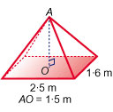
25.2 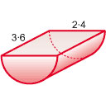
25.3 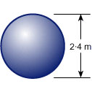
25.4 