Shappy chic:

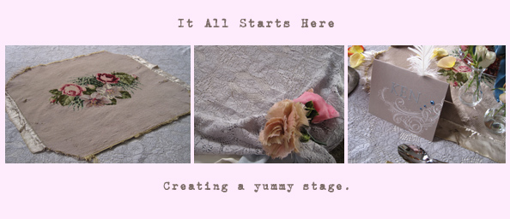

Layering interesting textures and fabrics makes for an interesting background to build upon. I commonly find unfinished or discarded needle points and always love to find a purpose to exhibit the labor of love.

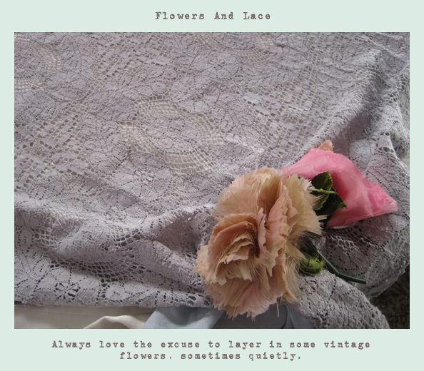

I'm not too good at labour intensive art and craft projects. But I do like to make things that are unique. I found some stationary and sticky letters and made some place setting cards
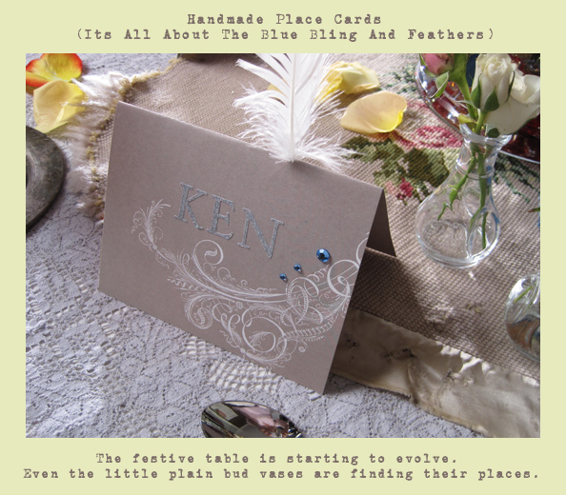

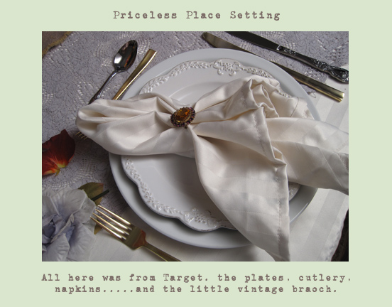

Layering affordable dinnerware, cutlery and linens is so much more satisfying and user friendly than "special occasion" pieces. And then adding little special details, makes it all priceless.

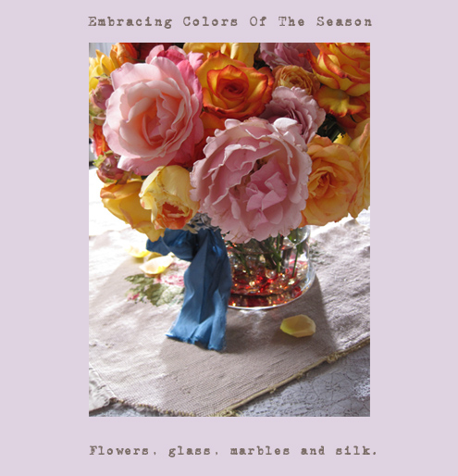

While pastels is where I naturally go for my palette, sometimes seasons and events have a different plan. I can embrace colors outside of my comfort zone, so long as I can still blend in elements that stay true to my aesthetics. Adding a floppy silk bow keeps the bolder colors in the world of softness.

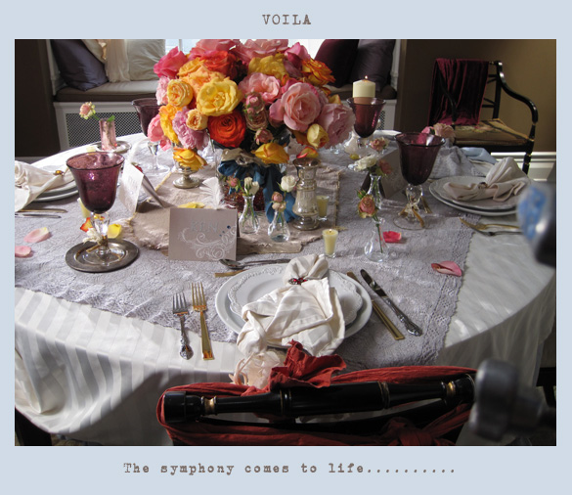

*Every little detail plays a role of equal importance. I was so happy with the affordability but still lavish end result.

