
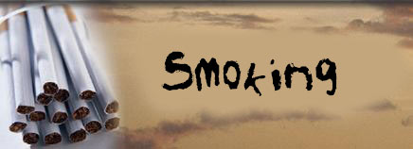





smoking
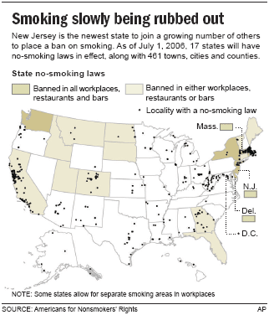
WASHINGTON — Separate smoking sections don’t cut it: Only smoke-free buildings and public places truly protect nonsmokers from the hazards of breathing in other people’s tobacco smoke, says a long-awaited surgeon general’s report.
Some 126 million nonsmokers are exposed to secondhand smoke, what U.S. Surgeon General Richard Carmona repeatedly calls “involuntary smoking” that puts people at increased risk of death from lung cancer, heart disease and other illnesses.
Moreover, there is no risk-free level of exposure to someone else’s drifting smoke, declares the report issued Tuesday — a conclusion sure to fuel already growing efforts at public smoking bans nationwide. Fourteen states have passed what are considered comprehensive smoke-free workplace laws, those that include restaurants and bars.
But the surgeon general is especially concerned about young children who can’t escape their parents’ addiction in search of cleaner air: Just over one in five children is exposed to secondhand smoke at home, where workplace bans don’t reach. Those children are at increased risk of SIDS, sudden infant death syndrome; lung infections such as pneumonia; ear infections; and more severe asthma.
“Exposure to secondhand smoke remains an alarming public health hazard,” Carmona said. “Nonsmokers need protection through the restriction of smoking in public places and workplaces” — and by smokers voluntarily not puffing around children.
Challenging the bans
The report won’t surprise doctors. It isn’t a new study but a compilation of the best research on secondhand smoke, the most comprehensive federal probe since the last surgeon general’s report on the topic in 1986, which declared secondhand smoke a cause of lung cancer in nonsmokers.
Since then, numerous other health agencies have linked to secondhand smoke to heart disease and other illnesses. Earlier this year, California health officials estimated that secondhand smoke kills about 3,400 nonsmoking Americans annually from lung cancer, 46,000 from heart disease, and 430 from SIDS.

Advertisement | ad info
The new surgeon general’s report doesn’t retally the deaths, but it cites that toll.
The tobacco industry and some businesses, particularly restaurant and bar owners concerned about loss of smoking customers, have challenged some of the broadest public smoking bans in cities and states.
The new report gives new scientific ammunition against those challenges, said Matthew Myers of the Campaign for Tobacco-Free Kids.
“There is no longer a scientific controversy that secondhand smoke is a killer,” he said. The report “eliminates any excuse from any state or city for taking halfway measures to restrict smoking, or permitting smoking in any indoor workplace.”
Among other findings:
- Separating smokers from nonsmokers, cleaning the air and ventilation systems don’t eliminate exposure to secondhand smoke.
- There is good evidence that comprehensive smoking bans, like those in New York City and Boston, don’t economically hurt the hospitality industry.
- Workplace smoking restrictions not only reduce secondhand smoke but discourage active smoking by employees.
- Secondhand smoke can act on the arteries so quickly that even a brief pass through someone else’s smoke can endanger people at high risk of heart disease. Don’t ever smoke around a sick relative, Carmona advised.
- Living with a smoker increases a nonsmoker’s risk of lung cancer and heart disease by up to 30 percent.
- There isn’t proof that secondhand smoke causes breast cancer, although the evidence is suggestive. California earlier this year cited that link in becoming the first state to declare secondhand smoke a toxic air pollutant.
- On the plus side, blood measurements of a nicotine byproduct show that exposure to secondhand smoke has decreased. Levels dropped by 75 percent in adults and 68 percent in children between the early 1990s and 2002.
However, not only has children’s exposure declined less rapidly, but levels of that byproduct among children are more than twice as high as in nonsmoking adults.
http://www.msnbc.msn.com/id/13569976/ns/health-addictions

smoking
Introduction
It is a known fact that tobacco smoking has many disadvantages! Medical research has found that smoking is a major factor for developing several health problems such as lung cancer, emphysema, cardiovascular disease…It is also known fact that this tobacco smoke contains stimulant nicotine which forms a strong physical and psychological chemical addiction. Although not too many people know about this- the Centers for Disease Control and Prevention believe that nicotine can be as addictive as heroin or cocaine. Nicotine is vasoconstrictor and a nerve toxin, it has been classified as a class I insecticide.
How this dependence is usually developed? Well, this addiction is definitely strongest when tobacco smoke is inhaled into the lungs. Several studies done in the past have proven that Nicotine is typically eliminated from the body within 2 to 3 days, but it is also proven that physical and psychological withdrawal symptoms may last for much longer.
Tobacco toxins
It is proven that there are over 4000 chemicals in tobacco with 100 identified poisons and 63 known carcinogens -drugs which cause cancer. The most talked about drug in tobacco is nicotine but there are other also which include:
• Arsenic,
• Cyanide,
• Carbon monoxide (found in car exhaust fumes)
• Formaldehyde (used to embalm bodies),
• Ammonia Bromide (a toilet cleaner )
Incidence of smoking
It is a known fact that each year, because of exposure to environmental tobacco smoke, an estimated 3,000 nonsmoking Americans die of lung cancer, and 300,000 children suffer from lower respiratory tract infections
More than 5 million children living today will die prematurely because of a decision to use tobacco and smoke cigarettes. More than 3 million young people under age 18smoke half a billion cigarettes each year and that more than one-half of them consider themselves dependent upon cigarettes.
Health affects of smoking tobacco those nine effectives
The health effects of tobacco smoking are related to direct tobacco smoking, as well as passive smoking, inhalation of environmental or secondhand tobacco smoke. It is a fact that when cigarette smoke is inhaled, thousands of chemicals get into your bloodstream and travel throughout your body. These chemicals cause damages to different parts of the body:
1-Eyes
It is proven that different chemicals in tobacco can cause damage to the macula, which represents the most sensitive part of the retina. How this happens? Well, those tiny blood vessels can burst through the macula, leading to irreversible damage. Not only that - smoking also causes morphological and functional changes to the lens and retina due to its atherosclerotic and thrombotic effects on the ocular capillaries.
2-Digestive system
Although most smokers don’t think about this- it is a fact that smoking is a risk factor for all cancers associated with the larynx, oral cavity and esophagus. There is no doubt that heavy smokers have laryngeal cancer mortality risks 20 to 30 times greater than non-smokers.
3-Heart and circulation
Smoking has two main effects on heart and circulations are
• an increase in your heartbeat rate,
• a sharp rise in blood pressure
This happens because nicotine attacks directly the nerves, causing the heart rate to rise and blood vessels to constrict. Because smokers have lungs filled with those dangerous fumes- it means that the heart has to pump harder to get enough oxygen to the rest of the body. Smoking can also increase in the blood cholesterol and fibrinogen levels. The heart and circulation attacks caused by smoking include:
• Coronary heart disease (CHD),
• Aneurysm,
• Peripheral vascular disease (PVD),
• stroke
4-Lungs
There is no doubt that the tar $$$$$$$ of cigarette smoke directly damages the cells in the airways of the lung. This can eventually cause cancer of the lung or larynx. It can also lead to chronic bronchitis and emphysema. Several factors are contributing the lung cancer:
• the daily dose of tobacco;
• the duration of regular smoking and
• the form in which tobacco is smoked
5-Brain
Because smoking has linked to the buildup of fatty substances in the carotid artery, the main neck artery supplying blood to the brain, it represent one of the most important factors for developing stroke. Not only that –nicotine also
• raises blood pressure;
• carbon monoxide reduces the amount of oxygen blood can carry to the brain;
• cigarette smoke makes the blood thicker and more likely to clot
6-Digestive system
Smoking has been shown to have harmful effects on all parts of the digestive system, contributing to developing of many diseases such as:
• Heartburn
• Peptic ulcers
• Crohn's disease
• Gallstones
• stomach cancer
7-Liver and pancreas
Not too many smokers know that almost half of all the bladder and kidney cancer in men are caused by smoking.
8-Skin and hair
Smoking can danger the skin, mainly one substance called collagen which keeps the skin elastic. Smokers get more and deeper wrinkles all over their faces because nicotine constricts the tiny capillaries that nourish the skin. Not only that - smokers are also prone to premature thinning and graying of the hair.
9-Bone and muscles
It is proven that tobacco smoke chemicals are poisons that inhibit the development of new tissue cells. The tissue of smokers does not get an adequate blood supply to promote healing, thus smokers are at a much higher risk of developing osteoporosis.
Smoking Is Expensive!!!
Beside the fact that smoking does cause damage health, it could be very expensive habit! Depending on where smoker live, smoking a pack of cigarettes a day can cost about $1,800 dollars a year.
Dangers of second-hand smoking
Passive smoking is breathing in environmental tobacco smoke, which consists of smoke directly from the burning tobacco and exhaled mainstream smoke.Centers for Disease Control and Prevention claim that about 90 percent of nonsmoking people in the United States are exposed to environmental or second-hand tobacco smoke. It is proven that constant exposure to environmental tobacco smoke, in the workplace or home, nearly doubles the risk of having a heart attack. American Heart Association's Council on Cardiopulmonary and Critical Care have published a study in which they claim that environmental tobacco smoke is a major preventable cause of cardiovascular disease and death. The statement urges that environmental smoke be treated as an environmental toxin, and that ways be found to protect workers and the public from this health hazard.The following health problems have been associated with second-hand smoking:
• asthma in children
• lower respiratory tract infections
• lung cancer
• Coronary heart disease.
Second-hand smoke appears to present an equal danger to the fetus.
Withdrawal symptoms
Smokers continue to smoke in order to avoid withdrawal symptoms, which can be very unpleasant. Withdrawal can bring about physical and emotional changes, which may include:
• Cravings
• Irritability, frustration, depression and/or anxiety
• Restlessness
• Difficulty concentrating
• Changed sleeping patterns
• Increase in appetite and weight gain
• Coughing.
Withdrawal symptoms are all signs that the body is recovering and getting used to living without nicotine. On average, most symptoms are gone within two to four weeks. Heavy smokers may have some symptoms for a few more weeks.
Summary
• Person shouldn’t smoke any number or any kind of cigarette, because smoking even a few cigarettes a day can hurt health. If you try to smoke fewer cigarettes, but do not stop completely, soon you’ll be smoking the same amount again.
• Quitting smoking isn't easy! Person that’s planning to quit should know that it will take effort to quit smoking. Nicotine is habit forming and almost half of the battle in quitting knows you need to quit. There are many ways smokers quit, including using nicotine replacement products (gum and patches). Nearly all smokers have some feelings of nicotine withdrawal when they try to quit.
• Half of all adult smokers have quit, so you can too- that’s the truth! That’s the good news. There are millions of people alive today who have learned to face life without a cigarette. For staying healthy, quitting smoking is the best step you can take.
• If you need help- do it! Many groups offer written materials, programs, and advice to help smokers quit for good.
Avoid temptation! In the difficult first few days you can change your routine to avoid situations where you would usually smoke.
Reference
1- www.healthworld.com
2-www.nosmoking/hazard.html
3- essay about smoking in Al-Ithad newspapers'



Br Med J 1976; 2 : 1525 doi: 10.1136/bmj.2.6051.1525 (Published 25 December 1976)
- Research Article

Mortality in relation to smoking: 20 years' observations on male British doctors.
- R Doll,
- R Peto

Abstract
In 1951 the British Medical Association forwarded to all British doctors a questionnaire about their smoking habits, and 34440 men replied. With few exceptions, all men who replied in 1951 have been followed for 20 years. The certified causes of all 10 072 deaths and subsequent changes in smoking habits were recorded. The ratio of the death rate among cigarette smokers to that among lifelong non-smokers of comparable age was, for men under 70 years, about 2:1, while for men over 70 years it was about 1-5:1. These ratios suggest that between a half and a third of all cigarette smokers will die because of their smoking, if the excess death rates are actually caused by smoking. To investigate whether this is the case, the relation of many different causes of death to age and tobacco consumption were examined, as were the effects of giving up smoking. Smoking caused death chiefly by heart disease among middle-aged men (and, with a less extreme relative risk, among old men,) lung cancer, chronic obstructive lung disease, and various vascular diseases. The distinctive features of this study were the completeness of follow-up, the accuracy of death certification, and the fact that the study population as a whole reduced its cigarette consumption substantially during the period of observation.
As a result lung cancer grew relatively less common as the study progressed, but other cancers did not, thus illustrating in an unusual way the causal nature of the association between smoking and lung cancer.
http://www.bmj.com/content/2/6051/1525.abstract

Stages and processes of self-change of smoking: Toward an integrative model of change

James O. Prochaskaª and Carlo C. DiClemente
ªU Rhode Island, Kingston
Available online 14 May 2007.

An integrative model of change was applied to the study of 872 Ss (mean age 40 yrs) who were changing their smoking habits on their own. Ss represented the following 5 stages of change: precontemplation, contemplation, action, maintenance, and relapse. 10 processes of change were expected to receive differential emphases during particular stages of change. Results indicate that Ss (a) used the fewest processes of change during precontemplation; (b) emphasized consciousness raising during the contemplation stage; (c) emphasized self-reevaluation in both contemplation and action stages; (d) emphasized self-liberation, a helping relationship, and reinforcement management during the action stage; and (e) used counter conditioning and stimulus control the most in both action and maintenance stages. Relapsers responded as a combination of contemplators and people in action would. Results are discussed in terms of developing a model of self-change of smoking and enhancing a more integrative general model of change. (14 ref) (PsycINFO Database Record (c) 2006 APA, all rights reserved)
Author Keywords: integrative model of self change of smoking habits, Ss with mean age of 40 yrs.
http://www.sciencedirect.com/science?_ob=ArticleURL&_udi=B6WY64NR51YN9&_user=10&_coverDate=06%2F30%2F1983&_rdoc=1&_fmt=high&_orig=search&_origin=search&_sort=d&_docanchor=&view=c&_searchStrId=1549717425&_rerunOrigin=scholar.google&_acct=C000050221&_version=1&_urlVersion=0&_userid=10&md5=64bc71013c71aa49af3c734b851da0df&searchtype=a

My Quit Smoking Story
rate or flag this pageTweet thisBy myquitstory
My story starts 36 years ago. Still to this day, I have trouble believing I became a smoker. Both of my parents smoked. I hated that, and was continually waving away the smoke, hiding their cigarettes, and complaining. Finally, when I was in college, my roommate and I decided we'd add smoking to our weight loss plan. We'd eat a very small amount, then choke down a cigarette or two. It certainly did cut down on our eating...UNTIL we became used to smoking, and didn't get sick every time we lit up! Before we knew it, both of us NEEDED to smoke. We were addicts. Gail •Ciga Cease worked for me
Hi My Name is Gaylene Buchanan
I had been smoking for about thirty-six years until I started developing a cough recently. This cough started out as occasional and progressed to very often. Not wanting to admit that maybe the cause of the cough could be smoking, I decided I must have allergies to the chemicals I use every day while working in my hair salon. This led me to purchase all kinds of cough syrups, over the counter allergy meds, and throat lozenges. I bought machines to clean the air and stopped using aerosol sprays. Funny thing, the cough didn't go away or even diminish.
I started getting slightly short of breath, then progressed to VERY short of breath. I could no longer climb mountains, water ski, or play sports with my boys. I used to walk for miles daily. My boundless energy was gone. At night I would lie in bed and feel my heart pounding while my chest ached. I began to suspect COPD. Denial made me hope that I had something wrong with my heart. I felt something could be done to help me if I had heart troubles. COPD sounded too scary, too final. I went to a heart clinic to get checked out. After a treadmill test, ultra sounds, etc., it was determined that my heart was fine. This left me no choice but to admit I had a serious lung problem.
A trip to my doctor confirmed my worst suspicion. I had emphysema. Without being told, I knew I had to stop smoking. Now began the endless cycle of stopping and starting smoking. I tried almost every quit smoking aid on the market. I would stop for a few days, then start bumming the occasional puff from my husband. Of course this would lead me to buying my own cigarettes and trying to limit myself to so many per day. Then, before I knew it, I would be back up to my pack or more daily. My breathing got harder and harder until I couldn't walk across my yard without my heart pounding and my lungs gasping for breath. Doing chores that involved bending or carrying were very hard.
My doctor prescribed Wellbutrin to help me quit smoking. This helped, but I knew I needed more help than that. Later one day I was talking to a good friend of mine, she told me about herbal quit smoking formula and how she had managed to quit with it.
Later that night I was thinking about what my friend had told me, and decided to check out the product she was using called "Zero Nicotine". So I went to their website and was encouraged by what I found. There where dozens of stories and testimonials of people explaining how it helped them to quit..
I Tried Zero Nicotine And It Worked...
I decided to go ahead and buy a one-month supply of Zero Nicotine and test it out for myself, seeing as how it looked safe and professional I figured worst case scenario, nothing would happen. I will spare you the details, but after about two weeks on the program my cravings decreased by 50%.
After a month on the program I have almost reduced to less than 5 cigarettes a day from a pack a day, and I my shortness of breath has decreased. Also I was actually sleeping better, and had a lot more energy throughout the day! I felt a lot healthier. The all natural blend of ingredients inside Zero Nicotine worked wonders for me, and didn't have any side effects as far as I could tell.
...But "Ciga Cease" Was Better
Just before I was about to order another months worth of Zero Nicotine (They recommend a 3 month program to achieve the maximum benefit.) I found a better product called "Ciga Cease". What I liked the most about it was that it had all the same benefits as Zero Nictonine, but also the formula had ingredients to lower stress and anxiety levels and also included a detox, to cleanse the body from smoking related toxins. Overall It seemed to me that it was actually more healthy product, and a much better deal.
I still wasn't completely sure if I wanted to risk switching products after I had already seen such amazing results with Zero Nicotine, but they offered a risk free, pay nothing for 30 days trial. They even pay shipping, so that really gave me no excuse to say no. I had them ship me the 30-day supply and after I had used it all, I quit completely and I am smoke free for over a month now.
http://hubpages.com/hub/My-Quit-Smoking-Story
A story about smoking
I have tried many times over the last few years to kick this addiction once and for all, but somehow, I always managed to be lured back into its clutches after a few weeks, or even after a 6 month quit. I thought I had it beaten! I think it must have been the "just one" lie which got me the last time. I smoked for another couple of years before I found the will power to try again. Every time I failed, I felt ashamed. Other people were quitting and staying quit, but I kept falling by the wayside, and smoking more as a result. How could they get it right and not me?
I began smoking at 13 years of age...just one or two with a friend in the evenings when we were out. In those days, many moons ago, we were able to buy loose cigarettes, usually unfiltered, from any shop! We would each have our money, and the bravest one of us would walk in, hoping not to bump into anyone we knew, and buy 4 cigarettes! Two each for the coming evening, usually smoked outside, behind the youth club. It was hidden, a dirty little secret, even in those days. My parents would have murdered me had they found out, though they were both smokers themselves. I didn't "come out" with the fact that I smoked till I was working, around 16 years old. I smoked about 10 a day then!
So it continued...
I never thought of the damage I was doing to myself. I felt exciting, in the swing of things, and accepted as an adult. So I had a bad cough after a cold, and my teeth weren't as white as my sister's, who never smoked. I no longer played any sports, but most of my friends smoked, so I never felt different.
I met and married my husband Paul when we were 22, both smoking like chimneys. I had 2 children by the time I was 26, and life went on as normal. We smoked around our children, never thinking it would be doing them any harm. They both begged us to stop when they learned about the dangers of smoking. We just rolled our eyes at each other, patronizingly poo-pooing their pleas. We weren't going to die! Other people did that!
My son has never smoked, while my daughter does, starting when she was 18. We never thought she would! My parents quit smoking, my aunts quit smoking, but they were older. I had loads of time to quit further down the line. Paul's mother died from a heart attack at only 55, after suffering a brain hemorrhage the year before, both smoking related illnesses. And still we smoked.
At age 36, I had a child with profound mental and physical retardation. We moved outside to smoke, as she had such trouble breathing, and we didn't want to add to that! Thank God no doctor ever said to us that Sinead's condition was smoking related. I couldn't have borne that guilt!
My father died a few years later from cancer throughout his body, as well as emphysema - already damaged even though he had quit for years. Still I smoked, even as he asked me on his deathbed to try to stop. I did mean to, but thought that I had too many worries to cope with. How would I cope without a smoke?! Little did I know then, the smoking was only adding to my inability to cope, clouding my whole world in smoke.
Sinead died after almost 11 years in our home. I smoked more than ever. Paul had a stent inserted into a valve in his heart - caused by blockage, smoking related! We both quit for awhile then, began to exercise more, and for the first time, realized that we were not invincible, and would surely die of some horrible disease if we didn't give it a darned good try! Even though I intended to cheat while Paul was at work, and then pretend to be smober when he came home, I found that the only person I was cheating was myself. After a spell of self-loathing, I put my heart and soul into it!
This is our last and most successful quit. Both of us still feel that we will never smoke again. I only wish we could have found this strength of purpose before. I know that this wonderful forum has kept me focused, and educated me fully about the addiction to nicotine, and how to beat it. I have found a peace this time, which I had never experienced before...an awareness of my world and everything in it. I have an abundance of energy, a joy in living, more confidence than ever before, and after 11 months of smobriety, I am more committed to this quit than ever before!
This forum has definitely saved my life. I have met the most genuine, wonderful people, all willing to support eachother, and also share some of the best laughs I've ever had!
To any newcomer looking in here, I would say to stay awhile, read and post, and the magic of this place will embrace you too.
Anna(Annabanana)
"Don't pout, put it out!"
http://quitsmoking.about.com/cs/ourstories/a/annaquitstory.htm

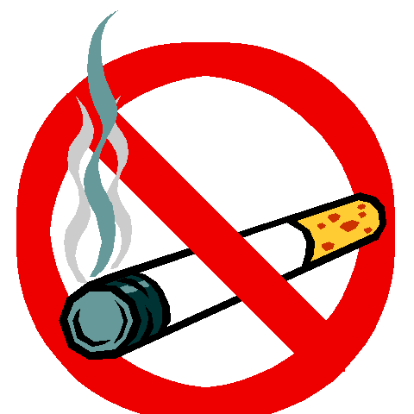
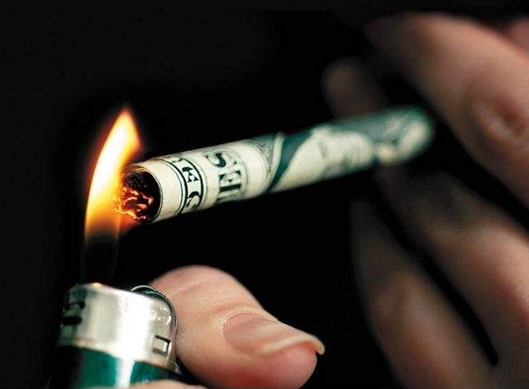
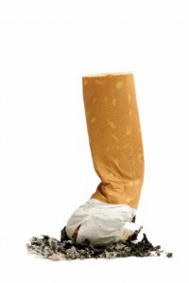
Smoking is harmful to health .

Quit smoking now

Do not smoke

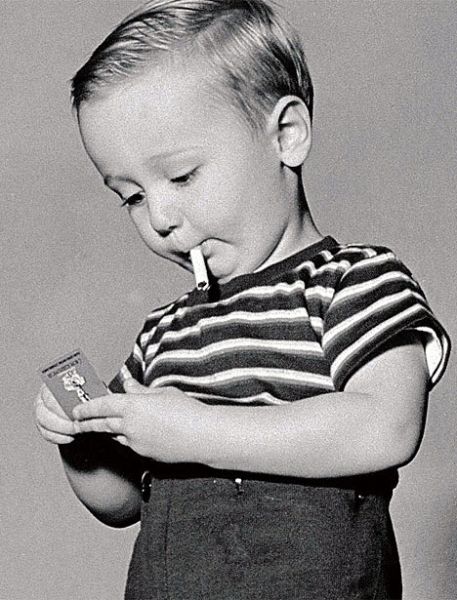
Avoid smoking in front of children

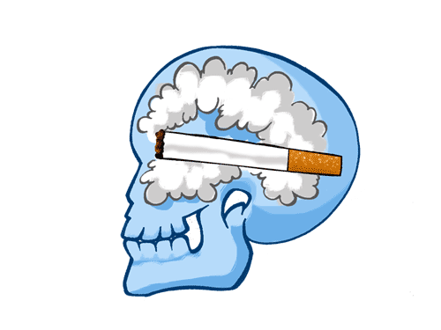

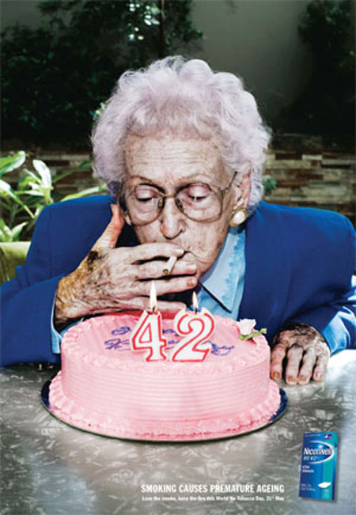

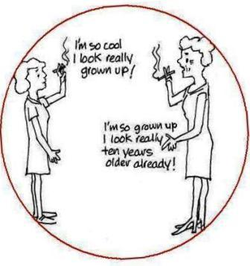

Avoid smoking in front of children.

