
The Ministry of Education and youth
Abu Dhabi Education Council
ALfarazdq school

Report talks about
( wedding traditions in UAE )

Student work : alhammadi .

Gread : 10 / B

Teacher :

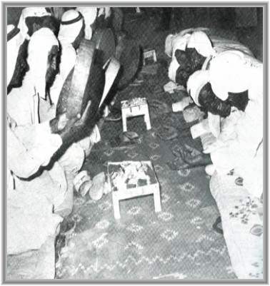
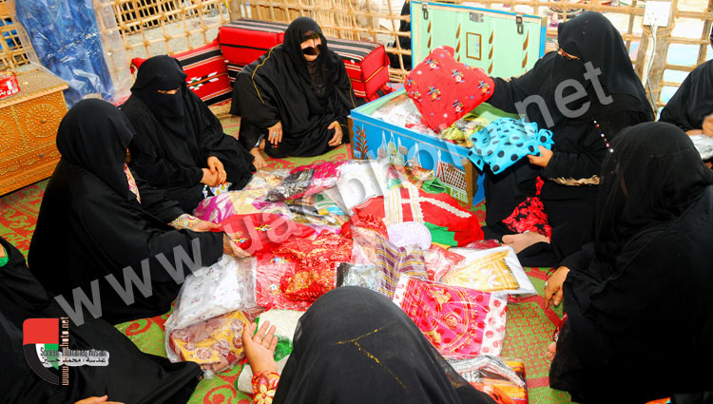

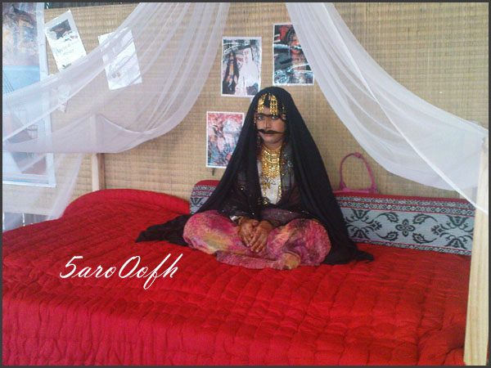
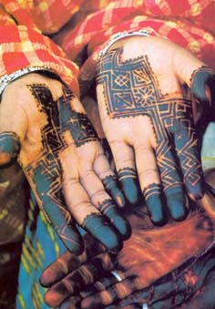

Introduction :
Islam being the predominant religion in UAE the local customs and traditions of UAE is influenced to a great extent by this religion. However it does not make UAE a closed society. It seeks to promote the best in its traditions and customs so that the nation becomes vibrant and attractive to all the people.

Politeness and courteous behavior is very much visible while dealing with guest of any kind. While enjoying food with other people of UAE one is supposed to eat with the right hand. The aromic and sugarless coffee forms a very important part of the customs of UAE. There are generally two reception rooms in the houses as part of UAE custom. These reception rooms called majlis are separate for men and women. During the Eid special sitting arrangements are made in the majlis and an age hierarchy is generally maintained. As the majlis comes to an end incense burners are brought and rose water is also sprinkled in each guests head.

As part of wedding traditions in UAE, the finalization of marriage date marks the beginning of the preparations for bride's grooming for her wedding, which at times can be quite elaborate. In preparation for her wedding day, she is given best of foods and supposed to take lots of rest. Traditionally, she is not supposed to be seen for forty days except for her family members and relatives. As her wedding day approaches, she is anointed with a variety of traditional oil and perfumes from head to toe and her hair is washed with extracts of amber and jasmine. On the night of Laylat Al Henna the bride's hand and feet are decorated with henna. The family members and relatives sing and dance traditional songs and express their joy. The marriage is more of contractual in nature rather than being religious. The groom also needs preparation for his marriage but as compared to the bride it is very less.

Although 96% of the population follow Islam it is tolerant to other religious communities. One can get alcohols in restaurants and hotels and the local population can also drink it in restaurants. However they are not supposed to appear drunk on the road. Shisha pipes are smoked at most establishments. They are traditional water pipes that use flavored tobaccos like strawberry or apple. Shisha is usually enjoyed while sitting at a café or restaurant. As part of the local UAE custom the men wear the dishdasha or khandura, a white full-length shirt-dress. It is worn with a white or red-checkered headdress known as a gutra. Women in UAE wear the black abaya, a long black robe that covers their normal clothes and they also wear a headscarf in the public. However the foreign tourists and followers of other religions can wear any cloth that they like. They can even wear bikini in the beaches. But in public places they are expected to respect the local custom and tradition of UAE and maintain modesty in public appearance.

Although Arabic is the official language of the country communicating in English is not a problem in UAE. Even sign board of business establishments and restaurants appear in both the language. Thus the tolerant culture of UAE is reflected in all the local customs and tradition of UAE.

As a tradition in the UAE, the setting of the wedding date marks the beginning of the bride’s preparation for her wedding. Although the groom is also put through a series of preparations, the bride’s preparations are naturally more elaborate and time consuming.
Wedding preparations :
In preparation for her wedding, she is anointed with all sorts of traditional oils and perfumes from head to toe. Her body is rubbed with cleansing and conditioning oils and creams, the hands and feet are decorated with henna and the hair is washed with extracts of amber and jasmine. She is fed only the best of foods and her girlfriends prepare the best dishes which they share with her. Traditionally, she is not seen for forty days except for family members as she rests at home in preparation for her wedding day. Fine pieces of jewelry, perfumes, silk materials, and other necessary items are presented to her by the groom, from which she creates her elaborate trousseau called Addahbia.
Festivities :
The festivities usually take about one week before the wedding night. During that week, traditional music, continuous singing, and dancing take place reflecting the joy shared by the bride’s and the groom’s family. Nowadays, although most weddings are celebrated in less than one week, they are just as elaborate and ceremonial, if not more.
Henna night :
A few days before the wedding night is the henna night or Laylat Al Henna which is a very special night for the bride since it is a ladies’ night only. On this night, the bride’s hands and feet are decorated with henna, which is a dark brown paste made from the henna plant. When left on the skin for some time, the henna leaves a dark red stain.The henna night is a time for all the bride’s sisters, female family members, and girlfriends to get together and sing and dance. All female family members and guests also decorate their hands with henna. The henna is not used for decorative purposes only but it serves also as a hair and skin conditioner as well as a medicament for some wounds, when mixed with special ingredients.
Other customs :
Another traditional element of the UAE customs is the Arabian Kohl or eyeliner. The bride, as well as many other UAE women, like to line their eyes on almost all occasions. Famous for their beautiful, large, and black eyes, the UAE women have used the Arabian kohl for many years.
Taken from a black stone known as Al Athmed which is brought from Saudi Arabia, the kohl is prepared through different methods and stages. First, the stone is heated until it disintegrates and then it is processed in water and Arabian coffee or sometimes henna leaves (depending on the method used) and it is left for forty days to process. Finally, it is ground into a fine powder and it is ready to be used as an eyeliner for the eyes. Used by women of all ages, the Arabian eyeliner is also known to be useful for the eyes.
After her eyes are lined, her hair is perfumed and her hands and feet are decorated with henna, the bride is ready for her wedding night. The back-to-back feasts and celebrations involve both men and women who usually celebrate separately. Although different areas of the country may have slightly differences in their celebrations and customs, the general traditions are the same throughout the country most of which are still adhered to.
Marriage Fund & State efforts :
In 1992, under the directives of His Highness Sheikh Zayed Bin Sultan Al Nahyan, a Marriage Fund has been set up in order to limit over-spending on weddings and celebrations. The fund was aimed at encouraging the UAE men to marry UAE women, assisting in covering the expenses of both the wedding and the setting-up of a family, increasing the birth rate, and discouraging men from marrying foreigners.
The Fund provides between Dh 60,000 to Dh 70,000 depending on certain criteria to young UAE nationals. In tandem with this, the government has launched a campaign aimed at persuading UAE fathers to accept lower dowries. It has also built special wedding halls where receptions can take place without incurring the expenses associated with expensive hotel receptions.
Under the directives and instructions from President His Highness Sheikh Zayed Bin Sultan Al Nahyan to curb soaring wedding expenses which burden the youth, the UAE’s Cabinet, on the 29th of September, 1997 approved a letter from the Justice and Islamic Affairs Minister outlining a draft law defining dowries, the money paid by a groom to his bride, under Islamic Law, at Dh 20,000, divorce compensation at Dh 30,000, and wedding parties should not exceed one day.
Conclusion:
As far as this topic is concerned , we notice that wedding customs in UAE signify the importance of this occasion , starting from pre-wedding preparations to weeding night . The traditions of it inherited from one generation to another .
Despite of differences in the living standards with progress of time , the social culture still being preserved and treated as a heritage that should not be ignored .
The state efforts to facilitate marriage and encourage youth to it , found a great appreciation from all social classes . and many harvested the fruits of this great social project .
Sources and references:
http://www.study4uae.com/vb/study4uae130/article152107/
http://www.study4uae.com/vb/study4uae72/article147580/
http://translate.google.ae/#ar|en|%D8%A7%D9%84%D9%85%D8%B5%D8%A7%D8%AF%D8%B1%20%D9%88%D8%A7%D9%84%D9%85%D8%B1%D8%A7%D8%AC%D8%B9
MY ECART

focus : ( wedding traditions in UAE )

Summary :
As a tradition in the UAE, the setting of the wedding date marks the beginning of the bride’s preparation for her wedding. Although the groom is also put through a series of preparations, the bride’s preparations are naturally more elaborate and time consuming.

written essay :
The festivities usually take about one week before the wedding night. During that week, traditional music, continuous singing, and dancing take place reflecting the joy shared by the bride’s and the groom’s family. Nowadays, although most weddings are celebrated in less than one week, they are just as elaborate and ceremonial, if not more.
A few days before the wedding night is the henna night or Laylat Al Henna which is a very special night for the bride since it is a ladies’ night only. On this night, the bride’s hands and feet are decorated with henna, which is a dark brown paste made from the henna plant. When left on the skin for some time, the henna leaves a dark red stain.The henna night is a time for all the bride’s sisters, female family members, and girlfriends to get together and sing and dance. All female family members and guests also decorate their hands with henna. The henna is not used for decorative purposes only but it serves also as a hair and skin conditioner as well as a medicament for some wounds, when mixed with special ingredients
In 1992, under the directives of His Highness Sheikh Zayed Bin Sultan Al Nahyan, a Marriage Fund has been set up in order to limit over-spending on weddings and celebrations. The fund was aimed at encouraging the UAE men to marry UAE women, assisting in covering the expenses of both the wedding and the setting-up of a family, increasing the birth rate, and discouraging men from marrying foreigners

Meaning |  |  | vocabulary
a square piece of cloth that women wear on their heads and tie under their chins |  | headscarf
the relationship between two people who are married, or the state of being married |  | marriage
the process of preparing something |  | preparations
to show the edge of something, or draw around its edge, so that its shape is clear |  | outlining
relating to religion in general or to a particular religion |  | religious
a grant-maintained school in Britain receives its money directly from the central government rather than from the local government |  | maintain
something that someone wears on their head, especially for decoration on a special occasion |  | headdress
coloured make-up that you put along the edges of your eyelids to make your eyes look bigger or more noticeable |  | eyeliner
if a person or a thing is reflected in a mirror, glass, or water, you can see an image of the person or thing on the surface of the mirror, glass, or water | reflecting
a rise in amount, number, or degree | increasing
new vocabulary

