امتحان تجريبي للفصل الدراسي الأول  للصف الثاني عشر  العام الدراسي 2010/2011 م  الزمن: ســاعة ونصف  عدد صفحات الامتحان (7) |  | دولة الإمارات العربية المتحدة  وزارة التربية والتعليم  إدارة التقويم والامتحانات
الإجابة على الورقة نفســــها

50

الإجابة على ســؤال واحد فقط في القراءة A أوB
- Reading

Choose ONLY ONE text (A or B)

30

If you answer both A and B you will be marked on the first one.

- Read the text below and answer the questions.

The Arabian Camel
Arabian camels, also known as dromedaries, have only one hump, but they employ it to great effect. The hump stores up to 36 kilograms of fat; which a camel can break down into water and energy when sustenance is not available. These humps give camels their legendary ability to travel up to 161 kilometers without water. Camels rarely sweat, even in desert temperatures that reach 49°C. So when they do take in fluids, they can conserve them for long periods of time. In winter, even desert plants may hold enough moisture to allow a camel to live without water for several weeks. When camels do refill, however, they soak up water like a sponge. A very thirsty animal can drink 135 liters of water in only 13 minutes.

Other adaptations help dromedaries thrive in desert conditions. Their nostrils close to keep sand at bay, and they have bushy eyebrows and two rows of long eyelashes to protect their eyes. Large, tough lips enable them to pick at thorny desert vegetation. Big, thick footpads help them navigate the rough rocky terrain and shifting desert sands.
Traditionally associated with Arabia, the camel has long been a beast of burden. Before the discovery of oil, camel caravans carrying firewood, dates and other agricultural produce regularly crossed the desert from Al Ain to Abu Dhabi, taking three full days to complete the journey. In summer, camels were used to transport entire families from the humid coast to cooler oases in the interior. Camels still play an important role in the UAE society, with many families owning a few camels for their milk or meat.
Arabian camels have been domesticated for 3,500 years and have been long valued as pack animals. They can carry large loads for up to 40 kilometers a day. Some cultures judge a person's wealth based on the number of camels they own. Today, nearly all of the world's camels are domestic animals. They are found in northern Africa and southwestern Asia, and have been introduced to Australia.

- The word employ in paragraph 1 means ________.

- need
- use

- carry
- provide

- The OPPOSITE of the word conserve in paragraph 1 is ________.

- lose
- save

- reserve
- preserve

- Camels are able to retain fluid in their bodies because ________.

- their nostrils close
- they do not sweat much

- they have very long legs
- they drink 135 liters of water

- According to the passage, camels can get water from ________.

- rocks
- sweat

- sponges
- desert plants

- The word bushy in paragraph 2 is a/an ________.

- verb
- noun

- adverb
- adjective

- Which paragraph focuses on the importance of camels in the UAE?
- paragraph 1
- paragraph 2

- paragraph 3
- paragraph 4

- Families travel from the coast to the interior because it is ________.

- safer
- cooler

- faster
- warmer

- According to the text, camels remain an important source of ________.

- food
- water

- leather
- entertainment

- The root of the word domesticated in paragraph 4 is ________.

- domestic
- domestics

- domesticate
- domesticating

10. The word wealth in paragraph 4 probably means ________.

- riches
- poverty

- sadness
- sickness

11. What is a camel’s hump mostly made up of?

- Milk
- Fat

- Sweat
- Dates

12. What were Arabian camels NOT USED for?

- Hunting
- Symbols of wealth

- Transportation
- Navigation

Complete the following table.
Facts about the camel
The distance a camel travels without water: | 13. ___________________________________
The time it takes a camel to drink 135 liters of water: | 14. ___________________________________
The maximum distance a camel can carry a load in one day: | 15. ___________________________________

- Read the text below and answer the questions.

The Ancient World - The Seven Year Famine
The region of the south, the Island of Elephantine and the district of Nubia in Ancient Egypt was ruled by the high official Mater. The King sent a message to the Ruler Mater as he was worried about the reports he was receiving at his palace. The Nile River had not overflowed its banks for seven years.
The result was that there was not enough grain or vegetables to feed the people. In fact the people had very little food to eat. They were in such need of food that they were robbing their neighbours. Men wanted to walk to the markets but they had no strength. Children were crying in agony from hunger. Young men collapsed in the streets through lack of food. In this terrible troubled time the King remembered Imhotep. He had saved Egypt before from such a trouble. However, this time Imhotep did not deliver the goods. The King was forced to ask the ruler, Mater.
The Ruler listened to the King as he complained. The King listened carefully because his people were suffering. From the Island of Elephantine rose the sun and the river from the double cavern of Qerti. The Nile guardian watched until the season of the flood came closer and then he rushed around like a vigorous young man and filled the whole country with water. The guardian of the flood was Khnemu. He kept the doors that held the Nile River in place and he unlocked the doors at the proper time. After the floods many food products were available to the community.
When the king heard about Khnemu and how he controlled the flood he made an offering to him. Finally Khnemu appeared before the king and said, “I am the Nile who rises at his will to give health to those who work hard. You have been generous and respectful.” He promised that the Nile would rise each year again like in the olden days. He described to the King the good things that would come to the land of Egypt after the famine.
When he had stopped talking the King remembered that Khnemu had complained that no one had bothered to take care of his shrine even though there was much stone available. The King decided then to order the land and stone around the shrine be used for Khnemu’s Temple. He also introduced a tax on all the products in the community to pay for this.
The King made a decree that was written in wood. When it did not last he ordered that a copy be made in stone and placed where everyone could see it. People would always know about Khnemu and the flooding of the Nile.

- How did the King know that his people were not happy?

  - He received reports.
  - He sent messages.

  - He lived in Nubia.
  - He was a high official.

- Which river had not overflowed for many years?

  - Elephantine
  - Khnemu

  - Nile
  - Imhotep

- Why were the children upset?

  - They were hurt.
  - They were hungry.

  - They were planting vegetables.
  - They were grieving.
- Why did the people steal from their neighbours?

  - Imhotep could not remember.
  - Men were crying in the streets.

  - They could not rob the market.
  - There was not enough to eat.

- Who had saved Egypt before?

  - Ruler Mater
  - Imhotep

  - The King
  - Khnemu
- What rose from the cavern of Qetri?

  - The sun
  - The river

  - The sun and the river
  - Sun, river and island

- How did Khnemu control the floods?

  - He rushed around vigorously.
  - He made products available to all.

  - He unlocked the doors at the right time.
  - He brought the flood from the island.

- Why would good things come to Egypt?

  - It was a rich country.
  - The river would flood annually.

  - People would bring good things.
  - The King said there would be.

- How did the King raise the money for the Temple?

  - By saving money
  - By flooding rivers

  - By laying a stone
  - By taxing products

- Why did the King make a decree to Khnemu?

  - So that people could complain
  - Because no one cared about him

  - To remember him in future generations
  - Wood does not last for long in a flood.

- Why was the famine such a troubled time for Egypt?
_____________________________________________________________________________
- What is your opinion of this ancient story as a lesson about life? Give your reasons for your opinion.

Why was the King respected for what he did? Complete the table.
Give a reason. | 13.
Give an example. | 14.
Show the long term effect. | 15.
____________________________________________________________________
II. Writing التعبير

20
Choose EITHER A OR B for writing. B أو A إختر أحد الموضوعين

- This question is made up of TWO parts. (Do BOTH A.1 and A.2)
الجزء A يتكون من قسمين A1 و A2
A.1. Writing Sentences
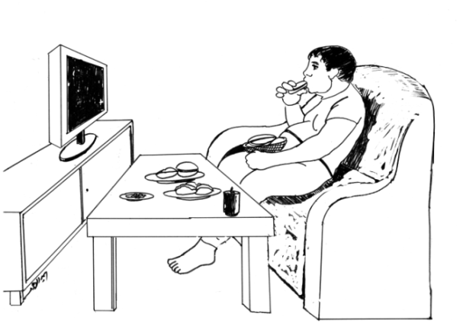 (5 sentences, each sentence worth 1 mark - total of 5 marks)
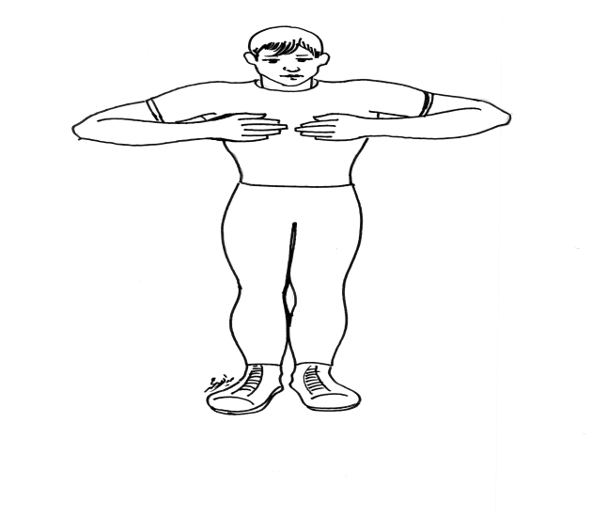

Write five sentences (two simple and three compound) describing the pictures below.
- ____________________________________________________________________________
- ____________________________________________________________________________
- ____________________________________________________________________________
- ____________________________________________________________________________
- ____________________________________________________________________________
A.2. Essay Writing (15 marks)
Directions
Write an essay of 200 words about the following topic.
A friend of yours wants to lead a healthy lifestyle.
He / She does not know how and where to start.
Write an essay in which you advise your friend how to lead a healthy lifestyle.
- You can include factors like exercise, healthy food and rest.
- You can also mention unhealthy habits such as smoking, not enough sleep and junk food that should be avoided.
اكتب مقالا من 200 كلمة تنصح صديقك كيف يعيش حياة صحية .
تحدث عن أثر الرياضة و الطعام الصحي.
اذكر أيضا أثر العادات السيئة كالتدخين و عدم الحصول على قسط كاف من الراحة و الأطعمة السريعة.
____________________________________________________________________________________________________________________________________________________________________________________________________________________________________________________________________________________________________________________________________________________________________________________________________________________________________________________________________________________________________________________________________________________________________________________________________________________________________________________________________________________________________________________________________________________________________________________________________________________________________________________________________________________________________________________________________________________________________________________________________________________________________________________________________________________________________________________________________________________________________________________________________________________________________________________________________________________________________________
- This question is made up of only ONE part. يتكون من مقالة فقط B الجزء

Writing (20 marks)

Write a text of about 250 words agreeing or disagreeing with the following statement:
The Ancient World teaches us what we need to know.
Your response should follow the structure of an exposition. It can include one or more than one aspect of each world.
________________________________________________________________________________________________________________________________________________________________________________________________________________________________________________________________________________________________________________________________________________________________________________________________________________________________________________________________________________________________________________________________________________________________________________________________________________________________________________________________________________________________________________________________________________________________________________________________________________________________________________________________________
Good Luck

