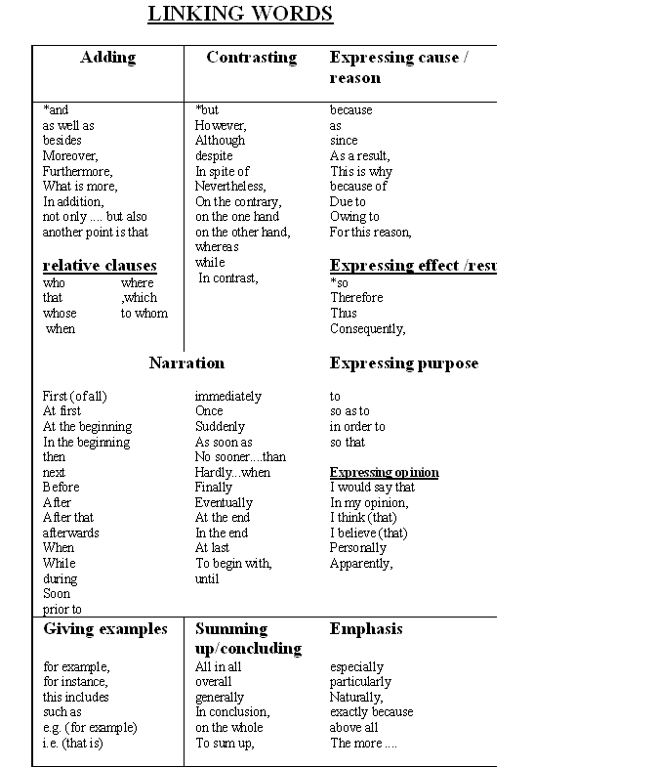

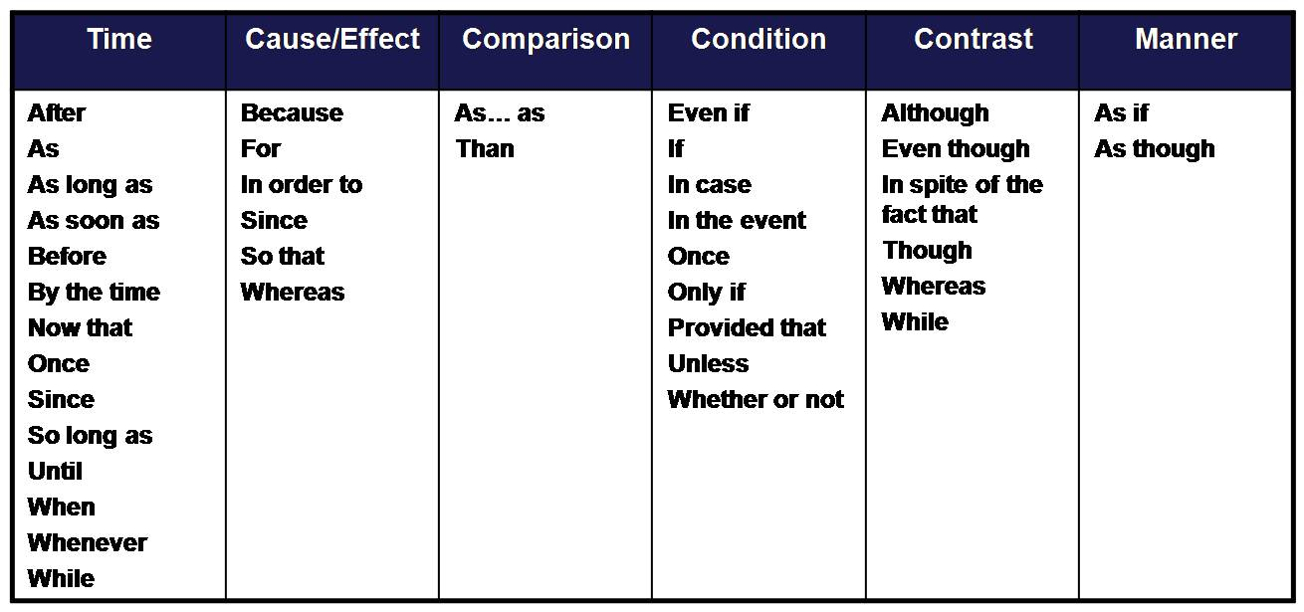

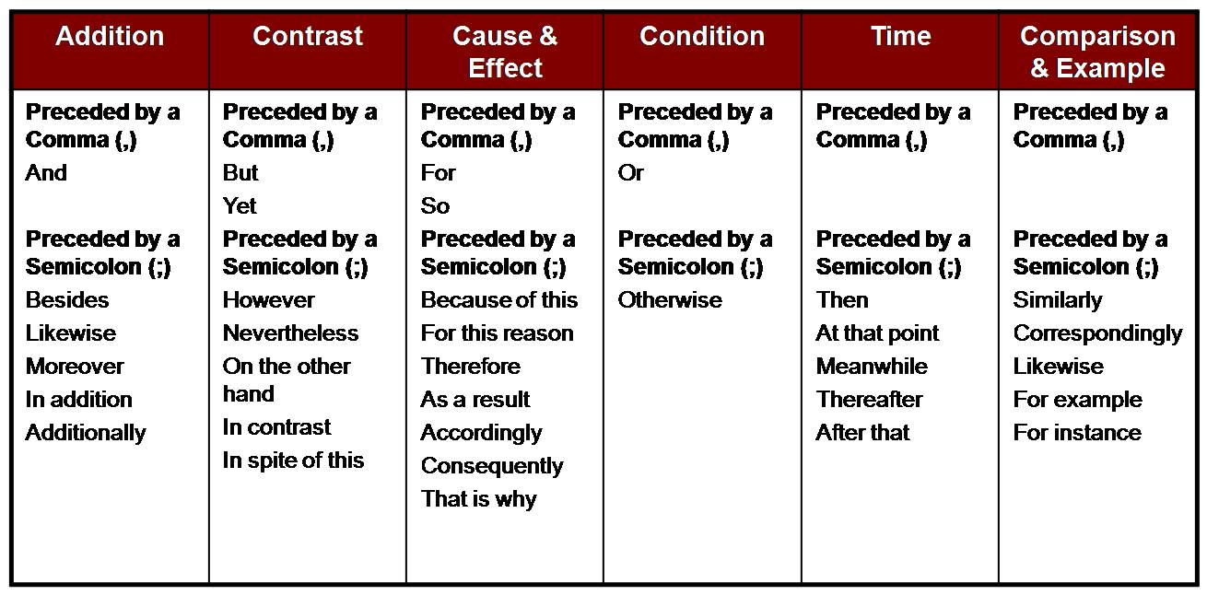

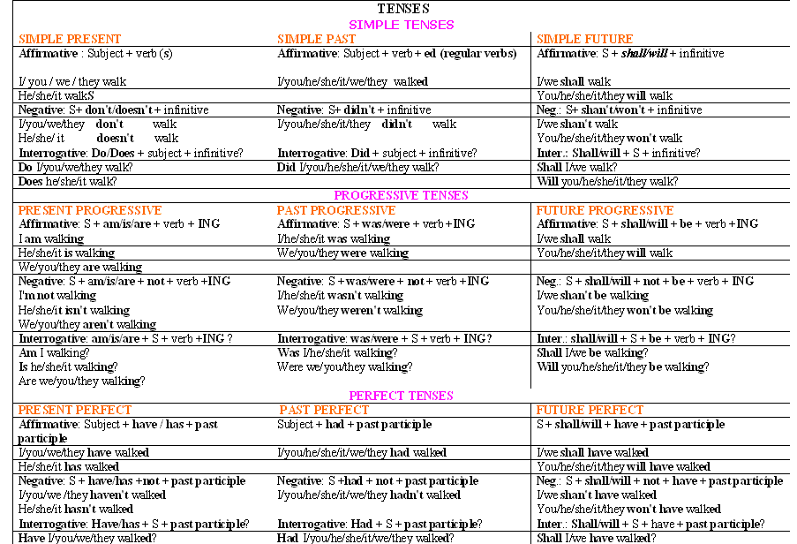

Linking words and phrases

Linking words and phrases Sequence  First, firstly, second, secondly, third, thirdly  next, last, finally  in addition, moreover  furthermore  also  In conclusion, to summarise  The first …  The/a second….  One…..  Another …..  An additional….  Addition  In addition  Furthermore  Also  and  as well as | Cause  For  because  since  as  because of  to cause  Effect  So  as a result  as a consequence  therefore  thus  consequently  hence  to result from  due to  as a result/consequence of  to result in  to affect | Emphasis  Undoubtedly  Indeed  Obviously  Generally  Admittedly  In theory/fact  Particularly  Especially  Clearly
Comparison  Similarly  Likewise  Also  Too  as  just as  and  like  just like  similar to  be similar to/ the same as  be alike  not only…but also  to compare to/with | Contrast  However  Nevertheless  Nonetheless  Still  Although, Even though, though  but  yet  Despite , In spite of  In contrast, In comparison  While, whereas  On the other hand  On the contrary  But | Example  For example  For instance  That is  Such as  Including  Namely

http://www.dlsweb.rmit.edu.au/lsu/content/4_WritingSkills/09linkingwords.htm#

http://www.flinders.edu.au/shadomx/apps/fms/fmsdownload.cfm?file_uuid=565C036F-D131-8865-5534-76353409B290&siteName=flinders

http://www.uni-klu.ac.at/hlg/sber/downloads/linking_words.pdf

