Kangaroo Island is one of Australia's best-kept secrets. While lots of people overseas sing its praises -- it was ranked the Best Island in the Asia Pacific region in the U.S. magazine National Geographic Traveler in late 2007 and was also voted Best Australian Experience by 8,500 North American travel agents at the industry's 2007 Opal Awards -- it's a place that seems to have slipped under the radar of many Australians. (When they consider an island holiday, they tend to automatically think tropical sun, sand, and sea and head to the Northern Queensland islands.) Which is a shame, because KI, as the locals call their island home, is the best place Down Under to see Australian marsupials in the wild.
Close to half of the island is either natural bushland or national park; and according to the boffins, who count these type of things, it is home to 4,000 penguins, 6,000 fur seals, 600 rare Australian sea lions, 5,000 koalas, 15,000 kangaroos, 254 species of birdlife, and somewhere between 500,000 and 1 million tammar wallabies, thanks largely to an environment free of introduced foxes or rabbits, who prey on the native inhabitants or their environment. While the animals are what most people come to see, the scenery is also spectacular. Think rugged coastal cliffs with startling rock formations, rolling pasture-clad hills, dense eucalypt forests, gorgeous beaches, caves, lagoons, and black-water swamps.
The island's history is a harsh one. Aborigines inhabited KI as early as 10,000 years ago but abandoned it for unexplained reasons. In the 19th century, pirates, mutineers, deserters from English, French, and American ships, and escaped convicts from the eastern colonies settled here. Sealers also arrived and devastated the seal and sea lion population: In just 1 year, from 1803 to 1804, they killed more than 20,000 animals. Between 1802 and 1836, Aboriginal women from both the mainland and Tasmania were kidnapped, brought to Kangaroo Island, and forced to work catching and skinning seals, kangaroos, and wallabies, and lugging salt from the salt mines.
In 1836, Kangaroo Island became the first place in South Australia to be officially settled. The state's capital was Kingscote (which was abandoned a couple of years later in favor of Adelaide). In spite of its early settlement, Kangaroo Island had very few residents until after World War II, when returning soldiers set up farms here. Today, more than a million sheep are raised on the island. The island also acts as an official bee sanctuary to protect the genetic purity of the Ligurian bee, introduced in 1881; it is believed to be the only place in the world where this strain of bee survives.

The word kangaroo derives from the Guugu Yimithirr word gangurru, referring to a grey kangaroo. The name was first recorded as "Kangooroo or Kanguru" on 4 August 1770, by Lieutenant (later Captain) James Cook on the banks of the Endeavour River at the site of modern Cooktown, when HM Bark Endeavour was beached for almost seven weeks to repair damage sustained on the Great Barrier Reef. Guugu Yimithirr is the language of the people of the area.
A common myth about the kangaroo's English name is that "kangaroo" was a Guugu Yimithirr phrase for "I don't understand you." According to this legend, Lieutenant Cook and naturalist Sir Joseph Banks were exploring the area when they happened upon the animal. They asked a nearby local what the creatures were called. The local responded "Kangaroo", meaning "I don't understand you", which Cook took to be the name of the creature. The Kangaroo myth was debunked in the 1970s by linguist John B. Haviland in his research with the Guugu Yimithirr people.
Male kangaroos are called bucks, boomers, jacks, or old men; females are does, flyers, or jills, and the young ones are joeys. The collective noun for kangaroos is a mob, troop, or court. Mobs usually have 10 or more kangaroos in them. Living in mobs provides protection for some of the weaker members of the group . Kangaroos are often colloquially referred to as roos

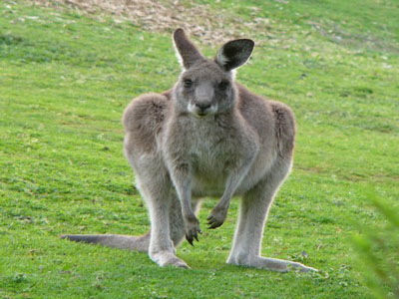
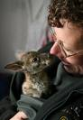

There are four species that are commonly referred to as kangaroos:
- The Red Kangaroo (Macropus rufus) is the largest surviving marsupial anywhere in the world. Fewer in numbers, the Red Kangaroo occupies the arid and semi-arid centre of the country. A large male can be 2 metres (6 ft 7 in) tall and weigh 90 kg (200 lb).^{[14]}
- The Eastern Grey Kangaroo (Macropus giganteus) is less well-known than the red (outside of Australia), but the most often seen, as its range covers the fertile eastern part of the country.
- The Western Grey Kangaroo (Macropus fuliginosus) is slightly smaller again at about 54 kg (119 lb) for a large male. It is found in the southern part of Western Australia, South Australia near the coast, and the Darling River basin.
- The Antilopine Kangaroo (Macropus antilopinus) is, essentially, the far-northern equivalent of the Eastern and Western Grey Kangaroos. Like them, it is a creature of the grassy plains and woodlands, and gregarious.
In addition, there are about 50 smaller macropods closely related to the kangaroo in the family Macropodidae
Europeans have long regarded kangaroos as strange animals. Early explorers described them as creatures that had heads like deer (without antlers), stood upright like men, and hopped like frogs. Combined with the two-headed appearance of a mother kangaroo, this led many back home to dismiss them as travellers' tales for quite some time.^{[citation needed]} The first kangaroo to be exhibited in the western world was an example shot by John Gore, an officer on Captain Cook's Endeavour in 1770.^{[15][16]} The animal was shot and its skin and skull transported back to England whereupon it was stuffed (by taxidermists who had never seen the animal before) and displayed to the general public as a curiosity.
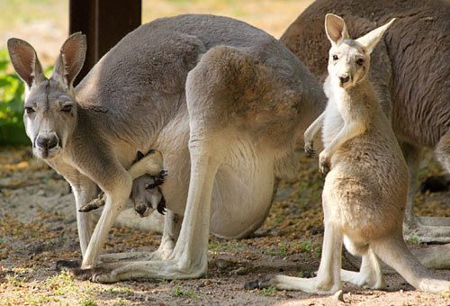
Kangaroos have large, powerful hind legs, large feet adapted for leaping, a long muscular tail for balance, and a small head. Like all marsupials, female kangaroos have a pouch called a marsupium in which joeys complete postnatal development
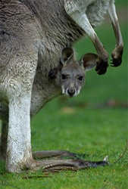

Kangaroos are the only large animals to use hopping as a means of locomotion. The comfortable hopping speed for Red Kangaroo is about 20–25 km/h (13–16 mph), but speeds of up to 70 km/h (44 mph) can be attained, over short distances, while it can sustain a speed of 40 km/h (25 mph) for nearly two kilometres. This fast and energy-efficient method of travel has evolved because of the need to regularly cover large distances in search of food and water, rather than the need to escape predators.^{[citation needed]} To move at slow speeds, it uses its tail to form a tripod with its two forelimbs it then raises its hind feet forward.
The average life expectancy of a kangaroo is about 4–6 years.

The kangaroo has always been a very important animal for Australian Aborigines, for its meat, hide, bone and tendon. Kangaroo hides were also sometimes used for recreation, in particular there are accounts of some tribes (Kurnai) using stuffed kangaroo scrotum as a ball for the traditional football game of marngrook. In addition, there were important Dreaming stories and ceremonies involving the kangaroo. Aherrenge is a current kangaroo dreaming site in the Northern Territory.
Unlike many of the smaller macropods, kangaroos have fared well since European settlement. European settlers cut down forests to create vast grasslands for sheep and cattle grazing, added stock watering points in arid areas, and have substantially reduced the number of dingoes.
Kangaroos are shy and retiring by nature, and in normal circumstances present no threat to humans. Male kangaroos often "box" amongst each other, playfully, for dominance, or in competition for mates. The dexterity of their forepaws is used in both punching and grappling with the foe, but the real danger lies in a serious kick with the hindleg. The sharpened hind claws can disembowel an opponent.
There are very few records of kangaroos attacking humans without provocation; however, several such unprovoked attacks in 2004 spurred fears of a rabies-like disease possibly affecting the marsupials. The only reliably documented case of a fatality from a kangaroo attack occurred in New South Wales, in 1936. A hunter was killed when he tried to rescue his two dogs from a heated fray. Other suggested causes for erratic and dangerous kangaroo behaviour include extreme thirst and hunger.
In 2003, Lulu, an Eastern Grey, saved a farmer's life by alerting family members to his location when he was injured by a falling treebranch. She received the RSPCA National Animal Valor Award on 19 May 2004.

Kangaroo harvesting is a well regulated activity with strict controls to ensure the animal welfare outcomes are as humane as possible. In fact the RSPCA is on record as suggesting that kangaroo harvesting could be one of the most humane slaughter methods possible. They note kangaroos are killed by a high powered bullet to the head in their own environment without any of the stress of trucking, food deprivation etc. involved in beef or lamb slaughter.
Against this is simply the poorly informed, emotive opinion of people who are opposed to any form of animal use. Unfortunately these well meaning people are often so passionate about their position that they clutch to and misrepresent anything which they think may strengthen their case.

- http://en.wikipedia.org/wiki/Kangaroo
- http://animals.nationalgeographic.com/animals/mammals/red-kangaroo/
- http://www.hmammaroc.com/t324-topic

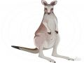
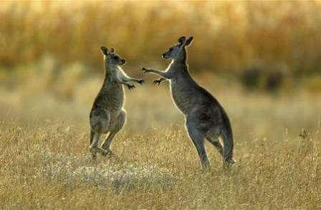


United Arab Emiratea
Ministry of Education
Fujairah Education Zone
Diba Al Fujairah Condary School
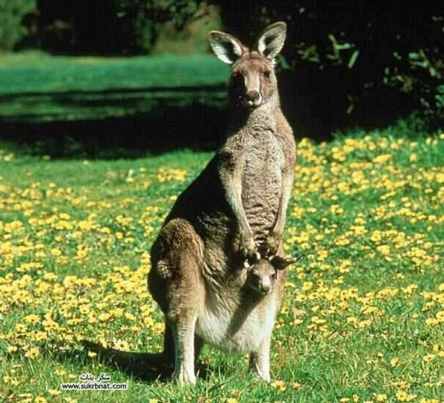

Presented by student:
Undersuper vision of: T.
Grade
2010-2011

