- Definitions:
Molecular substances: a substance that has atoms held together by covalent rather than bonds.
Distillation: the method of separating substances in a mixture by evaporation of a liquid and subsequent condensation of its vapor.
Molecular element: a molecule formed when atoms of the same element bond together.
Allotrope: any of two or more molecules of a single element that have different crystalline or molecular structures.
Organic compound: a compound that contains carbon, a few exceptions exist.
Inorganic compound: a compound that does not contain carbon.
Molecules of water | Prefix
1 | Mono-
2 | Di-
3 | Tri-
4 | Tetra-
5 | Penta-
6 | Hexa-
7 | Hepta-
8 | Octa-
9 | Nona-
10 | Deca-
Hydrocarbon: an organic compound that consists of only hydrogen and carbon.

Formula  Acids common name | Name
HCl | Hydrochloric acid
$$H_{2}SO_{4}$$ | Sulfuric acid

Formula  Bases common name | Name
NaOH | Sodium hydroxide
$${NH}_{3}$$ | Sulfuric acid

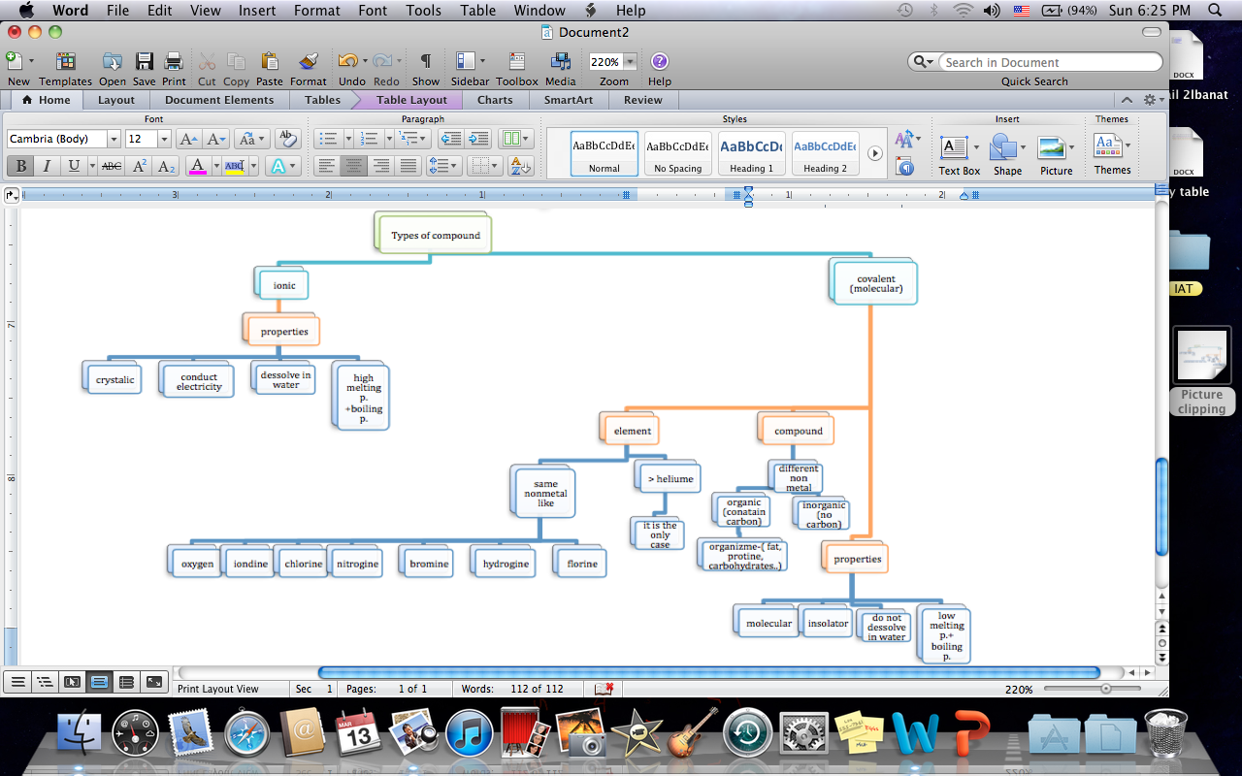
How To Name Binary Compounds:

- 1st: The Prefix.
- 2nd: The Whole First Element Name (symbol).
- 3rd: Again the prefix + Half The Element + Add – Ide –.

Note: If The First Element Has Only One Prefix (Do Not) Write The Prefixes (Mono) But The Second Element The Prefixes Must Be Written.

