5.1:
- Definitions:
- Ion: an atom or a group of combined atoms that have charge because of loss or gain of electrons.
- Binary compound: a compound that contains only two elements.
- Formula unite: the simplest ratio of ions in a compound.
- Oxidation number: the charge on an ion or an element; can be positive or negative.
- Polyatomic ion: an ion that consists of two or more different elements.
- Hydrate: a compound in which there is specific ratio of water to ionic compound.
- Hygroscopic: a substance that absorbs water molecules from the air to become hydrate.
- Deliquescent: a substance that takes up enough water from the air that it dissolves completely to a liquid solution.
- Anhydrous: a compound in which all water has been removed, usually by heating.
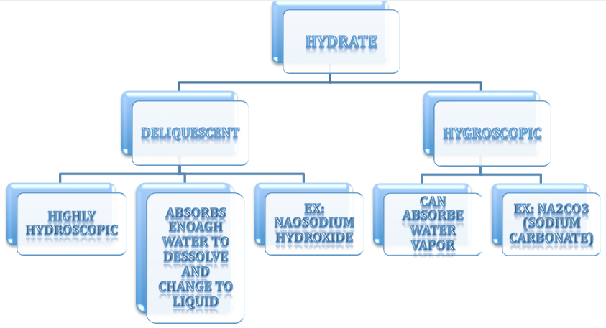
- Writing the formula:
- Binary / or 3 elements: 1st Write the symbol of the two elements. 2nd write the charge on the elements. 3rd balance the charges because ionic compounds are neutral.
Example 1: sodium oxide
$Na^{+1}$ $O^{-2}$
2 1
$$Na_{2}O$$
- Analyzing ex1: sodium is in group 1 so its oxidation no. is 1+ oxygen is in group 16 so its oxidation no. is 2-. Then we started to balance. To check if the formula is correct the overall charge or the formula should be zero.
$2\left(1+\right)+ \left(2-\right)=0$ So our formula is correct.
- Naming the formula:
- Ionic compound with binary elements: 1st write the name of the first element. 2nd write the root (half)name of the second element. 3rd add –ide-.
- Example: NaCl >> sodium chloride
- Ionic compound with 3 elements: 1st write the name of the first element. 2nd write the name of the polyatomic ion –table page 159-.
- Example: $MgCO_{3}$ >> magnesium carbonate.

3.important to understand:
- Hydrates are ionic compounds bonded to water molecules. They are named by following the name of the compound with a prefix attached to the word hydrate to indicate how many water molecules are bound.
- The position of an element in the periodic table indicates what charge its ions will have.
- Prefixes to use in naming hydrates:
Molecules of water | Prefix
1 | Mono-
2 | Di-
3 | Tri-
4 | Tetra-
5 | Penta-
6 | Hexa-
7 | Hepta-
8 | Octa-
9 | Nona-
10 | Deca-

_________________

