Answer key sec3.1
Question1
Choose the correct answer
1. The change is velocity over a certain time interval divided by this time interval is defined as
 | A. | Average velocity
 | B. | Instantaneous acceleration
 | C. | Average acceleration
 | D. | Instantaneous velocity
2. What is the unit of acceleration?
 | A. | m/s
 | B. | m
 | C. | m/s2
 | D. | S²
3. If an object is moving in uniform motion, the velocity is
 | A. | positive
 | B. | constant
 | C. | zero
 | D. | negative
4. If an object speeds up in the positive direction, what would be the signs of acceleration and velocity?
 | A. | a(+), v(-)
 | B. | a(+),v(+)
 | C. | a(-),v(-)
 | D. | a(-),v(+)
5. Is acceleration a vector quantity?
 | A. | Yes it is
 | B. | No it is not
 | C. | Sometimes it is
 | D. | It depends in which direction the object is moving
6. The slope of the tangent line on a v-t graph is the
 | A. | Displacement
 | B. | Velocity
 | C. | Average acceleration
 | D. | Instantaneous acceleration
7. In a linear relation, the slope of a v-t graph represents
 | A. | Instantaneous acceleration
 | B. | Average velocity
 | C. | Instantaneous velocity
 | D. | Average acceleration
8. When acceleration and velocity vectors are pointing in opposite directions, the object is
 | A. | Moving at constant speed
 | B. | Not moving
 | C. | Speeding up
 | D. | Slowing down

9. A graph that shows how velocity is related to time is called
 | A. | x-t graph
 | B. | a-t graph
 | C. | v-t graph
 | D. | v-a graph
10. If an object moves at constant speed, its v-t graph will be
 | A. | A vertical line
 | B. | A horizontal line
 | C. | An increasing slope line
 | D. | A decreasing slope line
11. In a v-t graph, the dependent variable is
 | A. | Time
 | B. | Velocity
 | C. | Acceleration
 | D. | Average acceleration
12. 100Km/hr equals to ___________
 | A. | 20m/s
 | B. | 600m/s
 | C. | 27.7m/s
 | D. | 360m/s

13. If the acceleration of a moving object is constant, its velocity will
 | A. | Be constant as well
 | B. | Be Zero
 | C. | increase or decrease at constant rate
 | D. | Can’t be determined
14. The v-t graph can be used to determine
 | A. | Velocity only
 | B. | Velocity and displacement only
 | C. | Average acceleration, velocity and displacement only
 | D. | Acceleration and displacement only
15. If a runner accelerates from 2m/s to 3m/s in 4s, her average accelearation is
 | A. | 4m/s²
 | B. | 2.5m/s²
 | C. | 0.25m/s2
 | D. | 0.4m/s²
16. The relation between a_{av}, v_{f}, v_{i} and t can be written as:
A.
B.
C.
D.

Refer to the graph to answer questions 17,18,19
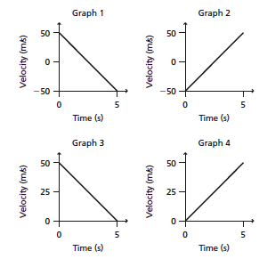
17. Which graph shows an airplane starting from rest and then moving on a runway?
 | A. | 1
 | B. | 2
 | C. | 3
 | D. | 4
18. Which graph shows an object moving backward then forward?
 | A. | 1
 | B. | 2
 | C. | 3
 | D. | 4

19. Which graph shows an object that stops completely?
 | A. | 1
 | B. | 2
 | C. | 3
 | D. | 4
20.
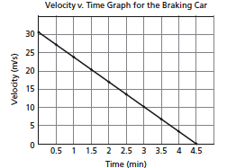
What is the displacement of the car from 0s to 4.5s?
 | A. | 6.66m
 | B. | 30m
 | C. | 67.5m
 | D. | 135m

Question2
1-
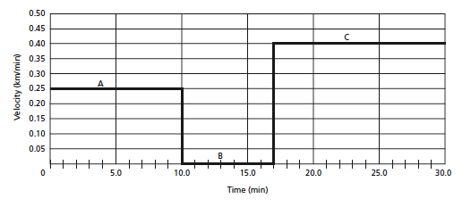

What is the independent variable? ________time__________
What is the dependent variable? __________velocity_________
What is the unit of velocity? ______________km/min________
What is the unit of time? _________________min_______
What is the velocity of the object at t=5min? _____0.25km/min_______
At what time interval the object has a velocity of 0.4km/min?_from 17 t0 30_min_____
What is the type of motion between 0min and 10min? ____Uniform motion__________
What is the type of motion between 10min and 17min?___object at rest___________
Is this object moving forward or backward? ____forward (velocity is positive)___________________

2-
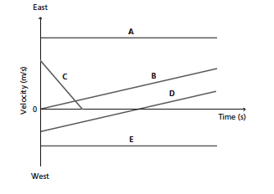
Which object starts from rest? ______B_________
Which object(s) moving at constant velocity? ______A and E_______
Is the average acceleration of B positive or negative? _____positive__________
Which one has a greater acceleration B or C? ____________C__________
Which object is moving backward then forward? ________D___________
Which object comes to a complete stop?__________C_____
Which object(s) are moving backward only? ______E______
Which object (s) has(ve) a negative acceleration? ______C______
Which object(s) has a zero acceleration? __________A and E_________

3-
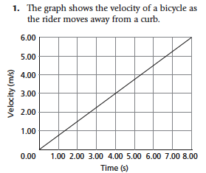

What is the slope of the line? _______0.75 m/s²__________
What does the slope represent? ______acceleration_________
What is the velocity at time 5 seconds? ____3.8 m/s_________
At what time the velocity reaches 3m/s? _____4 seconds________
Is this object moving in the positive or negative direction? _____positive______
What is the type of motion? Uniform motion or uniform accelerated motion? ____uniform accelerated motion____________
If the object continues at this rate, at what time the object will reach a velocity of 20m/s? _______use V_{f}=V_{i}+at and solve it for t answer is 26.67 sec_____________

Question3
Solve the following problems
- A car brakes from 25m/s to 16m/s in 2 seconds. What is its acceleration?
Use $a=\frac{v_{f}-v_{i}}{∆t}=\frac{16-25}{2}=\frac{-9}{2}=-4.5m/s^{2}$
- A jogger runs at a speed of 5m/s then speeds up to run at 8m/s in 0.5 seconds. What is the acceleration of the jogger?
$$a=\frac{v_{f}-v_{i}}{∆t}$$

- A truck moves at a velocity of 30m/s. The driver suddenly sees a car in front and applies the brakes till the truck comes to a stop in 6 seconds. What is the acceleration of the truck?
Use
$a=\frac{v_{f}-v_{i}}{∆t}$ to find a

- A car starts from rest then moves at a constant rate of 2m/s² for 20 seconds. What is the final velocity of the car?
Given:
V_{i}=0 , a=2m/s² , Δt=20 sec
Use $v_{f}=v_{i}+a∆t$ to find v_{f}

5- A ball is kicked up a hill at a speed of 4m/s, it took the ball 5 seconds to reach the top of the hill before starting to roll down. What is the average acceleration of the ball as it reaches the top of the hill?
Given:
v_{i}=4m/s, Δt=5 sec
At the top of the hill v_{f}=0,
Use
$a=\frac{v_{f}-v_{i}}{∆t}$ to find a

Question4
Answer the following questions
- What is average acceleration?
The change of velocity per unit time or the rate of change of velocity

- What is instantaneous acceleration?
The rate of change of velocity at a certain moment

- What is meant by uniform accelerated motion?
The acceleration that has a constant value.( the velocity increases or decreases uniformly).

- What is the difference between average velocity and average acceleration?
Average velocity is the change of position per unit time
Average acceleration is the change of velocity per unit time

5. If the acceleration is negative, the object is not necessarily slowing down. Explain.
The object must be moving in the negative direction

