Question1
Choose the correct answer
1. The change is velocity over a certain time interval divided by this time interval is defined as
 | A. | Average velocity
 | B. | Instantaneous acceleration
 | C. | Average acceleration
 | D. | Instantaneous velocity
2. What is the unit of acceleration?
 | A. | m/s
 | B. | m
 | C. | m/s²
 | D. | S²
3. If an object is moving in uniform motion, the velocity is
 | A. | positive
 | B. | constant
 | C. | zero
 | D. | negative
4. If an object speeds up in the positive direction, what would be the signs of acceleration and velocity?
 | A. | a(+), v(-)
 | B. | a(+),v(+)
 | C. | a(-),v(-)
 | D. | a(-),v(+)
5. Is acceleration a vector quantity?
 | A. | Yes it is
 | B. | No it is not
 | C. | Sometimes it is
 | D. | It depends in which direction the object is moving
6. The slope of the tangent line on a v-t graph is the
 | A. | Displacement
 | B. | Velocity
 | C. | Average acceleration
 | D. | Instantaneous acceleration
7. In a linear relation, the slope of a v-t graph represents
 | A. | Instantaneous acceleration
 | B. | Average velocity
 | C. | Instantaneous velocity
 | D. | Average acceleration
8. When acceleration and velocity vectors are pointing in opposite directions, the object is
 | A. | Moving at constant speed
 | B. | Not moving
 | C. | Speeding up
 | D. | Slowing down

9. A graph that shows how velocity is related to time is called
 | A. | x-t graph
 | B. | a-t graph
 | C. | v-t graph
 | D. | v-a graph
10. If an object moves at constant speed, its v-t graph will be
 | A. | A vertical line
 | B. | A horizontal line
 | C. | An increasing slope line
 | D. | A decreasing slope line
11. In a v-t graph, the dependent variable is
 | A. | Time
 | B. | Velocity
 | C. | Acceleration
 | D. | Average acceleration
12. 100Km/hr equals to ___________
 | A. | 20m/s
 | B. | 600m/s
 | C. | 27.7m/s
 | D. | 360m/s

13. If the acceleration of a moving object is constant, its velocity will
 | A. | Be constant as well
 | B. | Be Zero
 | C. | increase or decrease at constant rate
 | D. | Can’t be determined
14. The v-t graph can be used to determine
 | A. | Velocity only
 | B. | Velocity and displacement only
 | C. | Average acceleration, velocity and displacement only
 | D. | Acceleration and displacement only
15. If a runner accelerates from 2m/s to 3m/s in 4s, her average accelearation is
 | A. | 4m/s²
 | B. | 2.5m/s²
 | C. | 0.25m/s²
 | D. | 0.4m/s²
16. The relation between a_{av}, v_{f}, v_{i} and t can be written as:
A.
B.
C.
D.

Refer to the graph to answer questions 17,18,19
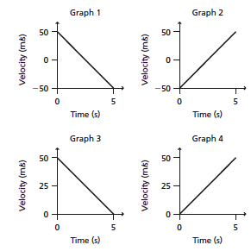
17. Which graph shows an airplane starting from rest and then moving on a runway?
 | A. | 1
 | B. | 2
 | C. | 3
 | D. | 4
18. Which graph shows an object moving backward then forward?
 | A. | 1
 | B. | 2
 | C. | 3
 | D. | 4

19. Which graph shows an object that stops completely?
 | A. | 1
 | B. | 2
 | C. | 3
 | D. | 4
20.
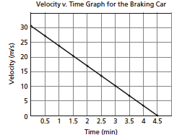
What is the displacement of the car from 0s to 4.5s?
 | A. | 6.66m
 | B. | 30m
 | C. | 67.5m
 | D. | 135m

Question2
1-
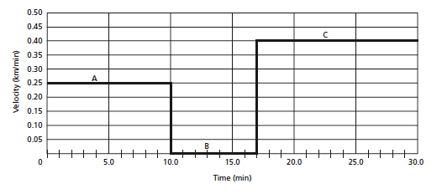

What is the independent variable? __________________
What is the dependent variable? ___________________
What is the unit of velocity? ______________________
What is the unit of time? ________________________
What is the velocity of the object at t=5min? ____________
At what time interval the object has a velocity of 0.4km/min?_________
What is the type of motion between 0min and 10min? ______________
What is the type of motion between 10min and 17min?______________
Is this object moving forward or backward? _______________________

2-
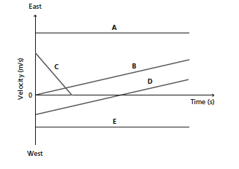
Which object starts from rest? _______________
Which object(s) moving at constant velocity? _____________
Is the average acceleration of B positive or negative? _______________
Which one has a greater acceleration B or C? ______________________
Which object is moving backward then forward? ___________________
Which object comes to a complete stop?_______________
Which object(s) are moving backward only? ____________
Which object (s) has(ve) a negative acceleration? ____________
Which object(s) has a zero acceleration? ___________________

3-
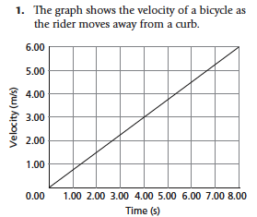

What is the slope of the line? _________________
What does the slope represent? _______________
What is the velocity at time 5 seconds? _____________
At what time the velocity reaches 3m/s? _____________
Is this object moving in the positive or negative direction? ___________
What is the type of motion? Uniform motion or uniform accelerated motion? ________________
If the object continues at this rate, at what time the object will reach a velocity of 20m/s? ____________________

Question3
Solve the following problems
- A car brakes from 25m/s to 16m/s in 2 seconds. What is its acceleration?

- A jogger runs at a speed of 5m/s then speeds up to run at 8m/s in 0.5 seconds. What is the acceleration of the jogger?

- A truck moves at a velocity of 30m/s. The driver suddenly sees a car in front and applies the brakes till the truck comes to a stop in 6 seconds. What is the acceleration of the truck?

- A car starts from rest then moves at a constant rate of 2m/s² for 20 seconds. What is the final velocity of the car?

5- A ball is kicked up a hill at a speed of 4m/s, it took the ball 5 seconds to reach the top of the hill before starting to roll down. What is the average acceleration of the ball as it reaches the top of the hill?

Question4
Answer the following questions
- What is average acceleration?

- What is instantaneous acceleration?

- What is meant by uniform accelerated motion?

- What is the difference between average velocity and average acceleration?

5. If the acceleration is negative, the object is not necessarily slowing down. Explain.

