Multiple Choice
Identify the choice that best completes the statement or answers the question.

____ 1. Microsoft Office Access can best be described as ____ software.
a. | Spreadsheet | c. | Database
b. | Presentation | d. | Systems

____ 2. A specific category of data such as a customer's name, city, state, or phone number is called a(n) ____.
a. | Object | c. | Field
b. | Record | d. | Table

____ 3. A group of related fields, such as all the demographic information for one customer, is called a(n) ____.
a. | Record | c. | Database
b. | Table | d. | Object

____ 4. A collection of records for a single subject, such as all of the customer records, is called a(n) ____.
a. | Table | c. | Element
b. | Control | d. | Object

____ 5. Tables, queries, and modules are examples of Access ____.
a. | Entities | c. | Values
b. | Objects | d. | Controls

____ 6. The term ____ database comes from the fact that two or more tables are linked by a common field.
a. | Hierarchical | c. | Schematic
b. | Network | d. | Relational

____ 7. This Access object provides an easy-to-use data entry screen.
a. | Macro | c. | Table
b. | Form | d. | Module

____ 8. Which of the following is not a Data Type?
a. | Number | c. | Date/Time
b. | Formula | d. | Text

____ 9. A(n) ____ is a collection of tables associated with a general topic such as sales of products to customers.
a. | Database | c. | Record
b. | Field | d. | Object

____ 10. In Navigation mode, press [Tab] or this keystroke to move to the next field within the same record.
a. | [End] | c. | [Down Arrow]
b. | [Page Down] | d. | [Enter]

____ 11. Press this keystroke combination to move focus to the last field of the last record.
a. | [Alt][Ctrl][Up Arrow] | c. | [Ctrl][End]
b. | [Ctrl][Up Arrow] | d. | [Ctrl][Page Up]

____ 12. In a datasheet, which mode assumes that you are trying to change the value of a particular field?
a. | Edit mode | c. | Update mode
b. | Navigation mode | d. | Form mode

____ 13. Which shortcut key moves focus to the previous field of the current record?
a. | [Home] | c. | [Up Arrow]
b. | [Shift][Tab] | d. | [F5]

____ 14. Which shortcut key moves focus to the first field of the current record?
a. | [Home] | c. | [F4]
b. | [End] | d. | [F5]

____ 15. While editing a record, pressing [Esc] a second time ____.
a. | Deletes the current field
b. | Deletes the current datasheet
c. | Removes all data from the current record
d. | Removes all changes made to the record you are currently editing

____ 16. Which of the following keys will help you delete unwanted data in Edit mode?
a. | [Insert] | c. | [Ctrl]
b. | [Home] | d. | [Backspace]

____ 17. Which editing keystroke deletes one character to the right of the insertion point?
a. | [Backspace] | c. | [F2]
b. | [Delete] | d. | [F7]

____ 18. Which data type stores only one of two values?
a. | OLE object | c. | Yes/No
b. | Hyperlink | d. | Null

____ 19. Which data type stores Web addresses?
a. | Lookup Wizard | c. | www address
b. | Hyperlink | d. | HTML

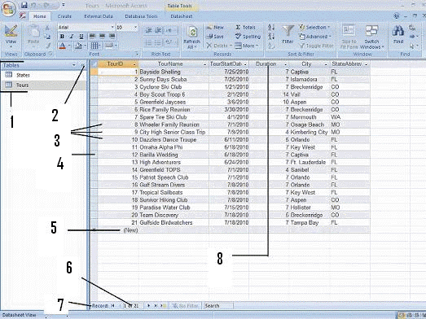

____ 20. Item 7 in the figure above is the:
a. | Record selector box | c. | Navigation pane
b. | Navigation bar | d. | Focus

____ 21. Item 8 in the figure above is:
a. | The date/time | c. | A field name
b. | A record | d. | The focus

____ 22. Item 5 in the figure above is:
a. | Where a new record would be entered | c. | A field name
b. | Where a new field would be entered | d. | The navigation pane

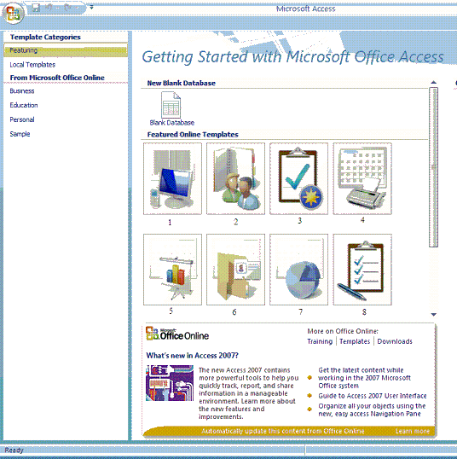

____ 23. In the figure above, template 8 is an example of:
a. | Tasks | c. | Issues
b. | Events | d. | Assets

Complete each statement from the following words

(one-to-many, Database, Autonumber, datasheet, two, relational, design)

24. ____________________ software is used to manage data that can be organized into lists of related information such as customers, products, vendors, employees, projects, or sales.

25. An Access database is able to store any number of records up to ____________________ gigabytes.

26. A(n) ____________________ relationship describes when a record from one table is related to several records in another table.

27. The ____________________ View is used to modify and define field properties that are not available in Datasheet View.

28. An Access database is called a(n) ____________________ database because more than one table can share information through a common linked field.

29. A(n) ____________________ is a spreadsheet-like grid that displays a table's fields and records.

30. A(n) ____________________ field automatically assigns a new number each time you add a record.

Answer Section

MULTIPLE CHOICE

1. ANS: C

2. ANS: C

3. ANS: A

4. ANS: A

5. ANS: B

6. ANS: D

7. ANS: B

8. ANS: B

9. ANS: A

10. ANS: D

11. ANS: C

12. ANS: A

13. ANS: B

14. ANS: A

15. ANS: D

16. ANS: D

17. ANS: B

18. ANS: C

19. ANS: B

20. ANS: B

21. ANS: C

22. ANS: A

23. ANS: A

COMPLETION

24. ANS: Database

25. ANS: two

26. ANS: one to many

27. ANS: Design

28. ANS: relational

29. ANS: datasheet

30. ANS: AutoNumber

