IAT/RAK
Computer and Information Technology – G10
Academic Year (2010/2011)
First Semester LC3
Solved Quizzes and Worksheets
Lesson 12

Multiple Choice
Identify the choice that best completes the statement or answers the question.

____ 1. Excel refers to a spreadsheet as a ____.
a. | spreadsheet | c. | Workbook
b. | worksheet | d. | Range

____ 2. ____ of the worksheet appear vertically and are identified by letters at the top of the worksheet window.
a. | Columns | c. | Cells
b. | Rows | d. | Headings

____ 3. A1 and B4 are examples of ____.
a. | column headings | c. | cell references
b. | row headings | d. | Ranges

____ 4. When a cell is selected, it is called the ____.
a. | worksheet | c. | active cell
b. | range | d. | cell reference

____ 5. The Name box shows the ____.
a. | cell contents | c. | status bar
b. | active cell | d. | formula bar

____ 6. The ____ shows the cell contents.
a. | status bar | c. | cell reference
b. | Name box | d. | formula bar

____ 7. If you enter hte, which feature will automatically change the text to the?
a. | AutoComplete | c. | AutoCorrect
b. | ScreenTip | d. | AutoFill

____ 8. Press the ____ key to move the insertion point to the first cell in a row.
a. | Page Up | c. | Page Down
b. | Home | d. | Tab

____ 9. Which view hides the Ribbon, the formula bar, and the status bar?
a. | Normal | c. | Page Break Preview
b. | Page Layout | d. | Full Screen

____ 10. A1:D4 is an example of a ____.
a. | cell reference | c. | column heading
b. | range | d. | row heading

____ 11. When you enter text in a cell, it also appears in the ____.
a. | status bar | c. | row heading
b. | formula bar | d. | name box

____ 12. The Ribbon, tabs, and command groups are part of the ____.
a. | Quick Access Toolbar | c. | Microsoft Office Fluent user interface
b. | Excel document window | d. | formula bar

FIGURE 17-1

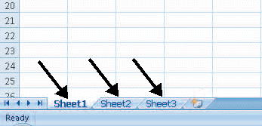

____ 13. The arrows in Figure 17-1 above are pointing to ____.
a. | active cells | c. | Ribbon tabs
b. | cell references | d. | worksheet tabs

FIGURE 17-2

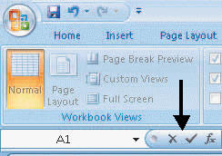

____ 14. What is the arrow pointing to in Figure 17-2 above?
a. | Cancel, Enter, and Insert Function buttons | c. | Status bar
b. | Quick Access Toolbar | d. | Formula bar

Case 17-1
Kristin is new to spreadsheets. She was asked to create a worksheet for her business club’s fundraiser.

____ 15. Kristin is entering data in cells. Why does she see ### in some of the cells?
a. | She entered more numbers than can fit in the cell | c. | She entered eight numbers in the cell
b. | She entered text instead of numbers in the cell | d. | She entered too few numbers in the cell

____ 16. Kristin wants to insert three new columns. What should she do before executing the Insert Sheet Columns command?
a. | Select one column | c. | Select three columns
b. | Select two columns | d. | She doesn’t need to select any columns

Case 17-2
Lino is creating a project schedule for the construction company where he works. He needs to list the tasks that need to be completed each day and show which employees will complete the work.

____ 17. Which feature can Lino use to quickly fill in a series of dates?
a. | AutoCorrect | c. | ScreenTip
b. | AutoComplete | d. | AutoFill

____ 18. What should Lino click to select an entire column so that he can change its formatting?
a. | Row heading | c. | Range
b. | Column heading | d. | Formula bar

Matching

Identify the letter of the choice that best matches the phrase or definition.

a. | AutoFill
b. | AutoComplete
c. | AutoCorrect
d. | AutoFit Column Width
e. | Marquee

____ 19. Compares the first few characters you enter in a cell with existing entries in the same column.

____ 20. Adjusts the column width automatically to fit the cell with the most content.

____ 21. Enables you to repeat the same data in a column or row.

____ 22. An animated border that appears around the selected cell.

____ 23. Corrects common mistakes as you enter data.

Lesson 13

Multiple Choice
Identify the choice that best completes the statement or answers the question.

____ 1. A ____ contains column headings or field names in a data source, such as a table or spreadsheet.
a. | filter | c. | header row
b. | sheet tab | d. | workbook

____ 2. An alternative way to freeze rows and columns is to ____ a worksheet, which divides the worksheet into two panes.
a. | split | c. | unhide
b. | hide | d. | filter

____ 3. When you want to add a new category to an Excel workbook, you click the ____ at the bottom of the screen.
a. | Split box | c. | Zoom settings
b. | Insert Worksheet button | d. | Sheet tab

____ 4. ____ at the bottom of the screen provide quick and easy access to worksheets.
a. | Buttons | c. | Workbooks
b. | Binders | d. | Sheet tabs

____ 5. The ____ allows you to remove the contents and the formatting in a cell.
a. | Delete key | c. | Sort & Filter button
b. | Backspace key | d. | Clear button

____ 6. The ____ button allows you to combine several cells into a single cell.
a. | Clear | c. | Borders
b. | Merge & Center | d. | Wrap Text

____ 7. Which button allows you to align text at an angle within a cell?
a. | Merge & Center | c. | Orientation
b. | Middle Align | d. | Wrap Text

____ 8. If text doesn’t fit on one line, you can use the ____ button to allow all the text to wrap to new lines within the cell.
a. | Clear | c. | Orientation
b. | Merge & Center | d. | Wrap Text

____ 9. Which button can you use to change the number format from .10 to .1 in a cell?
a. | Percent Style | c. | Increase Decimal
b. | Comma Style | d. | Decrease Decimal

____ 10. The ____ command scales the worksheet up or down as necessary so it fits on the number of pages you designate.
a. | Print Area | c. | Orientation
b. | Print Titles | d. | Fit to

____ 11. ____ provide useful information on a printed worksheet and are printed in the top margin of every worksheet page.
a. | Footers | c. | Fields
b. | Headers | d. | Filters

____ 12. Commands for changing print settings are located on the ____ tab.
a. | Page Layout | c. | Insert
b. | View | d. | Home

____ 13. Which option in the Print dialog box enables you to print only selected cells in the active worksheet?
a. | Active sheet | c. | Selection
b. | Entire workbook | d. | Table

____ 14. The ____ button spans text across several columns.
a. | Center | c. | Wrap Text
b. | Orientation | d. | Merge & Center

____ 15. Which button opens the Quick Styles gallery filled with table styles?
a. | Print Area | c. | Format as Table
b. | Convert to Range | d. | Cell styles

FIGURE 18-1

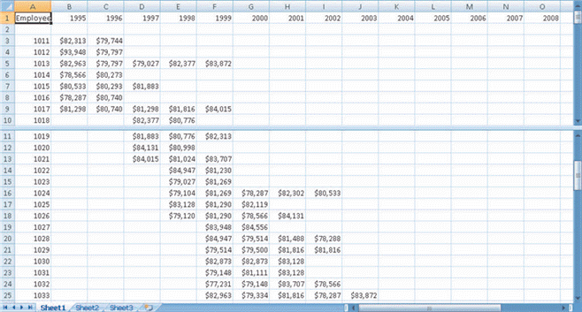

____ 16. What is pictured in Figure 18-1 above?
a. | A worksheet with frozen rows and columns | c. | A worksheet with merged rows and columns
b. | A worksheet with hidden rows and columns | d. | A worksheet split into two panes

FIGURE 18-2

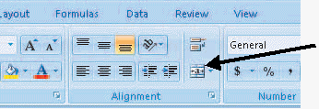

____ 17. Which button is the black arrow pointing to in Figure 18-2 above?
a. | Wrap Text | c. | Orientation
b. | Merge & Center | d. | Sort & Filter

Case 18-1
Martha is a high school math teacher. She has created a worksheet to track her students’ grades. She added two new students to the worksheet today and she wants to make sure the formatting is consistent.

____ 18. Which button should she use to copy the formatting of a cell without copying the contents of the cell?
a. | Format Painter | c. | Paste
b. | Copy | d. | Format

____ 19. Which button should Martha use to add a black line to the bottom of a row of cells that contain the midterm exam grades?
a. | Font | c. | Fill Color
b. | Border | d. | Font Color

Case 18-2
Sam is viewing a very large worksheet that contains product data for the warehouse where he works. He is getting frustrated trying to locate data. He tried splitting the worksheet, but that didn’t help him find what he was looking for.

____ 20. How can Sam remove the dividing line in the split worksheet?
a. | Right-click it | c. | Double-click it
b. | Press the Delete button | d. | Click the Remove Split button

____ 21. Sam has selected a range of cells he wants to freeze. Which option will allow him to freeze panes based on selected cells?
a. | Freeze Panes | c. | Freeze First Column
b. | Freeze Top Row | d. | Selection

Matching

Identify the letter of the choice that best matches the phrase or definition.

a. | Print area command
b. | Print Headings command
c. | Print Gridlines command
d. | Print Titles command
e. | Entire workbook command

____ 22. Prints all worksheets in the workbook.

____ 23. Prints gridlines.

____ 24. Prints row and column headings.

____ 25. Defines a range of cells you select before choosing the Print command.

____ 26. Repeats the printing of specified rows or columns on each page.
Lesson 14

Multiple Choice
Identify the choice that best completes the statement or answers the question.

____ 1. All Excel formulas begin with ____.
a. | $ | c. | SUM
b. | / | d. | =

____ 2. Formulas containing more than one operator are called ____.
a. | mixed cell references | c. | absolute cell references
b. | complex formulas | d. | relative cell references

____ 3. By default, when you create formulas, the cell references are formatted as ____.
a. | absolute cell references | c. | relative cell references
b. | mixed cell references | d. | complex cell references

____ 4. The formula =$A1 is an example of a(n) ____ cell reference.
a. | relative | c. | mixed
b. | absolute | d. | statistical

____ 5. ____ is a mathematical function.
a. | SUM | c. | MAX
b. | AVERAGE | d. | MIN

____ 6. A(n) ____ is a special formula that names a function instead of using operators to calculate a result.
a. | argument | c. | complex formula
b. | range | d. | function formula

____ 7. A ____ is used to separate cell references that are not adjacent.
a. | colon | c. | period
b. | comma | d. | asterisk

____ 8. ____ are often used in summary worksheets to condense and total data from other worksheets.
a. | Mixed cell references | c. | 3-D references
b. | Absolute cell references | d. | Relative cell references

____ 9. A ____ is a graphic representation of your worksheet data.
a. | legend | c. | function
b. | formula | d. | chart

____ 10. A shortcut for entering cell references is to ____.
a. | enter all the cell references | c. | enter a formula
b. | name a range of cells | d. | enter the function name

____ 11. Which of the following chart types does not have a horizontal and a vertical axis?
a. | pie | c. | bar
b. | column | d. | line

____ 12. Which formula will produce a result of 48?
a. | =8+4*4 | c. | =(8+4)*4
b. | =8*4+4 | d. | =8/4-4

____ 13. Which type of cell reference adjusts automatically when copied to another cell?
a. | Relative | c. | Absolute
b. | Mixed | d. | Complex

FIGURE 19-1

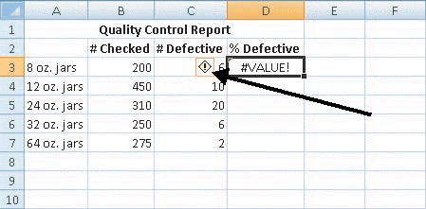

____ 14. What is the arrow pointing to in Figure 19-1 above?
a. | Change Chart Type button | c. | Excel Help button
b. | More button | d. | Error Checking button

FIGURE 19-2

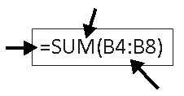

____ 15. Which part of the function formula shown in Figure 19-2 above is the argument?
a. | Equal sign (=) | c. | (B4:B8)
b. | SUM | d. | SUM(B4:B8)

Case 19-1
Macy is the treasurer for a professional organization, and she is compiling the financial data to present to the board members at the next meeting.

____ 16. Macy sees the error #NULL! in a cell of her worksheet. What is likely the problem?
a. | The column is not wide enough | c. | The wrong type of argument or operand is used
b. | Negative data is entered | d. | A space is used where it isn’t appropriate

____ 17. Macy wants to show the organization’s total dollar amount of dues collected in the cells B2 to B40. Which is the correct formula?
a. | =COUNT(B2:B40) | c. | =SUM(B2:B40)
b. | =SUM(B2,B40) | d. | =TOTAL(B2:B40)

Case 19-2
Pablo works as an assistant at a local art gallery. He is completing a worksheet that shows sales for the previous year. Now he wants to create a chart to represent the data.

____ 18. Pablo wants to use only part of the data in a column chart. What should he do first?
a. | Click the Column button | c. | Click the Insert tab
b. | Select the data he wants to use in the chart | d. | Select all the data in the worksheet

____ 19. Pablo decides a bar chart would illustrate the data more effectively. Which button will enable him to choose a new chart?
a. | Move Charts | c. | Data Labels
b. | Legend | d. | Change Chart Type

Matching

Identify the letter of the choice that best matches the phrase or definition.

a. | SUM
b. | AVERAGE
c. | MIN
d. | MAX
e. | COUNT

____ 20. Tallies the number of cells with values in the specified range.

____ 21. Shows the largest number contained in the range identified in the argument.

____ 22. Calculates the average of the range identified in the argument.

____ 23. Adds the values in the specified range of cells.

____ 24. Shows the smallest number contained in the range identified in the argument.

Lesson 15

Multiple Choice
Identify the choice that best completes the statement or answers the question.

____ 1. The ____ shows the text on each slide and it enables you to organize the content of the presentation.
a. | Slides tab | c. | Outline tab
b. | status bar | d. | Notes pane

____ 2. The ____ is the area in the presentation window that contains the slide content.
a. | Slide pane | c. | Outline tab
b. | Notes pane | d. | Slides tab

____ 3. The ____ provides space for adding notes to which you can refer while preparing for and giving your presentation.
a. | Slide pane | c. | status bar
b. | Notes pane | d. | Slides tab

____ 4. The Open, Save, and Save As commands are available by clicking the ____.
a. | Quick Access Toolbar | c. | status bar
b. | Start button | d. | Office Button

____ 5. As you drag the scroll box, a ____ shows the title and number of the slide.
a. | status bar | c. | ScreenTip
b. | placeholder | d. | thumbnail

____ 6. ____ refers to the arrangement of the placeholders on a slide.
a. | Fit to Window | c. | AutoCorrect
b. | Slide master | d. | Slide layout

____ 7. Speaker notes are entered in the ____.
a. | Slide pane | c. | Slides tab
b. | placeholder | d. | Notes pane

____ 8. To apply a theme, the presentation must be shown in ____ view.
a. | Slide Show | c. | Normal
b. | Notes Page | d. | Slide Sorter

____ 9. The ____ is the main slide that stores information about the theme and layouts of the presentation.
a. | slide layout | c. | theme
b. | slide master | d. | template

____ 10. You can add a footer to all slides in ____ view.
a. | Notes Page | c. | Slide Show
b. | Slide Sorter | d. | Slide Master

____ 11. In Slide Show view, when you move the mouse pointer around the ____ corner of the screen, four buttons appear that help you navigate and add annotations to the slides.
a. | upper-left | c. | lower-right
b. | lower-left | d. | upper-right

____ 12. ____ provide placement guides for adding text, pictures, tables, or charts.
a. | Placeholders | c. | Slide Shows
b. | Thumbnails | d. | Proofing options

____ 13. Use ____ to show the steps in a process or data that should be examined in order.
a. | bullets | c. | numbered lists
b. | Theme Effects | d. | placeholders

____ 14. The ____ is a temporary storage place in the computer’s memory.
a. | Clipboard | c. | Theme
b. | Placeholder | d. | Slide

____ 15. Which button allows you to add annotations to slides during a presentation?
a. | Shortcut Menu | c. | Go to Slide
b. | Pen button | d. | Custom Slide Show

____ 16. Where is the Repeat button located?
a. | Slide Show tab | c. | Quick Access Toolbar
b. | Office Button | d. | Status bar

____ 17. What can you use to see formatting effects before you apply them?
a. | Print Preview | c. | Slide Master View
b. | Live preview | d. | Zoom button

FIGURE 20-1

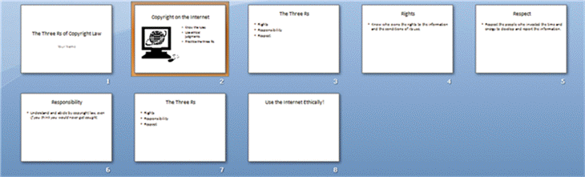

____ 18. Which view is displayed in Figure 20-1 above?
a. | Slide Show | c. | Normal
b. | Slide Sorter | d. | Slide Master

FIGURE 20-2

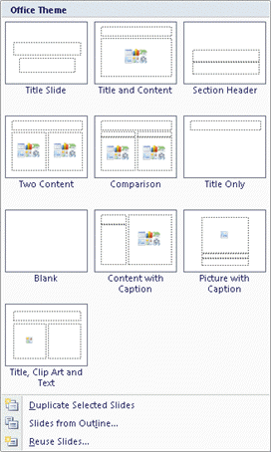

____ 19. Which button displays the options shown in Figure 20-2 above?
a. | Paste | c. | Background Styles
b. | Themes | d. | New Slide

Case 20-1
Ria is responsible for creating a presentation for the upcoming sales conference. She has decided to update a slide show that her coworker created for last year’s conference, so she wants it to have a different look, but she will keep the same basic outline.

____ 20. Ria has chosen a theme that she likes for the presentation, but she isn’t happy with the fonts. Which button will let her customize the fonts?
a. | Theme Colors | c. | Theme Effects
b. | Theme Fonts | d. | Background Styles

____ 21. Ria wants to change the background of all the slides in the presentation, but she wants it to coordinate with the theme she has chosen. Which button should she choose to make this change?
a. | Quick Styles | c. | Theme Colors
b. | Theme Effects | d. | Background Styles

Case 20-2
Max is creating a book report presentation for his language arts class. He doesn’t have much experience with PowerPoint and is having a difficult time adjusting slide layouts.

____ 22. Max does not have enough placeholders on a slide. What should he do?
a. | Add a slide | c. | Add text boxes
b. | View the slide master | d. | Change themes

____ 23. Which button should Max use to change the layout on a slide without changing the content?
a. | New Slide | c. | Quick Styles
b. | Layout | d. | Delete

Matching

Identify the letter of the choice that best matches the phrase or definition.

a. | Normal view
b. | Slide Sorter view
c. | Notes Page view
d. | Slide Show view
e. | Slide Master view

____ 24. Used to edit notes and see how the notes will appear when printed.

____ 25. Used to present the show to an audience.

____ 26. Makes it easy to add and delete multiple slides and copy and move slides.

____ 27. The default view.

____ 28. Used to make universal changes on all the slides in a presentation.
Lesson 16

Multiple Choice
Identify the choice that best completes the statement or answers the question.

____ 1. You can insert clip art and photographs from the ____.
a. | Insert Hyperlink dialog box | c. | Custom Animations task pane
b. | Clip Art task pane | d. | Office Button menu

____ 2. When a graphic is selected, eight small squares and circles called ____ appear on the border of the graphic.
a. | sizing handles | c. | graphic buttons
b. | placeholders | d. | thumbnails

____ 3. You can convert an existing list to a ____.
a. | table | c. | SmartArt graphic
b. | chart | d. | shape

____ 4. Clustered Column is a type of ____.
a. | table | c. | SmartArt graphic
b. | chart | d. | WordArt graphic

____ 5. ____ are settings that determine how a slide is introduced as you move from one slide to another in Slide Show view.
a. | Hyperlinks | c. | Animations
b. | Effects | d. | Slide transitions

____ 6. When you format ____ for the text boxes and graphics, you can determine how and when the text or graphics appear on each slide.
a. | hyperlinks | c. | transitions
b. | placeholders | d. | animations

____ 7. To modify an animation effect, you need to use the ____ command.
a. | Change | c. | Add Effect
b. | Remove | d. | Slide Show

____ 8. Which button on the Custom Animation task pane allows you to preview an animation?
a. | Change | c. | Play
b. | Remove | d. | Slide Show

____ 9. ____ files are always linked and stored outside the presentation file.
a. | Sound | c. | Movie
b. | Clip Art | d. | Photo

____ 10. The Insert Hyperlink button is located on the ____.
a. | content placeholder | c. | Clip Art task pane
b. | Insert tab | d. | Animations tab

____ 11. When you choose a shape tool, the mouse pointer changes to a(n) ____ that you can use to draw the shape.
a. | double-headed arrow | c. | cross hair
b. | four-headed arrow | d. | arrow pointer

____ 12. When the pointer changes to a(n) ____, you can drag to move text boxes and other objects.
a. | cross hair | c. | four-headed arrow
b. | arrow pointer | d. | two-headed arrow

____ 13. Which button creates decorative text?
a. | WordArt | c. | Picture
b. | Shape | d. | Clip Art

____ 14. What is the keyboard shortcut for opening the Print dialog box?
a. | Ctrl+V | c. | Ctrl+X
b. | Ctrl+C | d. | Ctrl+P

____ 15. Which Print option allows you to print 1, 2, 3, 4, 6, or 9 slides per page?
a. | Slides | c. | Notes Pages
b. | Handouts | d. | Outline view

____ 16. The term ____ is used to refer to information, material, or processes that were created by and belong to a person or corporation.
a. | public domain | c. | intellectual property
b. | copyright | d. | permission

____ 17. Use ____ only when they illustrate relevant points in a presentation.
a. | graphics | c. | motion paths
b. | features | d. | triggers

____ 18. ____ in slide layouts make the task of adding graphics easy.
a. | Content placeholders | c. | Entrance effects
b. | Sizing handles | d. | Task panes

FIGURE 21-1

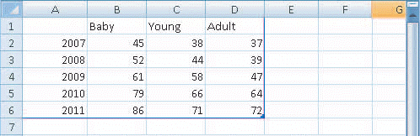

____ 19. What is shown in Figure 21-1 above?
a. | Table | c. | Chart
b. | Worksheet data for a chart | d. | SmartArt graphic

FIGURE 21-2

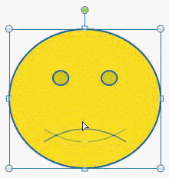

____ 20. The graphic in Figure 21-2 above was drawn with the ____ tool.
a. | WordArt | c. | Shapes
b. | SmartArt | d. | Picture from file

Case 21-1
Clay is creating a presentation about innovations in agriculture that he will post on the Internet. He doesn’t want his personal information to be saved along with the presentation file that he posts online.

____ 21. Which feature should Clay use to remove document properties and personal information from a file?
a. | Print Preview | c. | Spelling & Grammar Checker
b. | Custom Animation task pane | d. | Document Inspector

____ 22. Clay wants to email the presentation to someone but wants to make sure they can’t edit or use the slides in a slide show. What format should he save it in?
a. | PDF | c. | PPTX
b. | DOCX | d. | HTML

Case 21-2
Tanya is creating a slide show of her family’s vacation to Washington, D.C. She wants to include photos, video, and audio.

____ 23. Tanya wants to insert a file named TylerandLincoln.jpg. Which graphic button should she use?
a. | Clip Art | c. | Media Clip
b. | Insert Picture from File | d. | SmartArt

____ 24. Tanya wants music to play during the entire slide show. Which option will keep the music playing until she exits the slide show?
a. | Play Sound Automatically | c. | Hide During Show
b. | Max Sound File Size | d. | Loop Until Stopped

Matching

Identify the letter of the choice that best matches the phrase or definition.

a. | Entrance effects
b. | Emphasis effects
c. | Exit effects
d. | Trigger
e. | Motion paths

____ 25. Starts a sound effect or animation segment.

____ 26. Control how an object leaves the slide.

____ 27. Draw attention to an object that is already visible on the slide.

____ 28. Enable you to create a path for the object to follow on the slide.

____ 29. Control how the object enters onto the slide.
Lesson 17

Multiple Choice
Identify the choice that best completes the statement or answers the question.

____ 1. A ____ is an object that stores data in columns and rows.
a. | table | c. | report
b. | form | d. | query

____ 2. A ____ makes it easy for you to view, enter, and edit data in a table.
a. | table | c. | report
b. | form | d. | query

____ 3. A ____ finds and shows data that meet a specified criteria.
a. | table | c. | report
b. | form | d. | query

____ 4. The ____ is useful in sorting records, and it prevents duplicate entries.
a. | primary key | c. | datasheet
b. | field name | d. | field

____ 5. In ____ view, the table looks much like a spreadsheet.
a. | Design | c. | Field
b. | Datasheet | d. | Print

____ 6. ____ is the shortcut for creating a new blank database.
a. | Ctrl+D | c. | Ctrl+B
b. | Ctrl+N | d. | Ctrl+A

____ 7. The ____ determines what type of data the field can store, such as text or numbers.
a. | record | c. | data type
b. | field name | d. | field properties

____ 8. ____ define the characteristics and behavior of a field, such as the number of characters allowed.
a. | Data types | c. | Entries
b. | Primary keys | d. | Field properties

____ 9. When you work in ____ view, the changes are saved as they are made.
a. | Design | c. | Datasheet
b. | Form | d. | Report

____ 10. Access stores cut or copied text in the ____.
a. | Navigation Pane | c. | field
b. | Clipboard | d. | entry

____ 11. ____ is the illegal copying or use of programs.
a. | Intellectual property | c. | Shareware
b. | The Copyright Act | d. | Software piracy

____ 12. ____ is software that can be accessed for free.
a. | Software piracy | c. | The honor system
b. | Shareware | d. | Intellectual property

____ 13. The ____ key moves the insertion point to the next field.
a. | Home | c. | Tab
b. | End | d. | Up arrow

____ 14. The Next record button is located in the ____.
a. | Navigation pane | c. | Ribbon
b. | Navigation bar | d. | Status bar

____ 15. The default data type for a field is ____.
a. | Number | c. | Currency
b. | Text | d. | Yes/No

____ 16. The Blank Database button is located in the ____.
a. | Home tab on the Ribbon | c. | Navigation pane
b. | Create tab on the Ribbon | d. | Getting Started with Microsoft Office Access window

____ 17. Fields appear as columns, and each column has a ____.
a. | datasheet | c. | field name
b. | record | d. | primary key

____ 18. The ____ key moves the insertion point to the first field in the current record.
a. | Home | c. | Up arrow
b. | End | d. | Down arrow

FIGURE 22-1

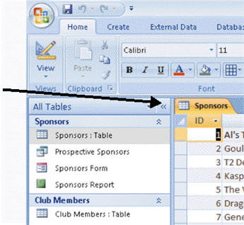

____ 19. What is the arrow pointing to in Figure 22-1 above?
a. | Status bar | c. | Restore Down button
b. | Vertical scroll box | d. | Shutter Bar Open/Close button

FIGURE 22-2

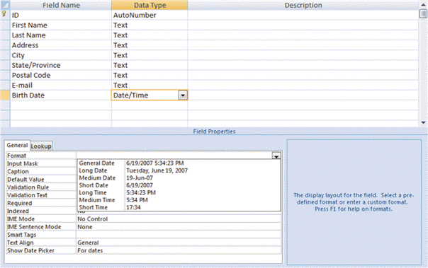

____ 20. Which view is displayed in Figure 22-2 above?
a. | Datasheet | c. | Table
b. | Format | d. | Design

Case 22-1
Dana has just been hired to create and maintain a database for a local sports organization. The organization has several different sports with many teams and divisions. She is creating the database in Design view.

____ 21. What setting will allow Dana to change the number of characters allowed in a field?
a. | Primary key | c. | Field properties
b. | Field name | d. | Data type

____ 22. If Dana doesn’t save the table in Design view and switches to Datasheet view, what will happen?
a. | She will lose all the data in the table.
b. | She will be prompted to save the table.
c. | Nothing. Access saves automatically in Design view.
d. | The database will be closed and all data will be lost.

Case 22-2
Jamir works for a distribution company and has taken over responsibility of the customer database. He has several changes to make to it in order to update the information.

____ 23. To remove a table field and all the data for the field, Jamir should delete the ____.
a. | column | c. | field name
b. | record | d. | entry

____ 24. Jamir needs to delete a record. He needs to select it and press ____ to remove the data.
a. | Undo | c. | the Delete key
b. | Redo | d. | the Enter key

Matching

Identify the letter of the choice that best matches the phrase or definition.

a. | table
b. | field
c. | field name
d. | record
e. | primary key

____ 25. A single piece of database information.

____ 26. A unique identifier for each record in the table.

____ 27. A group of related fields in a database.

____ 28. The primary object in the database.

____ 29. A label that helps identify the field.

