NAME ________________________ DATE _______________
PERIOD ______________________ CLASS ______________

5.2:Solving Quadratic Equations By Graphing
Use the related graph of each equation to determine its solutions.
- x² + 2x − 3 = 0
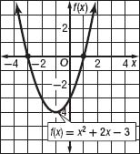
- -x² − 6x − 9 = 0
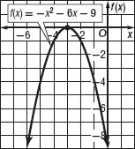
- 3x² + 4x + 3 = 0
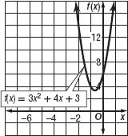

Solve each equation. If exact roots cannot be found, state the consecutive integers between which the roots are located.
- x² − 6x + 5 = 0
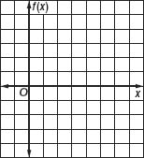
- -x² + 2x − 4 = 0
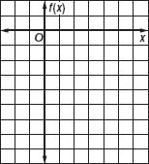
- x² − 6x + 4 = 0
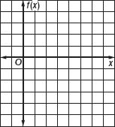
- -x² − 4x = 0
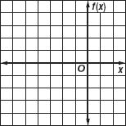
- -x² + 36 = 0
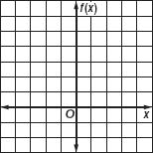

NAME ________________________ DATE _______________
PERIOD ______________________ CLASS ______________

5.2:Solving Quadratic Equations By Graphing- Part(1)
Q1] Use the related graph of each equation to determine its solutions.
- -3x² + 3 = 0
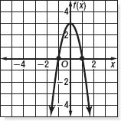
- 3x² + x + 3 = 0
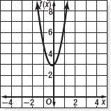
- x² − 3x + 2 = 0
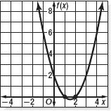
Q2] Solve each equation. If exact roots cannot be found, state the consecutive integers between which the roots are located.
- -2x² − 6x + 5 = 0
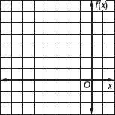
- x² + 10x + 24 = 0
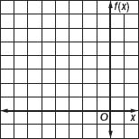
- 2x² − x − 6 = 0
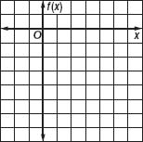

- -x² + x + 6 = 0
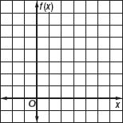

- -x² + 5x − 8 = 0
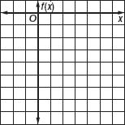
Q3] GRAVITY Use the formula h(t) = v₀t − 16t², where h(t) is the height of an object in feet, v₀ is the object's initial velocity in feet per second, and t is the time in seconds.
  - Marta throws a baseball with an initial upward velocity of 60 feet per second.
Ignoring Marta's height, how long after she releases the ball will it hit the ground?
  - A volcanic eruption blasts a boulder upward with an initial velocity of 240 feet per second. How long will it take the boulder to hit the ground if it lands at the same elevation from which it was ejected?

