NAME ________________________ DATE _______________
PERIOD ______________________ CLASS ______________

10.5:Tangents-Parts(1)
Q1] Determine whether each segment is tangent to the given circle. Justify your answer.
- 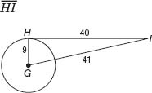
- 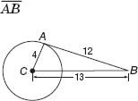

Q2] Find x. Assume that segments that appear to be tangent are tangent. Round to the nearest tenth if necessary.
- 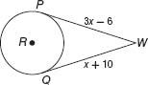
- 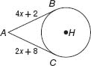
- 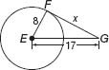
- 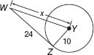

Q3] For each figure, find x. Then find the perimeter.
- 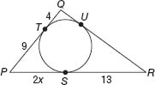
- 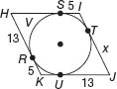

NAME ________________________ DATE _______________
PERIOD ______________________ CLASS ______________
10.5:Tangents-Parts(2)
Q1] Determine whether each segment is tangent to the given circle. Justify your answer.
- 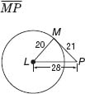
- 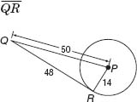

Q2] Find x. Assume that segments that appear to be tangent are tangent. Round to the nearest tenth if necessary.
- 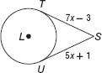
- 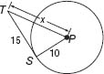
Q3] For each figure, find x. Then find the perimeter.
- 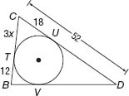
- 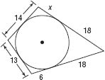
Q4] CLOCKS The design shown in the figure is that of a circular clock face inscribed in a triangular base. AF and FC are equal.
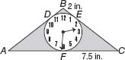
  - Find AB.
  - Find the perimeter of the clock.

