NAME ________________________ DATE _______________
PERIOD ______________________ CLASS ______________

10.4:Inscribed Angles-Part(1)
Q1] Find each measure.
- 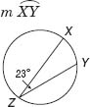
- m∠E
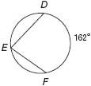
- m∠R
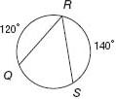
- 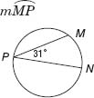

Q2] ALGEBRA Find each measure.
a. m∠N  b. m∠L | 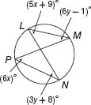
c. m∠C  d. m∠A | 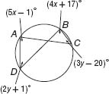
e. m∠J  f. m∠K | 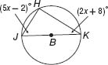
g. m∠S  h. m∠R | 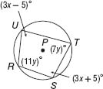

NAME ________________________ DATE _______________
PERIOD ______________________ CLASS ______________

10.4:Inscribed Angles-Part(2)
Q1] Find each measure.
- 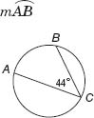
- m∠X
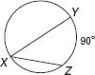
- 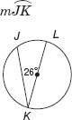
- m∠Q
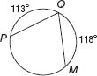
Q2] ALGEBRA Find each measure.
- m∠W  - m∠Y | 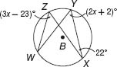
- m∠A  - m∠D | 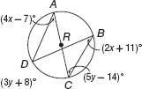
Q3] ALGEBRA Find each measure.
- m∠A  - m∠C | 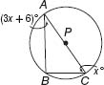
- m∠G  - m∠H | 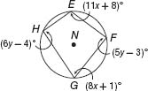
Q4] PROBABILITY In , point C is randomly located so that it does not coincide with points R or S. If , what is the probability that m∠RCS = 70?
