NAME ________________________ DATE _______________
PERIOD ______________________ CLASS ______________

5.1:Graphing Quadratic Functions- Part(1)
Q1] Complete parts a-c for each quadratic function.
- Find the y-intercept, the equation of the axis of symmetry, and the x-coordinate of the vertex.
- Make a table of values that includes the vertex.
- Use this information to graph the function.
- f(x) = -2x²
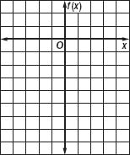
- f(x) = x² − 4x + 4
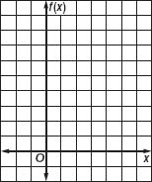
- f(x) = x² − 6x + 8
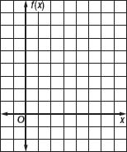
Q2] Determine whether each function has a maximum or a minimum value, and find that value. Then state the domain and range of the function.
- f(x) = 6x²
- f(x) = -8x²
- f(x) = x² + 2x
- f(x) = -2x² + 4x − 3
- f(x) = 3x² + 12x + 3
- f(x) = 2x² + 4x + 1
- f(x) = 3x²
- f(x) = x² + 1
- f(x) = -x² + 6x − 15
- f(x) = 2x² − 11
- f(x) = x² − 10x + 5
- f(x) = -2x² + 8x + 7

NAME ________________________ DATE _______________
PERIOD ______________________ CLASS ______________

5.1:Graphing Quadratic Functions- Part(2)

Q1] Complete parts a-c for each quadratic function.
- Find the y-intercept, the equation of the axis of symmetry, and the x-coordinate of the vertex.
- Make a table of values that includes the vertex.
- Use this information to graph the function.
- f(x) = x² − 8x + 15
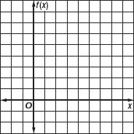
- f(x) = -x² − 4x + 12
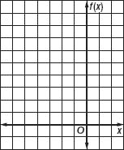
- f(x) = 2x² − 2x + 1
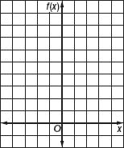
Q2] Determine whether each function has a maximum or minimum value, and find that value. Then state the domain and range of the function.
- f(x) = x² + 2x − 8
- f(x) = x² − 6x + 14
- v(x) = -x² + 14x − 57
- f(x) = 2x² + 4x − 6
- f(x) = -x² + 4x − 1
Q3] GRAVITATION From 4 feet above a swimming pool, Susan throws a ball upward with a velocity of 32 feet per second. The height h(t) of the ball t seconds after Susan throws it is given by h(t) = -16t² + 32t + 4. For t ≥ 0, find the maximum height reached by the ball and the time that this height is reached.
Q4] HEALTH CLUBS Last year, the SportsTime Athletic Club charged $20 to participate in an aerobics class. Seventy people attended the classes. The club wants to increase the class price this year. They expect to lose one customer for each $1 increase in the price.
  - What price should the club charge to maximize the income from the aerobics classes?

