excel

Multiple Choice
Identify the choice that best completes the statement or answers the question.

____ 1. An electronic ____ is an application you use to perform numeric calculations and to analyze and present numeric data.
a. | database | c. | dataform
b. | spreadsheet | d. | project

____ 2. In Excel, the electronic spreadsheet you work in is called a ____.
a. | workbook | c. | numericsheet
b. | databook | d. | worksheet

____ 3. In Excel, a worksheet is contained in a file called a ____.
a. | workbook | c. | notebook
b. | workpad | d. | datapad

____ 4. ____ below the worksheet grid let you switch from sheet to sheet in a workbook.
a. | Cell pointers | c. | Scroll bars
b. | Mode indicators | d. | Sheet tabs

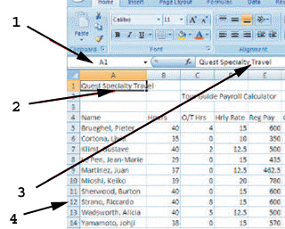

____ 5. As shown in the figure above, item ____ points to the Name box.
a. | 1 | c. | 3
b. | 2 | d. | 4

____ 6. As shown in the figure above, item ____ points to the formula bar.
a. | 1 | c. | 3
b. | 2 | d. | 4

____ 7. As shown in the figure above, item ____ points to the cell pointer, which outlines the active cell.
a. | 1 | c. | 3
b. | 2 | d. | 4

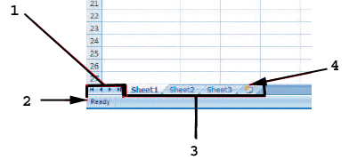

____ 8. As shown in the figure above, item 1 points to the ____.
a. | sheet tabs | c. | cell pointers
b. | status bar | d. | sheet tab scrolling buttons

____ 9. As shown in the figure above, item 2 points to the ____.
a. | sheet tabs | c. | mode indicator
b. | status bar | d. | sheet tab scrolling buttons

____ 10. As shown in the figure above, item 3 points to the ____.
a. | sheet tabs | c. | cell pointers
b. | status bar | d. | sheet tab scrolling buttons

____ 11. As shown in the figure above, item 4 points to the ____.
a. | formula button | c. | mode indicator
b. | status bar | d. | Insert Worksheet button

____ 12. All Excel formulas begin with the ____.
a. | plus sign (+) | c. | equal sign (=)
b. | asterisk (*) | d. | slash (/)

____ 13. The Excel operator for division is ____.
a. | / | c. | %
b. | \ | d. | ^

____ 14. ____ are entries that contain text and numerical information not used in calculations.
a. | Values | c. | Sheet tabs
b. | Labels | d. | Arguments

____ 15. ____ consist of the information needed by a function to calculate an answer.
a. | Labels | c. | Values
b. | Arguments | d. | Templates

____ 16. Excel recognizes an entry as a value if it is a number or it begins with ____.
a. | + | c. | $
b. | = | d. | All of the above

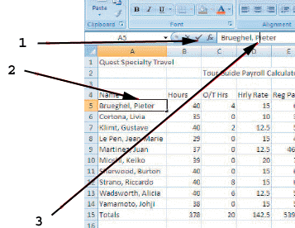

____ 17. As shown in the figure above, item 1 points to the ____.
a. | insertion point | c. | Enter button
b. | mode indicator | d. | active cell

____ 18. As shown in the figure above, item 2 points to the ____.
a. | insertion point | c. | Enter button
b. | mode indicator | d. | active cell

____ 19. As shown in the figure above, item 3 points to the ____.
a. | insertion point | c. | Enter button
b. | mode indicator | d. | active cell

____ 20. Possible paper orientations for printing a worksheet are landscape and ____.
a. | preview | c. | normal
b. | portrait | d. | page break

____ 21. In the Sheet Options group of the Page Layout tab, you can ____.
a. | turn on and off column/row headings | c. | adjust page breaks
b. | adjust paper size | d. | adjust line spacing

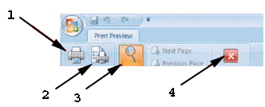

____ 22. In the figure above, item 1 points to the ____ button.
a. | Close Print Preview | c. | Zoom
b. | Page Setup | d. | Print

____ 23. In the figure above, item 2 points to the ____ button.
a. | Close Print Preview | c. | Zoom
b. | Page Setup | d. | Print

____ 24. In the figure above, item 3 points to the ____ button.
a. | Close Print Preview | c. | Zoom
b. | Page Setup | d. | Print

____ 25. In the figure above, item 4 points to the ____ button.
a. | Close Print Preview | c. | Zoom
b. | Page Setup | d. | Print

____ 26. The ____ of a cell determines how the labels and values look.
a. | value | c. | label
b. | formula | d. | format

____ 27. To format a cell or range, first you select it, and then you apply the formatting using the ____ or a keyboard shortcut.
a. | Name box | c. | Ribbon
b. | formula box | d. | Sheet tabs

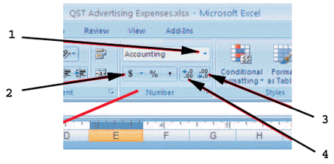

____ 28. As shown in the figure above, item 2 is the ____ button.
a. | Number Format | c. | Currency Style
b. | Accounting Format | d. | Percent Style

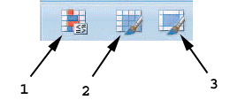

____ 29. As shown in the figure above, item 1 points to the ____ button in the Styles group on the Home tab of the Ribbon.
a. | Format as Table | c. | Format Painter
b. | Cell Styles | d. | Conditional Formatting

____ 30. As shown in the figure above, item 2 points to the ____ button in the Styles group on the Home tab of the Ribbon.
a. | Format as Table | c. | Format Painter
b. | Cell Styles | d. | Conditional Formatting

____ 31. As shown in the figure above, item 3 points to the ____ button in the Styles group on the Home tab of the Ribbon.
a. | Format as Table | c. | Format Painter
b. | Cell Styles | d. | Conditional Formatting

____ 32. The ____ size is the physical size of the text.
a. | style | c. | point
b. | format | d. | font

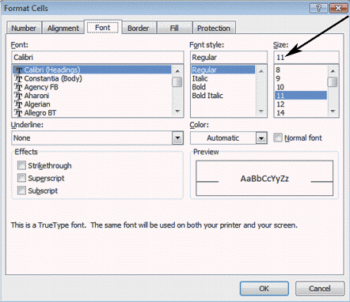

____ 33. The dialog box shown in the figure above is opened by right-clicking a cell and then clicking ____ on the shortcut menu.
a. | Format | c. | Cells
b. | Format Cells | d. | Fonts

____ 34. As shown in the figure above, the currently selected font is ____.
a. | Regular | c. | Times New Roman
b. | Calibri | d. | font 11

____ 35. The arrow shown in the figure above indicates the ____.
a. | effects size in points | c. | line length in picas
b. | currently selected font | d. | currently selected font size

____ 36. A ____ is an individual media file, such as art, sound, animation, or a movie.
a. | point | c. | clip
b. | cell style | d. | template

____ 37. The Format Painter button is found in the ____ group on the Home tab of the Ribbon.
a. | Alignment | c. | Clipboard
b. | Styles | d. | Font

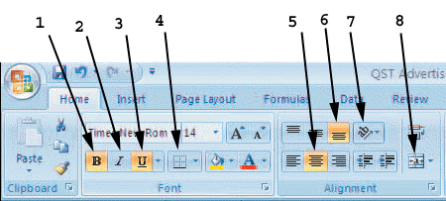

____ 38. As shown in the figure above, item 1 points to the ____ button.
a. | Bold | c. | Box
b. | Border | d. | Styles

____ 39. As shown in the figure above, item ____ points to the button that italicizes text.
a. | 1 | c. | 4
b. | 2 | d. | 6

____ 40. As shown in the figure above, item ____ points to the Center button.
a. | 4 | c. | 6
b. | 5 | d. | 8

____ 41. As shown in the figure above, item ____ points to the Merge & Center button.
a. | 4 | c. | 6
b. | 5 | d. | 8

____ 42. As shown in the figure above, item ____ points to the button that underlines text.
a. | 3 | c. | 7
b. | 4 | d. | 8

____ 43. As shown in the figure above, item ____ points to the button that adds lines or borders.
a. | 3 | c. | 7
b. | 4 | d. | 8

____ 44. Double-clicking the column line to the right of a column activates the ____ feature for the column.
a. | AutoCorrect | c. | AutoFit
b. | Format | d. | Format as Table

____ 45. A(n) ____ identifies each data series in a chart.
a. | axis | c. | data marker
b. | data point | d. | legend

____ 46. The x-axis and y-axis are, respectively, the ____.
a. | horizontal and vertical axes | c. | tick markers and data series
b. | data series and gridlines | d. | vertical and horizontal axes

____ 47. Each value in a cell selected for a chart is called a ____.
a. | data marker | c. | data point
b. | tick mark | d. | data series

____ 48. On a chart created in Excel, the horizontal axis is called the ____.
a. | x-axis | c. | data marker
b. | y-axis | d. | legend

____ 49. On a chart created in Excel, the vertical axis is called the ____.
a. | x-axis | c. | data marker
b. | y-axis | d. | legend

____ 50. A scatter chart ____.
a. | compares distinct, unrelated objects over time using a horizontal format
b. | compares trends over even time intervals
c. | compares trends over uneven time or measurement intervals
d. | combines a column and line chart to compare data requiring different scales of measure

____ 51. A pie chart ____.
a. | compares distinct, unrelated objects over time using a horizontal format
b. | compares trends over even time intervals
c. | compares trends over uneven time or measurement intervals
d. | compares sizes of pieces as part of a whole

____ 52. Which two charts compare trends over time intervals?
a. | Bar and pie | c. | Area and line
b. | Pie and area | d. | Line and scatter

____ 53. A chart that is inserted directly in the current worksheet is called a(n) ____ chart.
a. | inner | c. | sub
b. | embedded | d. | interactive

____ 54. You can add data labels by selecting your chart, and clicking the Data Labels button in the Labels group in the Chart Tools ____ tab on the Ribbon.
a. | Design | c. | Format
b. | Layout | d. | Text

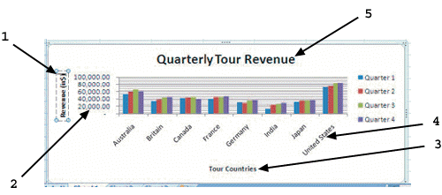

____ 55. As shown in the figure above, item 1 points to a ____.
a. | vertical axis label | c. | horizontal axis title
b. | horizontal axis label | d. | vertical axis title

____ 56. As shown in the figure above, item 2 points to a ____.
a. | vertical axis label | c. | horizontal axis title
b. | horizontal axis label | d. | vertical axis title

____ 57. As shown in the figure above, item 3 points to a ____.
a. | vertical axis label | c. | horizontal axis title
b. | horizontal axis label | d. | vertical axis title

____ 58. As shown in the figure above, item 4 points to a ____.
a. | vertical axis label | c. | horizontal axis title
b. | horizontal axis label | d. | vertical axis title

____ 59. Which error code will display if a column is not wide enough to display data?
a. | #### | c. | #NULL!
b. | #NUM! | d. | #NA

