
Grade: 10 phy Work sheet 4LC4 Chapter 4, Section 3
Name: ------------------------------------- Section: ------------ ID: --------------------
Date: ----- / 5 / 2011
Answer the following questions :
- A box A is rested on a frictionless surface as illustrated on the figure. A man pushes box A with a force of 100 N to the right, Use the diagram to answer the following questions:

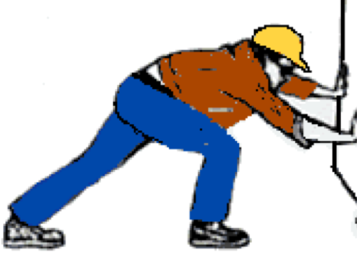
A
100N

- What is the value of the force that the box exerts on the man? Illustrate it on the figure.

100 left
- If the box has a mass of 60kg, what is its weight on Earth?
W=mg
=60(9.8)=58.4N
- The man exerts a force on the box, the box exerts a force on the man, which law does this statement explain? Newton’s first law or Newton’s third law?

Newton’s third law
- Will the man move backward or forward?

Back word
- The man has a mass of 60kg, what is the magnitude of his acceleration?

________________________________________________________
2- A box has a mass of 6.0 kg rests on a table, what will the normal force of the table on the box be?
______________________________________________________________
______________________________________________________________
______________________________________________________________
A ball with a mass of 1.2 kg is falling towards the ground. As it is falling, what magnitude of force does it exert on the ground?
______________________________________________________________
______________________________________________________________
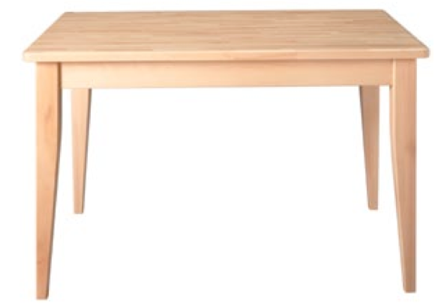5. A 6.0-kg block rests on top of a 7.0-kg block, which rests on a horizontal table.
a. What is the force (magnitude and direction) exerted by the 7.0-kg block on the 6.0-kg block? ____________________________________________
___________________________________________

b. What is the force (magnitude and direction) exerted by the 6.0-kg block on the 7.0-kg block?
__________________________________________________________

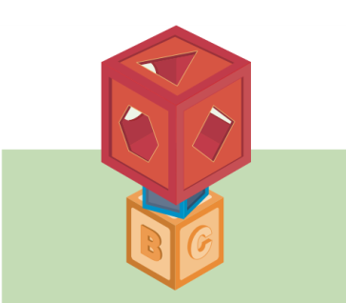
6. Three blocks are stacked on top of one another, as in the figure. The top block has a mass of 4.6 kg, the middle one has a mass of 1.2 kg, and the bottom one has a mass of 3.7 kg. Identify and calculate any normal forces between the objects.

______________________________________________________________
______________________________________________________________
Answer the following question in the space provided .
1. Two bumper cars collide and then move away from each other. How do the forces on the bumper cars exert on each other compare?
Equal in magnitude but opposite in direction
- Explain how a rocket accelerates upon takeoff.
Rocket give gas withheigh pressure down(action)
Then earth will push the rocket up ( reaction)

3- How do Newton’s third law connected to the law of universal gravity?
Object attract e3ach other in same magnitude and opposite direction force.(interaction pair)
4- A rock dropped from a bridge into a valley. Earth pulls on the rock and accelerates it downward. According to Newton’s third law, the rock must also be pulling on Earth, yet Earth does not seem to accelerate. Explain.
Earth has huge mass does not affect by acceleration done by the small rock

