
Grade: 10 phy Work sheet 4LC4 Chapter 7, Section 1
Name: ------------------------------------- Section: ------------ ID: --------------------
Date: ----- / 5 / 2011
I- Multiple Choice
force of attraction between two objects must be proportional to the objects’ masses, and is known as the ____________ force.
 | A. | gravitational
 | B. | friction
 | C. | contact
 | D. | Normal
2- The law of universal gravitation states that __________________________
(KPI 2.1)

 | A. | gravitational force is not exist between any two masses.
 | B. | objects attract other objects with a force that is proportional to the product of their masses and inversely proportional to the square of the distance between them.
 | C. | for every action there is an equal but opposite reaction.
 | D. | objects attract other objects with a force that is proportional to the distance between them and inversely proportional to the square of their masses.

3- The formula of the law of universal gravitation is ________________
A.
B.
C.
D.
4- In Newton's equation for the law of universal gravitation, F = Gm₁m₂/r²,
r is ________________________________________
 | A. | the distance between the centers of the masses
 | B. | a universal constant
 | C. | the distance between a planet and the Sun
 | D. | the difference in the two masses
5- According to the law of universal gravitation if the mass of a planet near the Sun were doubled, the force of attraction would be _____________
 | A. | reduced
 | B. | halved
 | C. | doubled
 | D. | the same
6- If the radius of the planet's orbit were doubled in the diagram below, what effect would it have on the universal gravitation force between the Sun and the planet?
 | A. | It wouldn’t change.
 | B. | It would decrease.
 | C. | It would increase.
 | D. | It would have no effect.

- The figure bellow illustrates the gravitational force between two planets in three situations.

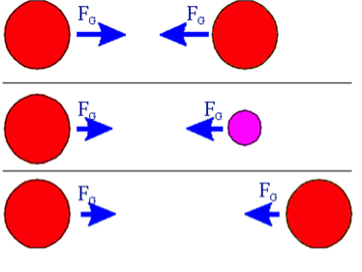
M
M
M
M
M
m
- What is the name of the law determines these forces?
Law universal gravitational

- What is the name of these forces according to Newton’s third law?

Interaction force or action- reaction
- Write down the formula used to determine the force between the planets.
F=g m₁*m₂/r²

- If the masses of the planets in the first set are equal to 5 x 10¹⁶ kg and the distance between their centers is 2.5 x 10⁸ m. what is the magnitude of the force that each planet exerts on the other?
------------------------------------------------------------------------------------------------------------------------------------------------------------------------------------------------------------------------------------------------------------------------------------------------------------------------------------------------------------------------------------------------------------------------------------------------------------------------------------------------------------------------------------

- How do the forces in the second pair compares to the first? (bigger or smaller)

Weaker / smaller
- Is the force bigger in the first pair, second, or third?

The first

2- . Two balls have their centers 3.0 m apart. One ball has a mass of 2.7 kg. The other has a mass of 4.5 kg. What is the gravitational force between them?
Assume G = 6.67×10⁻¹¹ N·m²/kg².

______________________________________________________________
______________________________________________________________

3. Two 1.00-kg masses have their centers 1.00 m apart. What is the force of attraction between them?
Assume G = 6.67×10⁻¹¹ N·m²/kg².
______________________________________________________________
______________________________________________________________
______________________________________________________________

