
Grade: 10 phy Work sheet 4LC4 Chapter 4, Section 3
Name: Khuloud Jamal AlKaabi Section: 10.51 ID: AT1001605
Date: 22 / 5 / 2011

I- Multiple Choice

1. All forces result from ________________between objects. (KPI 1.2)

 | A. | interaction
 | B. | velocity
 | C. | relations
 | D. | contact

2. Newton’s third law states that _________________
(KPI 1.1)

 | A. | an object will remain at rest or keep moving in a straight line with constant speed unless a force acts on it
 | B. | the force on an object can be found by dividing its mass by its acceleration
 | C. | the two forces that make up an interaction pair of forces are equal in magnitude, but opposite in direction and act on the same object.
 | D. | the two forces that make up an interaction pair of forces are equal in magnitude, but opposite in direction and act on different objects.

3. You push against a wall with a force of 5N. The wall exerts a force of ____ on your hand in the opposite direction.
(KPI 1.4)
 | A. | 0 N
 | B. | 3 N
 | C. | 5 N
 | D. | 7 N

4. A woman weighing 500 N sits on the floor. She exerts a force on the floor of _____________
(KPI 1.4)
 | A. | 1000 N
 | B. | 750 N
 | C. | 500 N
 | D. | 100 N

5. _____________________ is two forces that are in opposite directions and have equal magnitude.
(KPI 1.2)
 | A. | Weight
 | B. | Mass
 | C. | Interaction pair
 | D. | Universal Gravitation

6. Interaction pair also is called a (an) __________________ pair of forces.
(KPI 1.2)
 | A. | net force
 | B. | friction
 | C. | normal
 | D. | action-reaction

7. In an interaction pair, the two forces either _______________ or not at all.
(KPI 1.2)
 | A. | cancel each other
 | B. | exist together
 | C. | pull each other
 | D. | live together

8. When you push against the door, the door ______________________
(KPI 1.4)
 | A. | moves upward
 | B. | moves downward
 | C. | pulls you inward
 | D. | pushes you backward

9. The equation F _{A on B} = – F _{B on A} represents.
(KPI 1.1)

 | A. | Newton's first law
 | B. | Newton's second law
 | C. | Newton's third law
 | D. | Newton's fourth law

10. Forces always occur _______________.
(KPI 1.1)

 | A. | by themselves.
 | B. | as single quantities.
 | C. | in pairs.
 | D. | in triplets.

11. As a 500 N woman sits on the floor, the floor exerts a force on her of _________
(KPI 1.4)

 | A. | 1000 N
 | B. | 750 N
 | C. | 500 N
 | D. | 100 N

12. Action and reaction forces don’t cancel because they _________________
(KPI 1.3)
 | A. | are equal in magnitude but opposite in direction.
 | B. | act on different objects.
 | C. | act on the same object.
 | D. | break the object.

13. A student hits a nail with a hammer. During the collision, there is ____________________________ (identify the action- reaction pair)
(KPI 1.2)

 | A. | a force on the hammer but not on the nail.
 | B. | a force on the nail but not on the hammer.
 | C. | a force of the hammer on the nail and force of the nail on the hammer.
 | D. | no force on the nail nor on the hammer

14. A skydiver falls toward the earth. The attraction of the earth on the skydiver pulls him down. The reaction to this force is
(KPI 1.2)
 | A. | the earth’s surface pushes the skydiver away.
 | B. | the skydiver pulls up the earth.
 | C. | the skydiver pushes against the earth’s surface.
 | D. | neither a, b or c
15. A rocket is able to accelerate in the vacuum of space when it fires its engines. The force that propels the rocket is the force of ________________
(KPI 1.2)
 | A. | the exhaust gases from the rocket.
 | B. | the rocket on the exhaust gases.
 | C. | Earth’s gravity
 | D. | friction

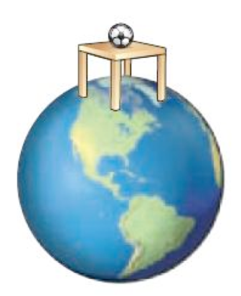
16. Which statement regarding this image is true?
(KPI 1.2)
 | A. | Earth does not exert a force on the ball.
 | B. | Earth does not exert a force on the table.
 | C. | The football is part of two interaction pairs.
 | D. | The table does not interact with the ball.

