

G-10- PHYSICS-week 3- Term 1

Name of student :……………… Grade10:…….

CHAPTER 1

Section 1.1 Apply Math in Physics

Write the term that correctly completes the statement. Use the each terms once

Hypothesis Dependent variable Independent variable
Scientific method Controls scientific theory
Significant digits Scientific law Constants

- The ………….. is the systematic way to observe, experiment, and analyze the world.
- A……………………. is an educated guess about how variables are related.
- The ………………………is a factor that is changed or manipulated during an experiment.
- A………………………… is a description of a rule of nature.
- A …………………… is an explanation supported by experimental results.
- The ………………………. Factor that depends on the independent variable.
- In scientific experiment the ……………. Serves as the standard of comparison.
- The valid digits in a measurement are called…………….
- In a scientific experiment the factors that the experimenter attempts to keep the same are called …………………..

QII. Answer the following questions:-

- Define scientific law give one example.

- What is a scientific model?

- What is scientific theory? How is it different from scientific law?

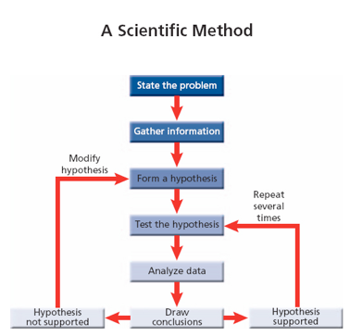

Q. II Analyze the graph and answer the question
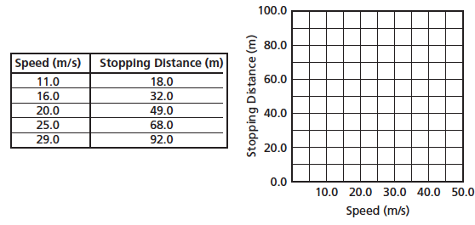
- what are the dependent and the independent varibles in the scenario shown?

- What is the difference between an independent variable and a dependent variable?

- Complete the steps of scientific method:-

- Given the equation , What is the relationship exists between each of the following.
(a). F and R

(b). F and m

©. F and V

- During a laboratory experiment the temperature of the gas in a balloon is varied and the volume of the balloon is measured. Which quantity is the independent variable? Which quantity is the dependent variable?

- Complete the following concept map using the following terms; hypothesis, graph, mathematical model, dependent variable, measurement
