
دولة الإمارات العربية المتحدة
وزارة التربية و التعليم
منطقة دبي التعليمية
مركز صلاح الدين
2012 /2011

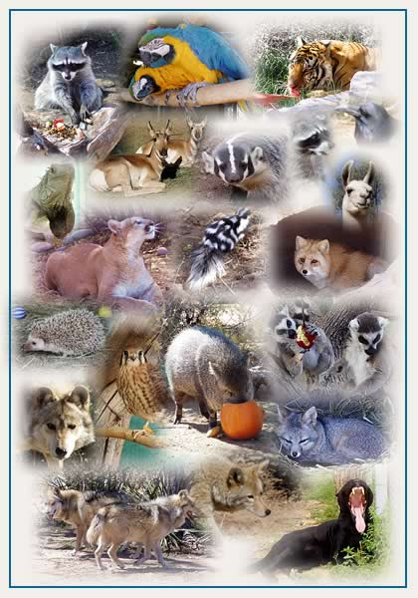
مادة: الانجليزي
عمل الطالب: منصور عبدالله محمد
الصف: الحادي عشر أدبي /1
إشراف المعلم : ايهاب سالم
The animals

Snakes
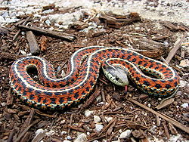
Snakes are elongate legless carnivorous reptiles of the suborder Serpentes that can be distinguished from legless lizards by their lack of eyelids and external ears. Like all squamates, snakes are ectothermic amniote vertebrates covered in overlapping scales. Many species of snakes have skulls with many more joints than their lizard ancestors, enabling them to swallow prey much larger than their heads with their highly mobile jaws. In order to accommodate their narrow bodies, snakes' paired organs (such as kidneys) appear one in front of the other instead of side by side, and most have only one functional lung. Some species retain a pelvic girdle with a pair of vestigial claws on either side of the cloaca.
Living snakes are found on every continent except Antarctica and on most islands. Fifteen families are currently recognized comprising 456 genera and over 2,900 species.^{[1][2]} They range in size from the tiny, 10 cm long thread snake to pythons and anacondas of up to 7.6 metres (25 ft) in length. The recently discovered fossil Titanoboa was 15 metres (49 ft) long. Snakes are thought to have evolved from either burrowing or aquatic lizards during the Cretaceous period (c 150 Ma). The diversity of modern snakes appeared during the Paleocene period (c 66 to 56 Ma).
Most species are non-venomous and those that have venom use it primarily to kill and subdue prey rather than for self-defense. Some possess venom potent enough to cause painful injury or death to humans. Those which are non-venomous either swallow prey alive or kill it via constriction.
All modern snakes are grouped within the suborder Serpentes in Linnean taxonomy, part of the order Squamata, though their precise placement within squamates is controversial.^{[1]}
There are two infraorders of Serpentes: Alethinophidia and Scolecophidia.^{[1]} This separation is based on morphological characteristics and mitochondrial DNA sequence similarity. Alethinophidia is sometimes split into Henophidia and Caenophidia, with the latter consisting of "Colubroid" snakes (colubrids, vipers, elapids, hydrophiids, and attractaspids) and acrochordids, while the other alethinophidian families comprise Henophidia.^{[14]} While not extant today, the Madtsoiidae, a family of giant, primitive, python-like snakes, was around until 50,000 years ago in Australia, represented by genera such as Wonambi.
There are numerous debates in the systematics within the group. For instance, many sources classify Boidae and Pythonidae as one family, while some keep the Elapidae and Hydrophiidae (sea snakes) separate for practical reasons despite their extremely close relation.
Recent molecular studies support the monophyly of the clades of modern snakes, scolecophidians, typhlopids + anomalepidids, alethinophidians, core alethinophidians, uropeltids (Cylindrophis, Anomochilus, uropeltines), macrostomatans, booids, boids, pythonids and caenophidians.

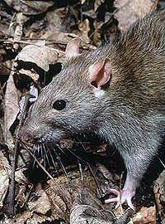
Rats
Rats are various medium-sized, long-tailed rodents of the superfamily Muroidea. "True rats" are members of the genus Rattus, the most important of which to humans are the black rat, Rattus rattus, and the brown rat, Rattus norvegicus. Many members of other rodent genera and families are also referred to as rats, and share many characteristics with true rats.
Rats are typically distinguished from mice by their size; rats are generally large muroid rodents, while mice are generally small muroid rodents. The muroid family is very large and complex, and the common terms rat and mouse are not taxonomically specific. Generally, when someone discovers a large muroid, its common name includes the term rat, while if it is small, the name includes the term mouse - scientifically, the terms are not confined to members of the Rattus and Mus genera. Compare the taxonomic classification of the pack rat and cotton mouse.

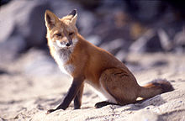
Fox
Fox is a common name for many species of carnivorous mammals belonging to the Canidae family. Foxes are small to medium-sized canids (slightly smaller than the median-sized domestic dog), characterized by possessing a long narrow snout, and a bushy tail (or brush).
Members of about 37 species are referred to as foxes, of which only 12 species actually belong to the Vulpes genus of 'true foxes'. By far the most common and widespread species of fox is the red fox (Vulpes vulpes), although various species are found on almost every continent. The presence of fox-like carnivores all over the globe has led to their appearance in both popular culture and folklore in many cultures around the world (see also Foxes in culture). The gray fox is one of only two canine species known to climb trees; the other is the raccoon dog.

The blue whale

The blue whale (Balaenoptera musculus) is a marine mammal belonging to the suborder of baleen whales (called Mysticeti).^{[3]} At up to 33 metres (108 ft) in length and 180 metric tons (200 short tons)^{[4]} or more in weight, it is the largest animal ever known to have existed.^{[5]}
Long and slender, the blue whale's body can be various shades of bluish-grey dorsally and somewhat lighter underneath.^{[6]} There are at least three distinct subspecies: B. m. musculus of the North Atlantic and North Pacific, B. m. intermedia of the Southern Ocean and B. m. brevicauda (also known as the pygmy blue whale) found in the Indian Ocean and South Pacific Ocean. B. m. indica, found in the Indian Ocean, may be another subspecies. As with other baleen whales, its diet consists almost exclusively of small crustaceans known as krill.^{[7]}
Blue whales were abundant in nearly all the oceans until the beginning of the twentieth century. For over 40 years, they were hunted almost to extinction by whalers until protected by the international community in 1966. A 2002 report estimated there were 5,000 to 12,000 blue whales worldwide^{[8]}, located in at least five groups. More recent research into the Pygmy subspecies suggests this may be an underestimate.^{[9]} Before whaling, the largest population was in the Antarctic, numbering approximately 239,000 (range 202,000 to 311,000).^{[10]} There remain only much smaller (around 2,000) concentrations in each of the North-East Pacific, Antarctic, and Indian Ocean groups. There are two more groups in the North Atlantic, and at least two in the Southern Hemisphere

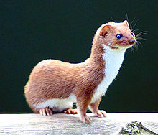
Weasels
Weasels are mammals of the genus Mustela of the Mustelidae family. They are small, active predators, long and slender with short legs.
The English word "weasel" (pronounced /ˈwiːzəl/) was originally applied to one species of the genus, the European form of the Least Weasel (Mustela nivalis). This usage is retained in British English, where the name is also extended to cover several other small species of the genus. However, in technical discourse and in American usage the term "weasel" can refer to any member of the genus, or to the genus as a whole. Of the 17 extant species currently classified in the genus Mustela, ten have "weasel" in their common name. Among those that do not are the stoat or ermine, the polecats or ferrets, and the European Mink (the superficially similar American Mink is now regarded as belonging in another genus, Neovison).
Weasels vary in length from 12 to 45 centimetres (5 to 18 in), and usually have a red or brown upper coat and a white belly; some populations of some species moult to a wholly white coat in winter. They have long slender bodies, which enable them to follow their prey into burrows. Their tails may be from 22 to 33 centimetres (9 to 13 in) long. As is typical of small carnivores, weasels have a reputation for cleverness and guile.
Weasels feed on small mammals, and have from time to time been considered^{[by whom?]} vermin since some species took poultry from farms, or rabbits from commercial warrens. Certain species of weasel and ferrets have been reported^{[by whom?]} to perform the mesmerizing weasel war dance, after fighting other creatures, or acquiring food from competing creatures. In folklore at least, this dance is particularly associated with the stoat^{[citation needed]} .
Collective nouns for a group of weasels include boogle, gang, pack, and confusion.^{[1]}
Weasels occur all across the world except for Antarctica, Australia, and neighbouring islands.
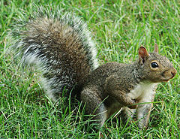
12-Squirrel
Squirrels belong to a large family of small or medium-sized rodents called the Sciuridae. The family includes tree squirrels, ground squirrels, chipmunks, marmots (including woodchucks), flying squirrels, and prairie dogs. Squirrels are indigenous to the Americas, Eurasia, and Africa and have been introduced to Australia. Squirrels are first attested in the Eocene, about forty million years ago, and are most closely related to the mountain beaver and to dormice among living species.
Squirrels are generally small animals, ranging in size from the African pygmy squirrel, at 7–10 cm (2.8–3.9 in) in length, and just 10 g (0.35 oz) in weight, to the Alpine marmot, which is 53–73 cm (21–29 in) long, and weighs from 5 to 8 kg (11 to 18 lb). Squirrels typically have slender bodies with bushy tails and large eyes. Their fur is generally soft and silky, although much thicker in some species than others. The color of squirrels is highly variable between – and often even within – species.
The hindlimbs are generally longer than the forelimbs, and they have four or five toes on each foot. Their paws on their forefeet include a thumb, although this is often poorly developed. The feet also have a soft pad on the underside.^{[3]}
Squirrels live in almost every habitat from tropical rainforest to semiarid desert, avoiding only the high polar regions and the driest of deserts. They are predominantly herbivorous, subsisting on seeds and nuts, but many will eat insects, and even small vertebrates.
As their large eyes indicate, squirrels generally have an excellent sense of vision, which is especially important for tree-dwelling species. They also have very versatile and sturdy claws for grasping and climbing.^{[4]} Many also have a good sense of touch, with vibrissae on their heads and limbs.^{[3]}
The teeth of sciurids follow the typical rodent pattern, with large gnawing incisors that grow throughout life, and grinding cheek teeth set back behind a wide gap, or diastema.

