E card
Student work: mayed khmmis almurar
Grade:1\9
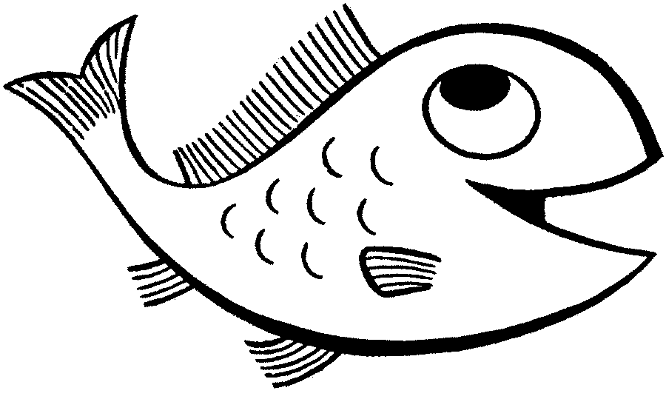

Teacher:osama

Big fish
It is said that a big fish, and her daughter, were playing in the calm blue sea, Fshahdta three ships sailing in the long term.
Said the big fish: they human beings.
Shouted the fish with emotion: the Whitney to know where they are going! - A journey of exploration risk.
- How I wish to do such a trip!. I want to know the other bays and seas of the other.
- Maybe one day, not now, my dear. You are still a small risk of exploration.
- I'm not as small as you think, O my mother.
- I mean when Tkiprin more, my daughter, the whole world will be at your disposal.And then did discover it as you like. She lamented: How can this be, and I did not find until now no one helps me, at least, I get my chance to play and play!. Heard the cancer into bits of talk, little fish, asked her: What is the thing that I hear disgruntledit? Ears do not take you enough of the fun
Fun? In your opinion, a mistake of this?. - I do not know. I wanted to do an exploratory trip, and my mother says I am still small, and to wait even more. Nawras participated in modern birds, and said: Your mother was right. - I see you are also standing in front of my desire, and help me. - For fear you, the Tdilan your way and Tadhaaan, we do not want you to do so. replied the fish arguing: I will not go astray on my way will not miss. Why do not you can see I am big enough, to do my adventure that I want? It is that felt by one, slipped out of the Gulf towards theunknown, Vmaht one of those ships cruising, she found she and her mother before. I swam as fast as you can to reach them, but their ability to so was much less than you think. Antzerana O ship! I shouted with all their strength. Did not hear one of the sailors call, and in moments of absent ship beyond the horizon. Felt the fish tired and disappointed, so I decided to return to her homeland. But it was lost, not knowing how to reach the Gulf, home to her family and friends, all around was strange and unfamiliar. While she swims confused concerned, I came across octopus, I asked him: Do you know where the road to my house? shake octopus body, and the extension of legs in all directions, and ignoring the question. I hastened towards some oysters sleeping, and I asked them: I've lost the way to my house, you could help me to find him?. and also did not receive an answer, I pleaded with the jellyfish: the Atk direct me to the path brings me to my house? and also did not receive fish response, and did not find it help her to reach her home, everyone is the lesser of them, indifferent Bmhantha. - What do I do now, and what is my destiny? My mother and my friends are right when they said I am a small adventure to do alone. And suddenly, I noticed that the fish that swim around rapidly. And before you ask what is going on here, it fell under the large. I felt cold water and silently, and I knew that the next is the shark and the fish ran away for fear of it. Try shark, The Fish to catch small, and swallowed. But was able to poke itself among the rocks minutes, it is difficult for the large-scale entry. And when she felt the demise of the risk out of Mkmenha, and it is to watch out behind them swam with all its power away, and found herself at home. In fact, she does not know how arrived, but know they will not return to the adventure of a new, in this young age. so said to her mother and her friends, who welcomed her and so happy her back safely into the arms of the Gulf safe.

