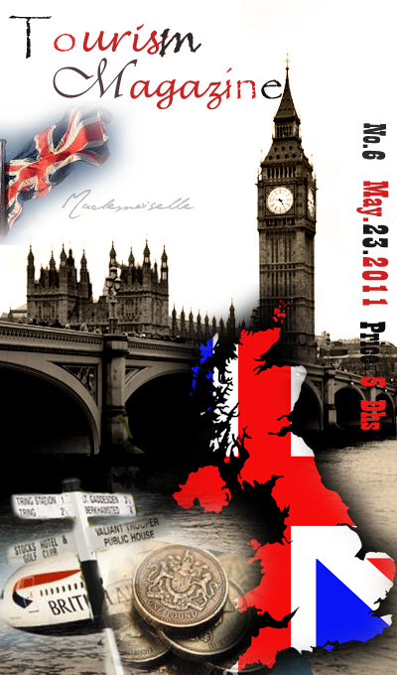
In this issue we are going to show you are going to see about Britain the famous country for tourism (it’s the sixth most visited country).
TOURISM MAGAZINE
Published monthly
Tourist Company for tourism information’s


UAE - Abu Dhabi (Al Ain) BOX. 5695
School:………class:……
Teacher: ……….
www.TourismMagazine.ae

|| Editors ||
………
……….
……..

In this issue:
Influence of tourism in Britain economy------------------ 3
Top tourist attractions in Britain ------------------------- 4
Most visited sites ------------------------------------------ 6
Top restaurants in Britain --------------------------------- 7
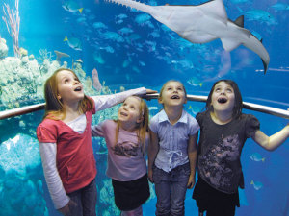
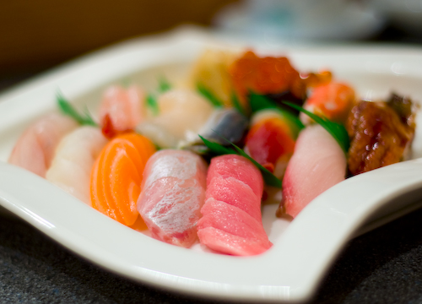
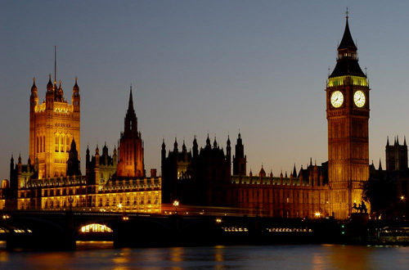
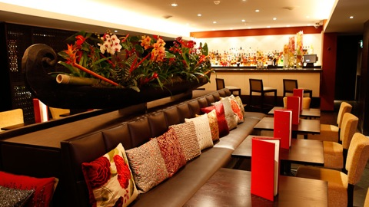


|| The effect of tourism
On the British economy ||

If you built your understand, dear reader on what you hear and read about the British economy, your information will be inaccurate; because the Britain economy doesn’t depend just on the industry.
The British economy was always based on trade, a natural result because Britain is an island, has strong ties with the world, but tourism has become one of the pillars of this economy, where it’s the sixth rank in the strongest economics.
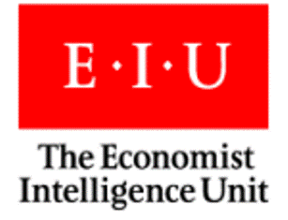
According to the Economist Intelligence Unit, will remain Britain has the strongest business environment between all the major European economies until 2012.
London is the paradise of nightlife, restaurants and the capital of artistic activities and theaters, Darm city also contain a historical heritage and scenic nature and even a place to shoot movies, large proportion of tourists coming to visit Britain to visit those cities and that increase the income.
With high growth rates in the British tourist traffic, the tourism companies have attracted from all countries. These companies have found in London market an international travel and an effective way. And we shouldn’t forget the raises in the values of the pound sterling against other foreign currencies.
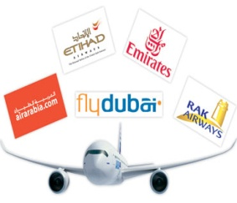
Top Tourist Attractions in the UK

The United Kingdom boasts a long, rich and vibrant history, making it one of the top tourist destinations in the world. If you're planning a tour of the UK, or living there and stuck for something to do, here - in no particular order - are some of the top tourist attractions you'll find in the United Kingdom.

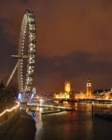
The London Eye

More than just a Big Wheel
The London Eye (originally called the millennium wheel) is an instantly recognizable landmark sitting on the South Bank of the River Thames. It is also currently the biggest Ferris wheel in Europe standing a proud 135 meters in height.

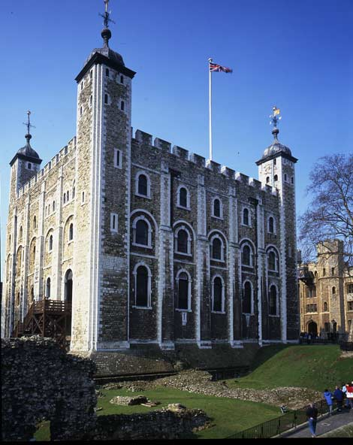
The Tower of London
The Tower of London has a long and often chequered history. It began life as a white tower erected by William the Conqueror to maintain a viselike hold on the city of London and assert his authority as the new ruler of England. The white tower stands to this day and is the centerpiece to what over the course of history has become a heavily armored fortress.
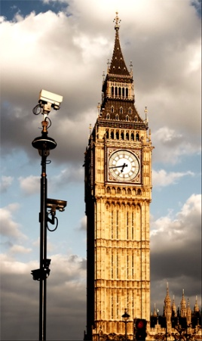
Big Ben Clock
The name Big Ben is often used to describe the tower, the clock and the bell but the name was first given to the Great Bell.
The Clock Tower was completed in 1859 and the Great Clock started on 31 May, with the Great Bell's strikes heard for the first time on 11 July and the quarter bells first chimed on 7 September.

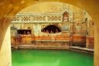
The Roman Baths at Bath

The Hot Spring of Roman Britain
Bath is home to the only hot springs in the UK.
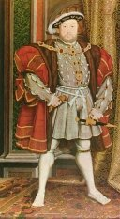

Hampton Court Palace

Hampton House of Horrors
Hampton court is famous for two things, its hedge maze and the reported sightings of numerous ghosts.

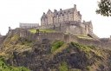
Edinburgh Castle

Perched Atop the Heart of Scotland
Edinburgh Castle stamps a majestic authority upon the capital city of Scotland, as it sits high on its perch atop Castle Rock, overlooking the city sweeping out beneath.

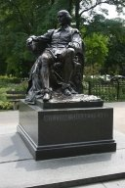
Stratford-upon-Avon

Birthplace of the Legendary Bard
Home to the Royal Shakespeare Company, Stratford-upon-Avon has long been a favorite tourist attraction of those living in and outside of the United Kingdom.

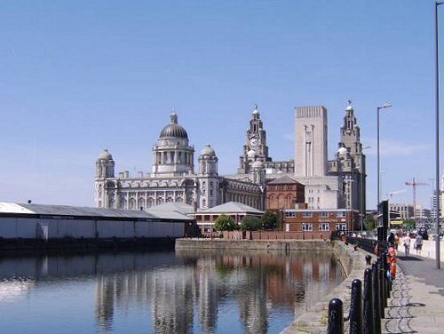
Most visited sites

The City of Liverpool is amongst the 100 most visited cities in the world.

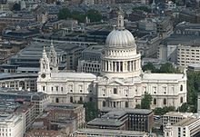

St Paul's Cathedral in London is the country's most visited religious building.
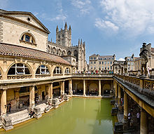

The city of Bath has some of the best preserved Roman architecture in England.

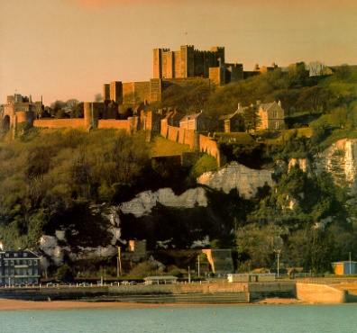
Dover A major port with access to the continent. Also well known for its white cliffs, and to a lesser extent for its castle, Dover Castle.

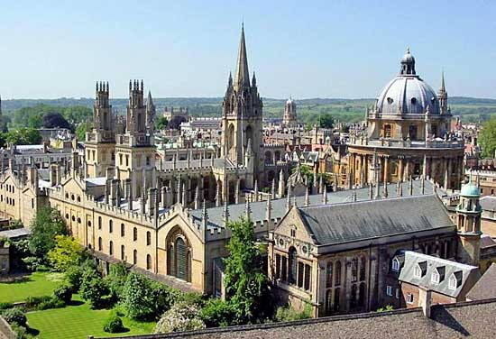

Oxford A city known for its university, the University of Oxford.

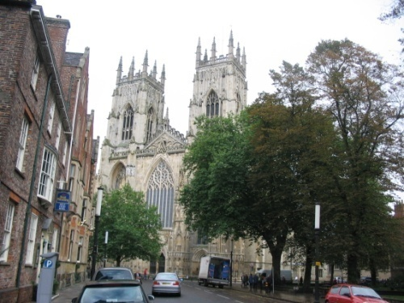
York Famous for the York Minster cathedral. Also the location of the National Railway Museum and a wealth of preserved medieval streets and buildings, such as the Merchant Adventurers' Hall and the Shambles.

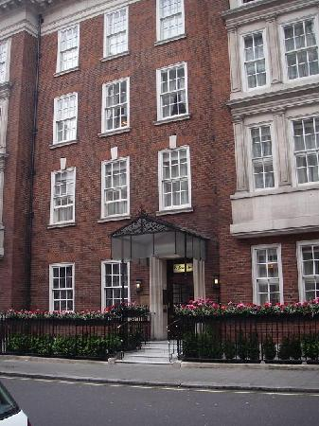
Top UK restaurants

1. Le Gavroche
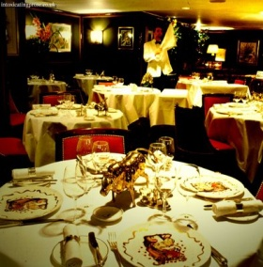
Forty years on and Le Gavroche still sets standards of service and cooking that few restaurants in the country come close to. The interior of this basement restaurant may strike some as somewhat old fashioned, but it is reassuringly established in an age of glitzy design. (That does not mean it is snooty or uncomfortably posh.) If only Rolls Royces ran as smoothly as the service under the watchful eye of that master of maître d’hôtel’s, Silva no Giraldin, and if only other kitchens matched the balance of inventiveness and classicism of Michel Roux Jr’s cooking.
· Le Gavroche, 43 Upper Brook Street, London W1. Tel: 020 7408 0881
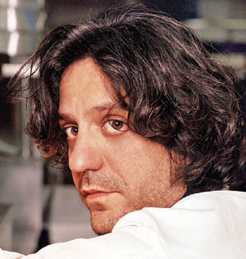
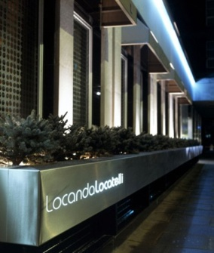

2. Locanda Locatelli
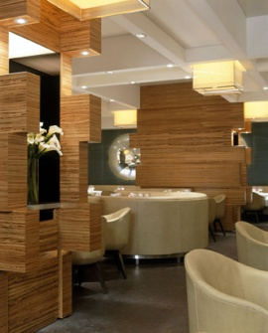
Giorgio Locatelli is a starry, starry chef and his food is starry, starry, too. It is not slavishly authentic. Locatelli is one of the very few chefs who can take the ingredients and dishes of his mother country and draw on his training in France and England to transform them into something new, without losing the essence of the original. The design of the place is smoothly retro, and the service is smoothly charming. There's a very fine wine list, particularly for those with elastic credit cards or deep pockets.
· Locanda Locatelli, 8 Seymour Street, London W1. Tel: 020 7935 9088

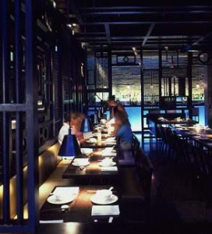
3. Hakkasan
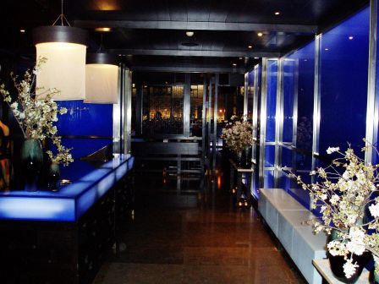
In many ways still the sexiest restaurant in London, several years after it opened. However, the glory of Hakkasan does not depend simply on slinky, urbane design. The food, the dim sum in particular, has always been several cuts above that of most other Chinese restaurants in the country. There is a certain opulence as well as delicacy about many of the dishes that makes it enormously tempting to plunder the menu to excess.
· Hakkasan, 8 Hanway Place, London W1. Tel: 020 7927 7000

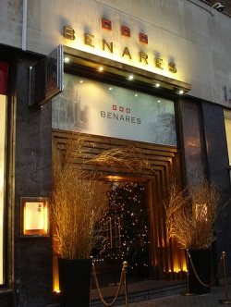

4. Benares
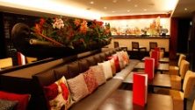
One of the cheeriest things about restaurant eating in the UK is the rise of serious Indian and Asian cooking. Why should we only think of French and, possibly, Italian, in terms of fine dining? There are a number of newer Indian restaurants in London glistening with metro-chic and serving refined, visually sophisticated dishes – Rasoi Nineet Bhatia, Amaya, Deya, and the Painted Heron. Benares, where Atul Kochar rules the kitchen, comes at the top of the list. His food is as subtle, smart and explosively flavoured as he is personally modest and self-effacing.
· Benares, 12A Berkley Square House, Berkley Square, London W1. Tel: 020 7629 8886

REFRENCES:
- http://www.guardian.co.uk/travel/2007/jan/31/uk.london.restaurants
- http://en.wikipedia.org/wiki/Tourism_in_England
- http://www.squidoo.com/tours-of-uk
- http://translate.google.ae/translate?hl=ar&sl=en&tl=ar&u=http%3A%2F%2Fwww.enjoyengland.com% 2F&anno=2

- http://www.nufooz.com/ar/article/content/miscellaneous-news/travel-and-tourism/post-3733.html
- http://mirror-uk-rb1.gallery.hd.org/_c/places-and-sights/_more2002/_more09/England-London-Big-Ben-equestrian-statue-mono-BG.jpg.html
- http://ukinjerusalem.fco.gov.uk/ar/business/020-killer-facts-arabic
- http://www.d-moos.mraircheck.com/?p=2597



