Name: - Rashed Saeed Al Hamidi
12 – L

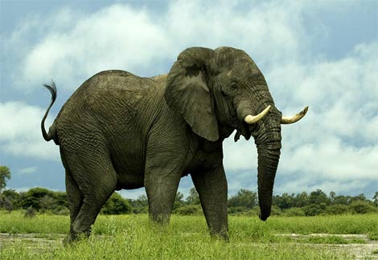

Elephant

Elephants are largest living land animals on earth to day.
At birth an elephant calf typically weighs 105 Kg .
The live for 50 to 70 year .

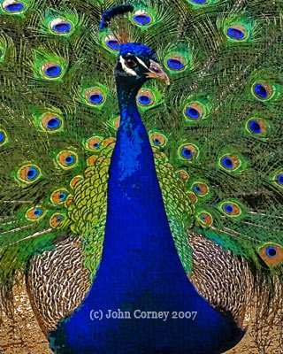

Indian peacock

Indian peacock male know as a peacock.
Is large bird with a length from bill to tail of 100 to 115 cm.
Most of Indian peacock lives on south Asia.

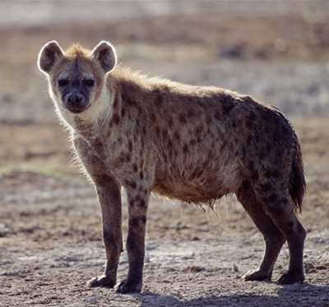

Spotted hyena

Spotted hyenas also know as laughing hyena or tiger wolf.
They have a complex set of postures in communes caution.
They most lives on Africa.
Nubian Vulture
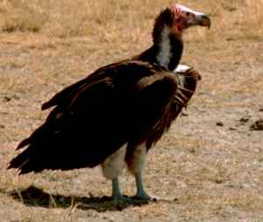
Nubian Vulture is about 95-115 cm in body length.
Nubian Vulture will on accession a tack young and weak living animals and raid the nests of other birds.

American alligator
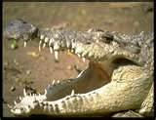
American alligator length averages 3.4m.
They can eat fish, birds and snakes.
Alligators feed mostly at might.
Octopuses
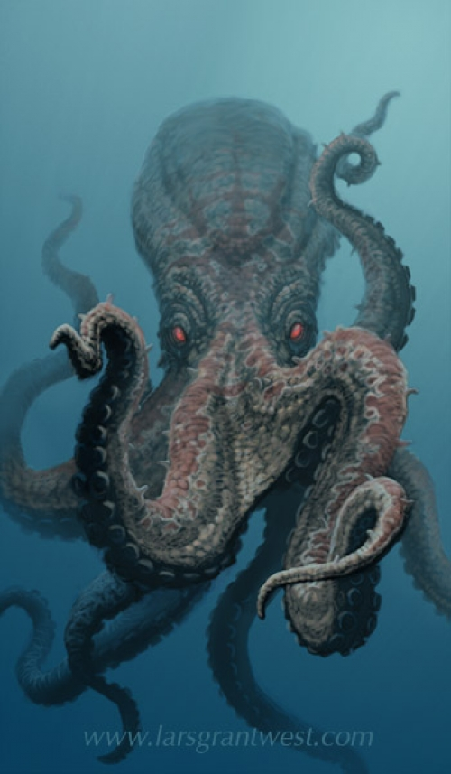
Octopuses are most common from both U.S and U.K.
An octopus has a hard beak with its mouth at the center point of the arms.
Octopuses have no internal or external skeleton.

