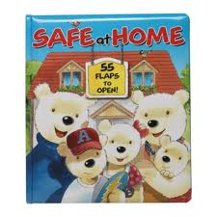
Done by: Rola Osama and Aya Bahaa
Class: 9-c
Supervised by: Ms. Abd Allateef

- safety in the kitchen
- Safety in the bathroom
- Safety in the living room
- Fire safety tips
- What to do when you see a crime
- First aid kit (must have)

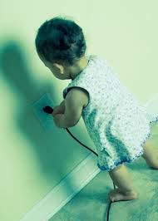
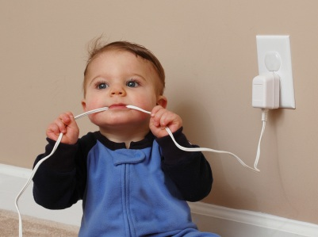
Safety in the living room

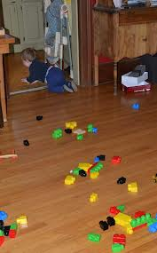
Keep children away from the electric plugs
Keep the toys away from the floor
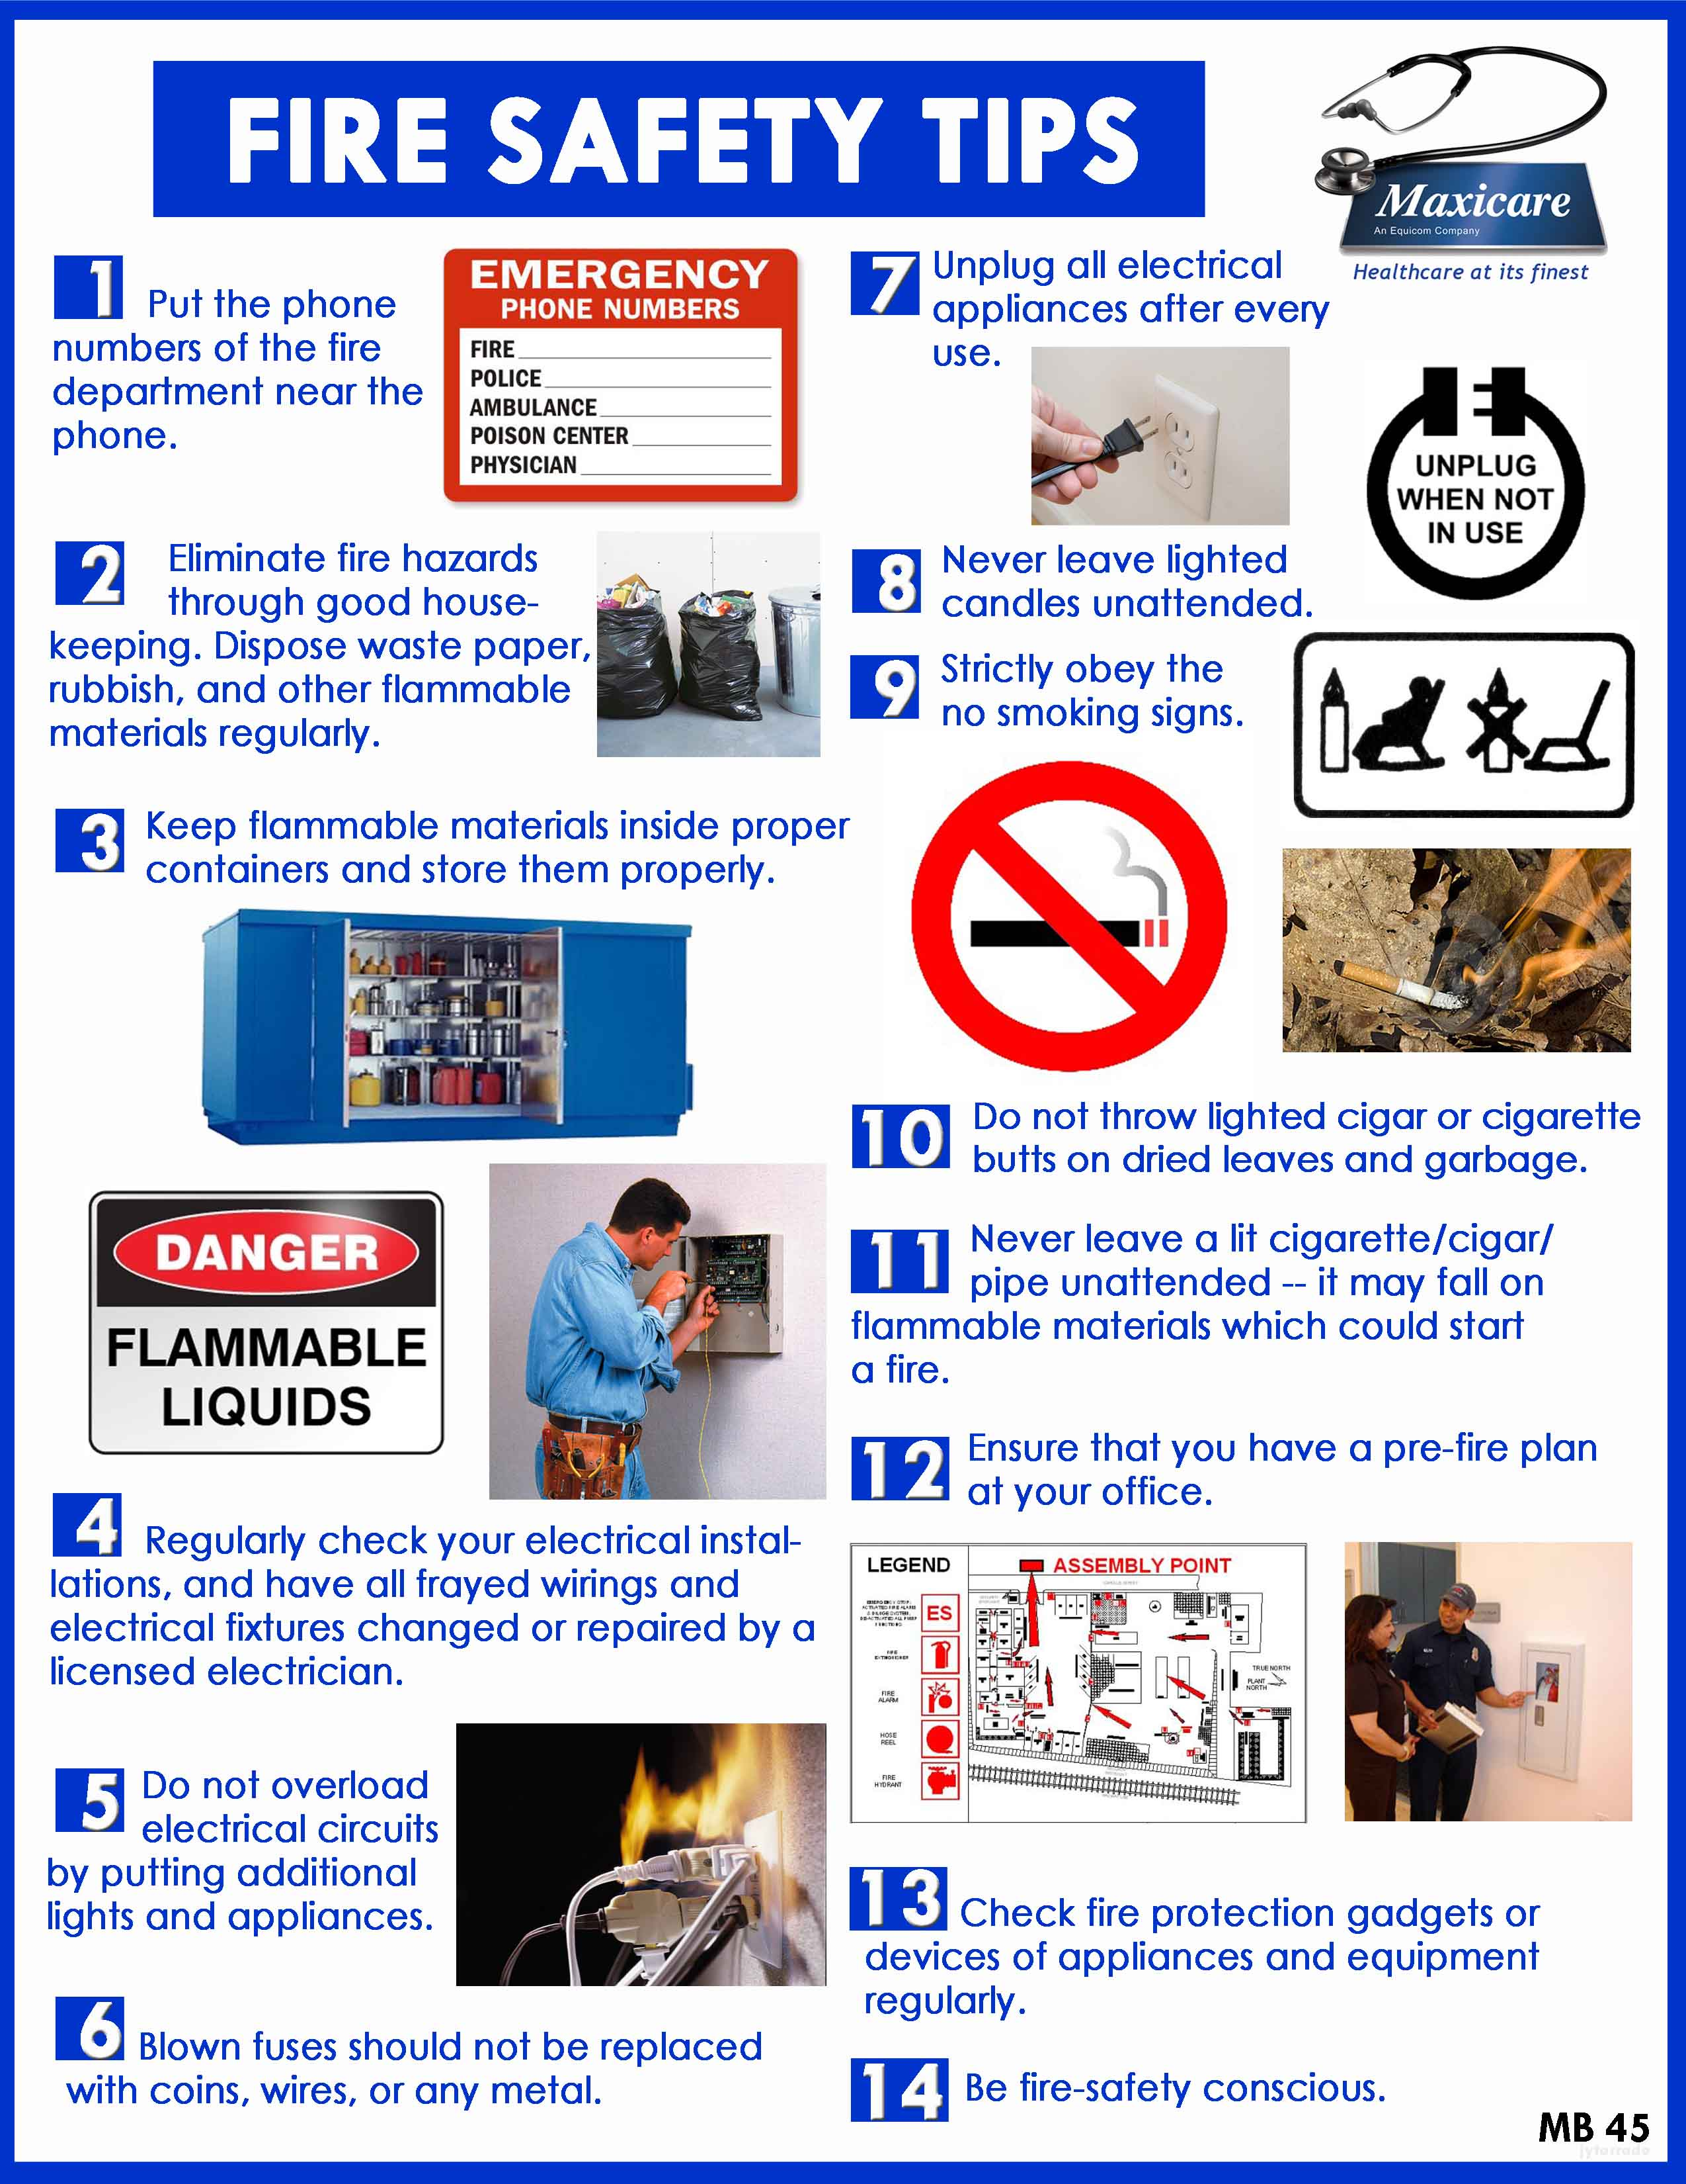
What to do when you see a crime

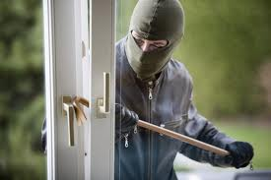
1.call the police
2.call the owners
3. keep watching and count the criminals and try to memorize how do they look like
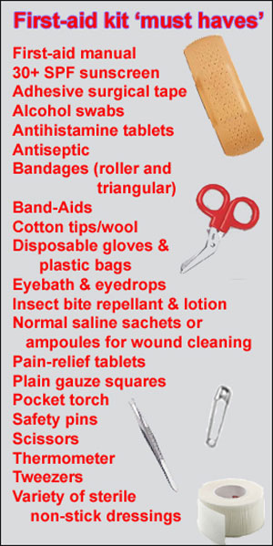

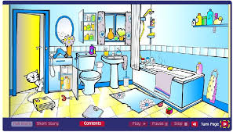
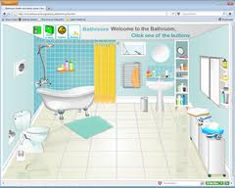
witch one is safer

*You have to keep it dry and clean so no one will get hurt
*don’t use your hair dryer near the bathtub
* also you should keep the toys and other small objects away from the floor

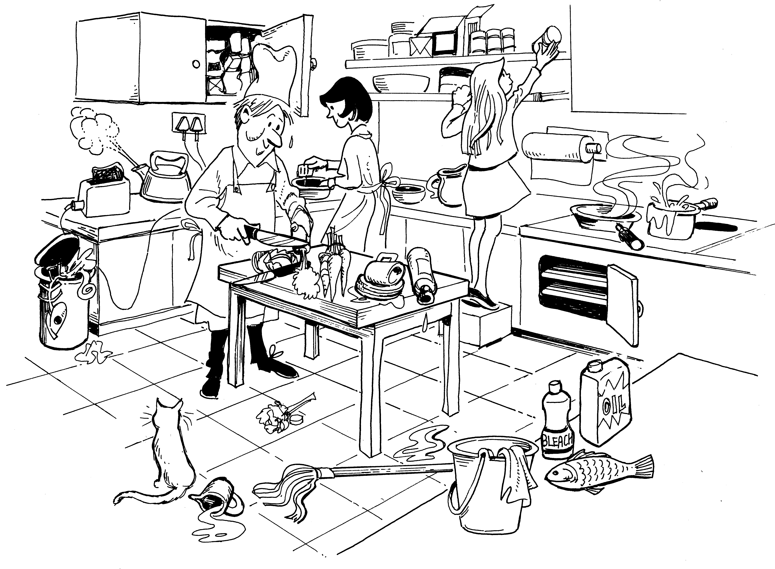
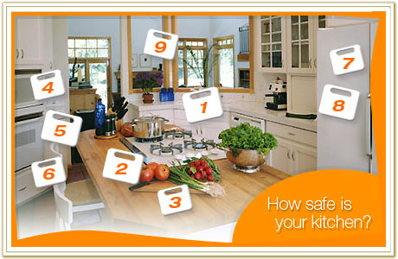
Kitchen quiz: witch one is safer


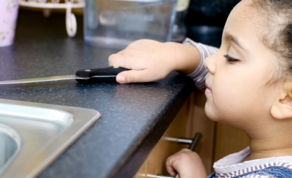


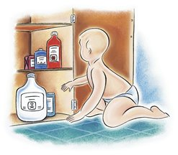
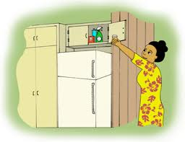
Keep the hot stuff and sharp knifes away from children
Keep the chemicals out of the reach of children

