
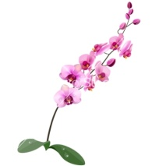

Peer Assistance Leader Support
Name: ___________________________
Grade: 10/__
Date: __/__/____
Ajman Educational Zone
Ajman School For Secondary Education
Sentence Writing Exercise no.2

Orchid
- Write five Compound Sentences for the picture below:


- Find the Topic Sentence in each question:
1. (_____) I enjoy summer sports like water skiing and baseball. The weather is usually sunny and hot, so I can go to the beach almost every day. Gardening is my hobby and I spend many summer days working in my garden. Unfortunately, the days pass too quickly in summer.

- I like to garden in summer.

- Summer is my favorite season.

c) Summer is to short.
1) __________________________________________________
2) __________________________________________________
3) __________________________________________________
4) __________________________________________________
5) __________________________________________________
2. (_____) First of all, we need money to repair old roads and build new roads. We also need more to pay teachers’ salaries and to pay for services such as trash collection. Finally, more tax money is needed to give financial help to the poor citizens of the city. It is clear that the city will have serious problems if taxes are not raised soon.

- We should raise city taxes.

- City taxes are too high.

c) City taxes pay for new roads.

