Formation of a star
Stars form from massive clouds of dust and gas in space. The animation summarises how this happens.
Gravity pulls the dust and gas together.
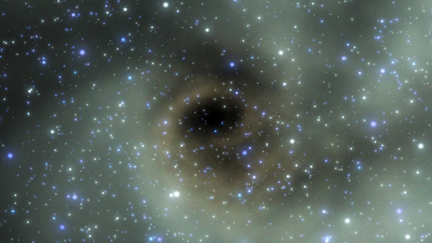
Stars form from massive clouds of dust and gas in space
As the gas falls together, it gets hot. A star forms when it is hot enough for nuclear reactions to start. This releases energy, and keeps the star hot.
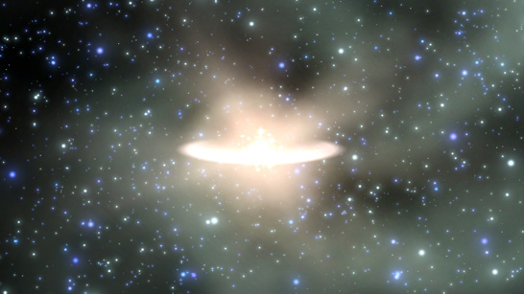
Gravity pulls the dust and gas together
During its 'main sequence' period of its life cycle, a star is stable because the forcesin it are balanced. The outward pressure from the expanding hot gases is balanced by the force of the star’s gravity. Our Sun is at this stable phase in its life.
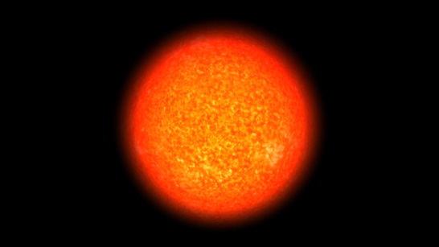
The Sun is halfway through its 10 billion year stable phase
Gravity pulls smaller amounts of dust and gas together, which form planets in orbit around the star.

